Additional Information

Job Title | Starting Salary | Contract
Environmental Practitioner Degree Apprenticeship  (Level 6)  Grade 3 | £20,033- On completion of the apprenticeship salary will increase to £25,042 | Permanent roles -Apprenticeships of 60 months included within permanent employment

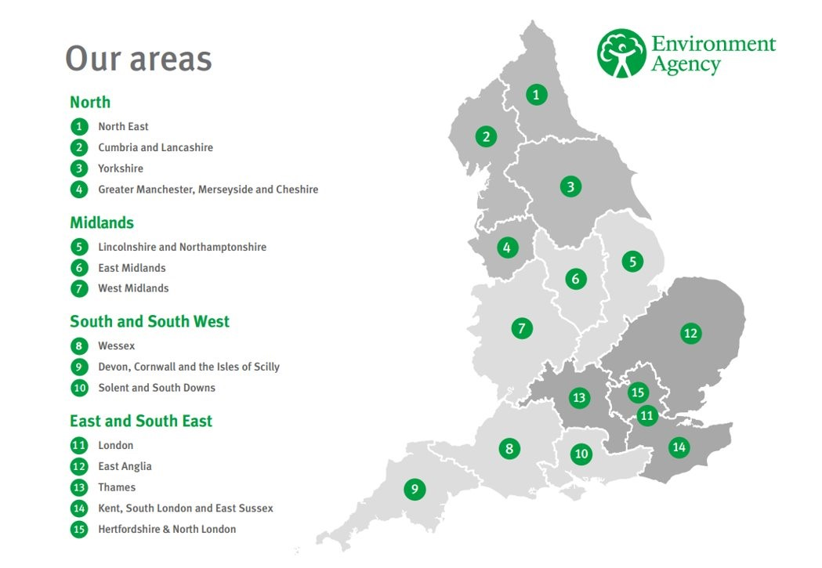

For more information about this apprenticeship standard>
https://www.instituteforapprenticeships.org/apprenticeship-standards/environmental-practitioner-degree/

Area Vacancies
Area | Location | No. vacancies
Hertfordshire & North London (HNL) | Welwyn Garden City | 1
Devon Cornwall & Isles of Scilly (DCS) | 1 x Manley House, Exeter  1x Sir John Moore House, Bodmin | 2
National | Flexible | 1
National OCS | Reading or Warrington | 1

Testimonials
Apprentices who started in Devon, Cornwall and Isles of Scilly in 2022

“I attended the local secondary school in Bodmin, and its 6th form, where I studied Biology, Chemistry and Maths for my A Levels. It was almost certain I was going to Exeter University to study a Biosciences degree until I found this brilliant degree apprenticeship course through my college’s Facebook page!

I have been working in the Partnership and Strategic Overview team since I joined the Environment Agency and will be staying with them for a year; then after that I will be moving around the teams to find out what most interests me. I have been involved in multiple areas of work. This has mainly consisted of getting involved in a Research and Development project down in Newlyn and working on GIS to map flood outlines from historical flood reconnaissance. I am looking forward to starting a new project using GIS to present a map of coastal risk across the area.

I have felt so welcome at the EA since my very first day – everyone I meet is friendly, kind and helpful; and this is what I love about this organisation. I look forward to working with like-minded people across all the departments to create a better place for people and wildlife in the coming years.” Amy

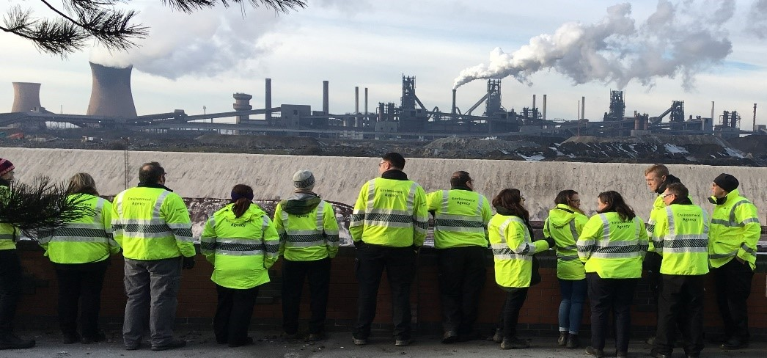

“I first found out about the Environment Agency in 2019 when I participated in a week’s work experience which gave me my first flavour of the varied and important work that the agency does. After my A levels I took a 2-year break to go traveling in UK and Scandinavia with a few gaps in-between to earn money. It was one of these breaks whilst working a rather tedious job in a Covid-19 testing centre that I found out about the apprenticeship programme run by the Environment Agency. Remembering the varied and meaningful work done by the Environment Agency from my work experience I jumped at the opportunity and applied and later after stammering my way through the interview was successful in obtaining the role.
My current placement is in the Land & Water Team. I am really enjoying the variety of work which is carried out by an Environment Officer, and I am enjoying the challenge of dealing with complex issues and engaging with different stakeholders. It is very gratifying seeing the work which myself and my team carry out having a real impact on improving the environment. I am now almost halfway through my first year of my apprenticeship and have found the EA to be a very supportive and welcoming place to work. I have Dyslexic tendency’s and have found the support provided to me through the provision of assistive technology as well as support from my team to be invaluable in allowing me to complete my role for which I am extremely grateful.
I am looking forward to the rest of my time in the land and water team and am very excited for the 6-month rotations I will do across the different teams in the agency. The experience which I will gain from these rotations will no doubt be very beneficial to me as I develop my career.” Tom

“Before I joined the Environment Agency, I had just completed my A-levels at Exeter College. I studied Environmental Science, Business studies and Sociology. During my time studying environmental science it gave me an insight into important topics such as pollution, sustainability and the importance of conservation. This led me into wanting to pursue an environmental career where I can help improve the environment and make a difference.
I am currently in the Analysis and Reporting team and am surrounded by a great team who are kind and always willing to help me. Since being in the team I have been out to different sites and collected samples including invertebrates, macrophytes and diatom samples. I have also been spending lots of time completing some invertebrate samples which involves using microscopes in the lab and using invertebrate identification books to help with the identification process. Recently I have also been doing some fish validation videos of the a fish counter, which involves me looking through the video footage and spending time making sure that the counter is measuring the fish correctly and making sure that it is actually fish going over the weir.
I have really enjoyed my time at the EA so far and everyone has made me feel very welcome. I am looking forward to my future at the Environment Agency and getting to meet new people and gain more experience.” Eloise

