Nuclear New Build Senior Infrastructure Planning Advisor

Additional Role Information
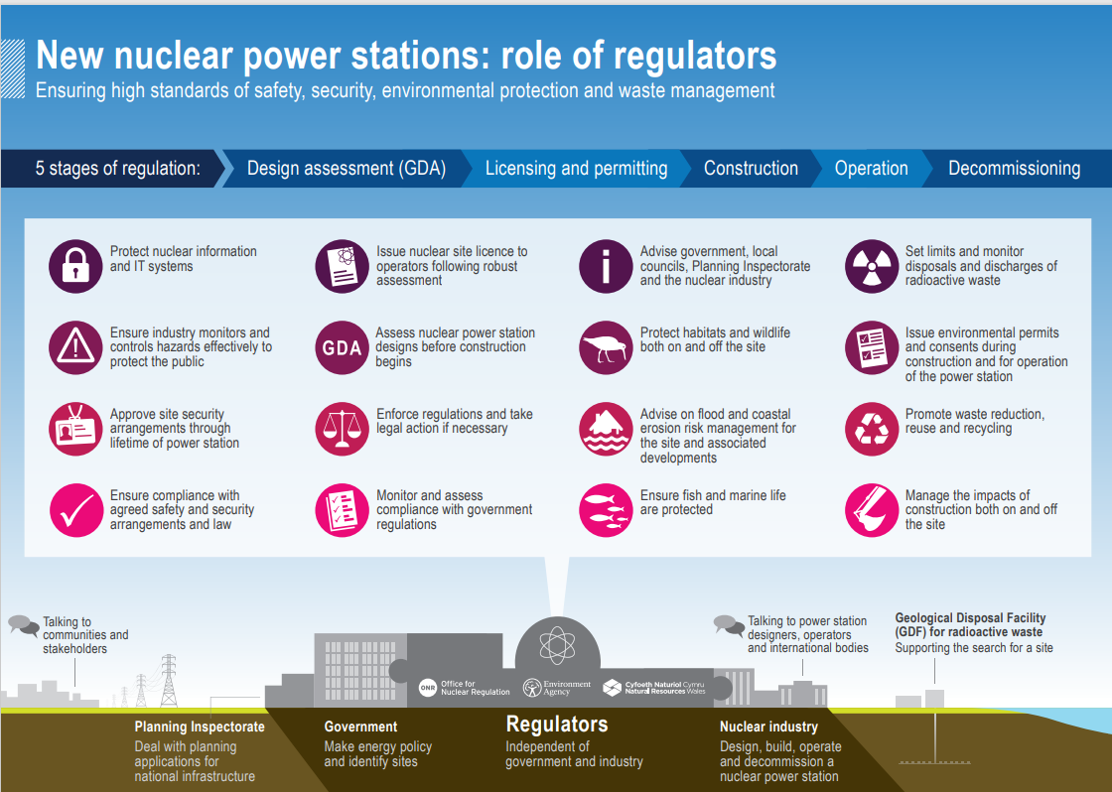

Further information on the role of the nuclear regulators through the different stages of regulation at nuclear power stations is available here:
Nuclear sites: environmental regulation - GOV.UK (www.gov.uk)
Sizewell: nuclear regulation - GOV.UK (www.gov.uk)
Hinkley Point: nuclear regulation - GOV.UK (www.gov.uk)

The team
The Nuclear New Build (NNB) Programme Team is currently made up of 11 members of staff.
We are a dispersed but supportive team. We work closely with each other and keep in regular contact using MS Teams calls.
We work closely with a wide range of other teams in the organisation, both nationally and in local Area teams.

The role
The role is a technical leadership role where you will be co-ordinating infrastructure planning applications across different new nuclear projects. You will provide strategic operational support to area project teams to ensure consistency in approaches across all new nuclear projects.
You will work closely with our area project teams and National Permitting Service to manage the planning / permitting interface as well as working directly with industry to influence their proposals to help achieve high standards of environmental protection.
You will also work closely with other organisations, including Natural England, the Marine Management Organisation and Natural Resources Wales.
This role will help deliver the Government’s 25 Year Environment Plan to reverse the biodiversity crisis and address climate change.

Employee testimonials
“I have been employed by the Environment Agency for over 15 years. For 10 of these I have been involved in responding to nuclear new build proposals.
I have spent time working as a planning specialist on the Sizewell C (Suffolk) nuclear proposal before I moved into the Project Manager role overseeing our response to another nuclear project, this time Bradwell B (Essex).
I now work as our Nuclear New Build (NNB) Deputy Programme Manager in our national programme team. The programme co-ordinates the Environment Agency’s contribution to the UK nuclear new build programme and therefore the Government’s target to bring all greenhouse gas emissions to net zero by 2050.
All my roles have allowed me to work with a wide range of people, including with other Defra organisations. The work is interesting, varied, and no one day is ever the same.
I have also worked as a Flood Warning Duty Officer as part of our incident response for over 10 years. Different to my day job, warning people at risk of flooding helps to make a difference to the communities we serve, and lets you develop different skills.”
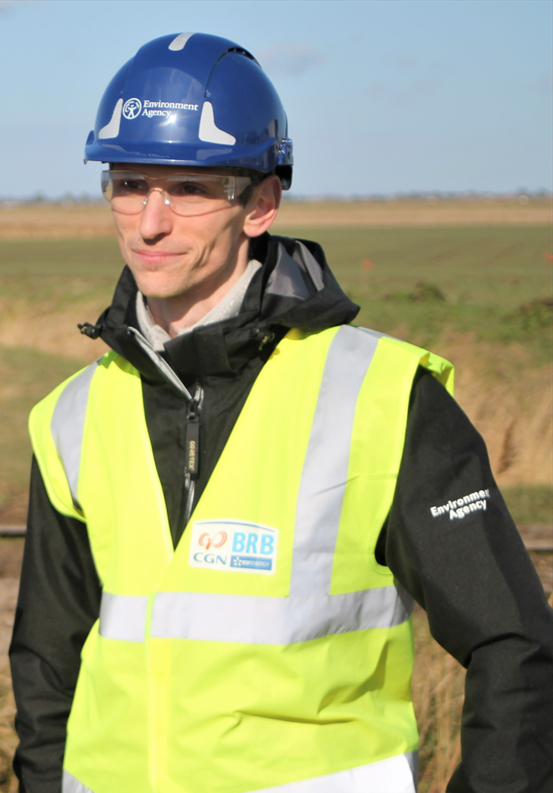

Capabilities for the role
Achieves Results:
The role involves working on and co-ordinating the Environment Agency’s response to multiple applications for new nuclear power stations. Central to this role is enabling delivery of environmental outcomes through the planning system, mainly Development Consent Orders.

You’ll need an in-depth knowledge of the planning regime and be able to demonstrate your experience working on major national infrastructure projects or local infrastructure developments.

Influences and Persuades Others:
There are many stakeholders involved in nuclear new build projects and in this role, you will need to demonstrate an ability to present your case in a convincing and attractive way that will win people over, encourage them to follow plans willingly; often succeeding where logic and reason alone would fail.

Takes decisions and solves problems efficiently:
At times you will need to find optimal solutions by effectively analysing all the information, probing to develop alternatives, and taking sound and timely decisions. This may be within tight timeframes.

Technical Exercise:
This will be presented to applicants at interview and will look to test your planning knowledge.

Our scoring system
All scoring during blind sifting and assessment stage follows a standard 1-7 scoring matrix:

- Not Demonstrated – No positive evidence of the competency
- Minimal Demonstration - Limited positive evidence of the competency
- Moderate Demonstration – Moderate positive evidence of the competency
- Acceptable Demonstration – Adequate positive evidence of the competency
- Good Demonstration – Substantial positive evidence of the competency
- Strong Demonstration – Substantial positive evidence of the competency and includes some evidence of exceeding expectations
- Outstanding Demonstration: Evidence provided wholly exceeds expectation at this level

The minimum score required to be considered for assessment is 4 per capability.

Additional Information – Applying for the role
It is your answers given to the questions asked that will be used for interview selection. More information on how to answer competency questions can be found in the candidate pack. It is highly recommended that you read this before answering.
STAR Method
Please consider the STAR Method below when structuring your answers.

- Situation - the situation you had to deal with
- Task - the task you were given to do
- Action - the action you took
- Result - what happened as a result of your action and what you learned from the experience

Please refer to the EA Capability Dictionary for guidance on how to support your answers.
Remember there’s a 250-word limit per competence including spaces. It’s an important part of the selection process so make sure you keep your statement relevant and concise. Think about what we need to know about you and what you’d bring to the role and our organisation.

