Additional Role Information

We have nine Operations Field Teams across Yorkshire, based out of depots in Rockingham (near Barnsley), Riccall (near York) and Tickton (near Beverley, along with a satellite Depot at Pickering). These dedicated teams work together to carry out flood risk management activities in mostly field-based roles. However, some roles are more office-based, co-ordinating the staff out on the ground.
Incident Management is at the heart of what motivates these teams. Their main and most exciting role is providing our emergency response to environmental incidents, particularly flooding. This role always takes priority. When an incident occurs in working hours, they drop what they’re doing and head out to the scene. Outside of working hours, they all take turns on an on-call rota to makes sure we can respond around the clock.
When they're not responding to emergencies, they carry out a busy programme of construction and maintenance on our rivers, flood defences and equipment. This proactive work keeps our assets in good condition for when emergencies occur.

As a Lead Team Member, you will lead a small team on the ground delivering our maintenance program, which requires daily working on our river and coastal defences, to prevent and respond to flooding and pollution incidents. As part of our commitment to your development, the EA has an exciting range of training available
Leading your team to efficiently and safely carry out routine maintenance of our assets, this hands-on role is mostly field-based and involves working outdoors in a variety of weather conditions. You'll participate in a wide range of activities, from cutting vegetation, to clearing debris and fallen trees, to operating mobile plant machinery repairing earth flood banks. You will drive our badged fleet vehicles, towing trailers with various mobile assets and equipment. As part of this role, you will at times also be required to carry out Depot support tasks to support the teams to safely deliver the annual work program.
As part of the role, you will be supplied and expected to use IT, mainly iPad applications to record and update progress
We act quickly when there’s an emergency such as flooding or pollution. You would be joining a field team and actively participating in various tasks including responding to operate our assets such as water pumps, barriers, and flood gates or deploying oil absorbents to reduce environmental damage
This role is currently available at Tickton, Pickering, Selby and Rockingham Depots
As responding to incidents is a central part of what we do, you will be required to have an incident role and make yourself available to respond to incidents or provide business continuity support during an incident. This may attract an additional payment and full training and alternative working arrangements will be available to support you with your incident role.

The team

The role

Employee testimonials
“I have been employed by the Environment Agency since 2018, I am currently working within one of the field teams in HNL (Herts & North London).
My role involves maintaining many of the assets and flood storage areas within this region. Dealing with flood and pollution events is the primary function, acting as a category 1 responder.
This role has opened so many opportunities, not just within my professional life but also personal, having the chance to learn how to cut a tree or to drive a tractor were things I would have never thought about, let alone achieve and carry out with confidence.
This has impacted my life as I have realised I’m at the point where I often think what else am I capable of…”

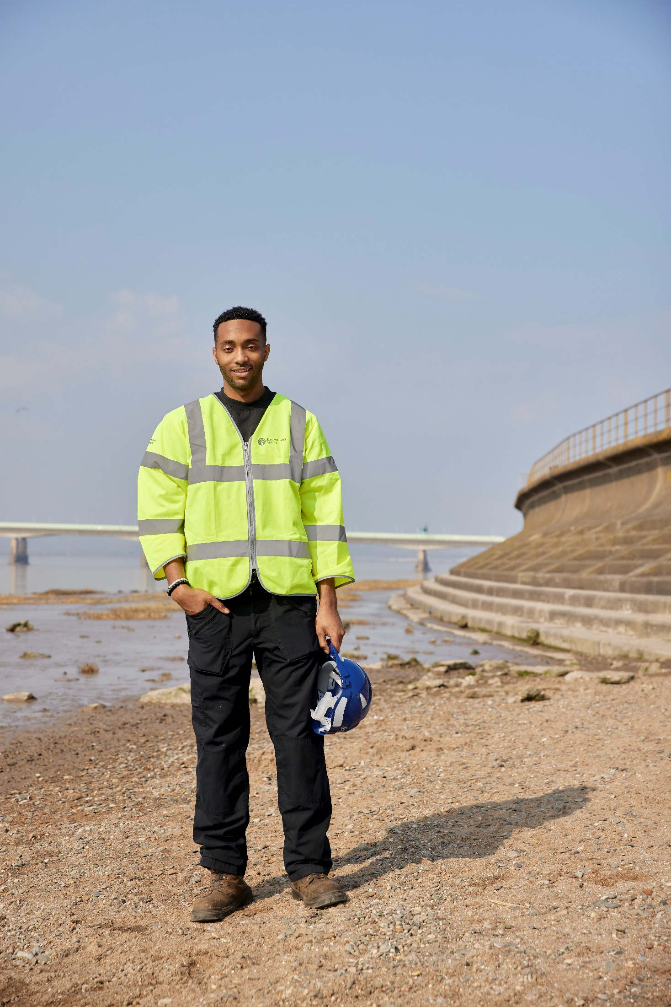

Capabilities for the role

- Interested in the environment and an understanding of the impact of flooding.
- Understanding and practical experience of Health, Safety and Wellbeing to ensure you and others around you stay safe and well.
- Strong communication skills and experience of working with the public.
- Ability to use own initiative and work as part of a team to suggest solutions to problems.
- Be hands-on and motivated to deliver work in all weather conditions.
- Previous experience of hand tools, power tools and plant machinery is desirable, and a background in risk assessment would be beneficial, but an aptitude and interest to learn is welcomed as full training is provided.
- Be computer literate with at least a basic ability to use Microsoft Office and other computer and tablet-based applications (strong Excel and Word skills are desirable). Training can be provided to develop existing skills.
- Experience of training, coaching and/or mentoring others is a desirable but not essential.
- Hold a full, clean manual driving licence.

