Team Leader

Major Investigation Room

Candidate Information Pack



**Job title: Team Leader – Major Investigation Room**

**Job location: Solihull, West Midlands**

**Date: January 2019**

**Reference:**

Contents

1. Our organisation

2. The role

3. Training and development

4. Salary and benefits

5. Further information

6. How to apply





# EA header coastOur organisation

**Our organisation**

We are the Environment Agency. We work to protect and improve the environment and create better, safer places for people and wildlife. We:

* protect and improve the quality of water, making sure there is enough for people, businesses, agriculture and the environment
* fight environmental crime
* work closely with businesses (such as those in the waste industry) to help them comply with environmental regulations
* reduce the risks to people, properties and businesses from flooding and coastal erosion

Our work helps to ensure people can enjoy the water environment through angling and navigation and we also look after land quality, promote sustainable land management and help protect and enhance wildlife habitats.

Of course, none of this will be possible without the professionalism and dedication of our staff.

We work with government, local councils, businesses, civil society groups and communities to make our environment a better place for people and wildlife. As a public body we are committed to promoting equality and diversity in all we do and valuing the diversity of our workforce, customers and communities.

We’re committed to helping our people find new ways of working to maintain our focus on creating a better place for people and wildlife. For more information on the Environment Agency and what we do, please visit: [www.environment-agency.gov.uk/aboutus](http://www.environment-agency.gov.uk/aboutus)

[](http://www.linkedin.com/company/environment-agency/careers?trk=top_nav_careers)[](http://www.youtube.com/user/EnvironmentAgencyTV)[](https://www.facebook.com/environmentagency?ref=hl)[](https://twitter.com/EnvAgencyJobs)

# 



# The role

As a Team Leader within the Environment Agency’s busy Major Investigation Room at Solihull you will be responsible for leading a professional team performing a variety of roles, including the registering of documents, indexing material, and dealing with the management of exhibits and preparing disclosure schedules under the provisions of the Criminal Procedures and Investigation Act 1996. As a leader of this team you will be responsible for looking after their individual and group needs and making sure that they deliver an exceptional service when investigating Organised Crime Groups who are primarily involved in the illegal deposit of waste on a large scale throughout England. Your team will assist in creating a cleaner, safer and healthier environment as well as prosecuting offenders.

You will need to be robust in your approach to challenge when there needs to be challenge and be ready to have difficult conversations. You will assess staff performance, set objectives and assist in helping them identify opportunities to develop. You will also be required to manage the smooth flow of material within the room during the investigation.

The Major Investigation Room currently consists of five team members and is part of the Environment Agency’s National Enforcement Service which provides support through several disciplines which includes prevention and disruption, investigations and intelligence.

The Major Investigation Room utilizes the Powercase system where all information pertinent to an investigation is gathered, documented and managed using a set of administrative procedures which enables the Senior Investigating Manager to direct and control the course of the enquiry.

There are several distinct roles within the Major Investigation Room that you will be expected to manage.

* Allocator/Receiver
* Indexer



* Exhibit Officer
* Disclosure Officer
* File Preparation

A full UK Driving Licence will be required as on occasions you will be required to visit various Environment Agency offices to offer support and assistance to area based colleagues investigating serious and significant offences.

**What skills do you need?**

As the Team Leader in the Major Investigation Room you will bring outstanding team leadership and people management skills and will also be expected to share your experience and knowledge within the team to help develop current working practices to a high standard.

* demonstrate leadership skills
* excellent verbal and written communication skills, including delivering feedback and managing performance
* show attention to detail when recording information to support the investigation
* ability to work under pressure and prioritise a varied workload
* ability to highlight areas for improvement and follow then through with action
* an appetite for developing people’s capabilities as well as your own
* demonstrate strong health, safety and wellbeing principles

**Top capabilities**

As part of the application and interview processes, we’ll be looking for you to tell us how you:

* achieve results
* build and sustain relationships
* communicate effectively



* focus on customers and partners
* share good working practices
* delivers results through others
* lead people
* develop people
* engage others
* manage change
* take decisions and solve problems

Please refer to the **Top Capabilities** document (attached to the vacancy) that describes our capability framework in further detail. The **How to Apply** section (section 6 below) provides advice on how to complete your application.

**What experience do you need?**

You will preferably have knowledge of the workings of a Major Investigation Room, in particular the roles of Indexer, Exhibits and Disclosure. Research experience and IT Skills would also be useful attributes.

If your experience is in a field other than Law Enforcement and you feel that you can meet the criteria for this role, please tell us about it in your application form.

**What qualifications and knowledge do you need?**

We are not seeking formal educational qualifications for this Team Leader role in the Major Investigations Room, however you will need to show leadership skills, be articulate and ideally have knowledge and understanding of the following;

* the provisions and practical application of the Criminal Procedure and Investigations Act 1996
* exhibit continuity and management
* the Major Incident Room Standardised Administrative Procedures



Many of the core skills and knowledge needed to perform this role can be learnt ‘on the job’ and you will be teamed up with a buddy/mentor who will provide guidance and support as you progress.

**What else do you need to know?**

* The role is centrally based (in Solihull, West Midlands). On occasions travel will be required to other Environment Agency offices and overnight stays may occasionally be required but you will be given plenty of notice beforehand.
* It is anticipated that the Solihull office will be closing in June 2019 and the Major Investigation Room will be moving to new premises in Central Birmingham together with other Environment Agency departments.
* Many people within the Environment Agency support our incident management response (such as flooding). Full training is provided for this and you will be invited to find an incident role that suits should you wish to do so.

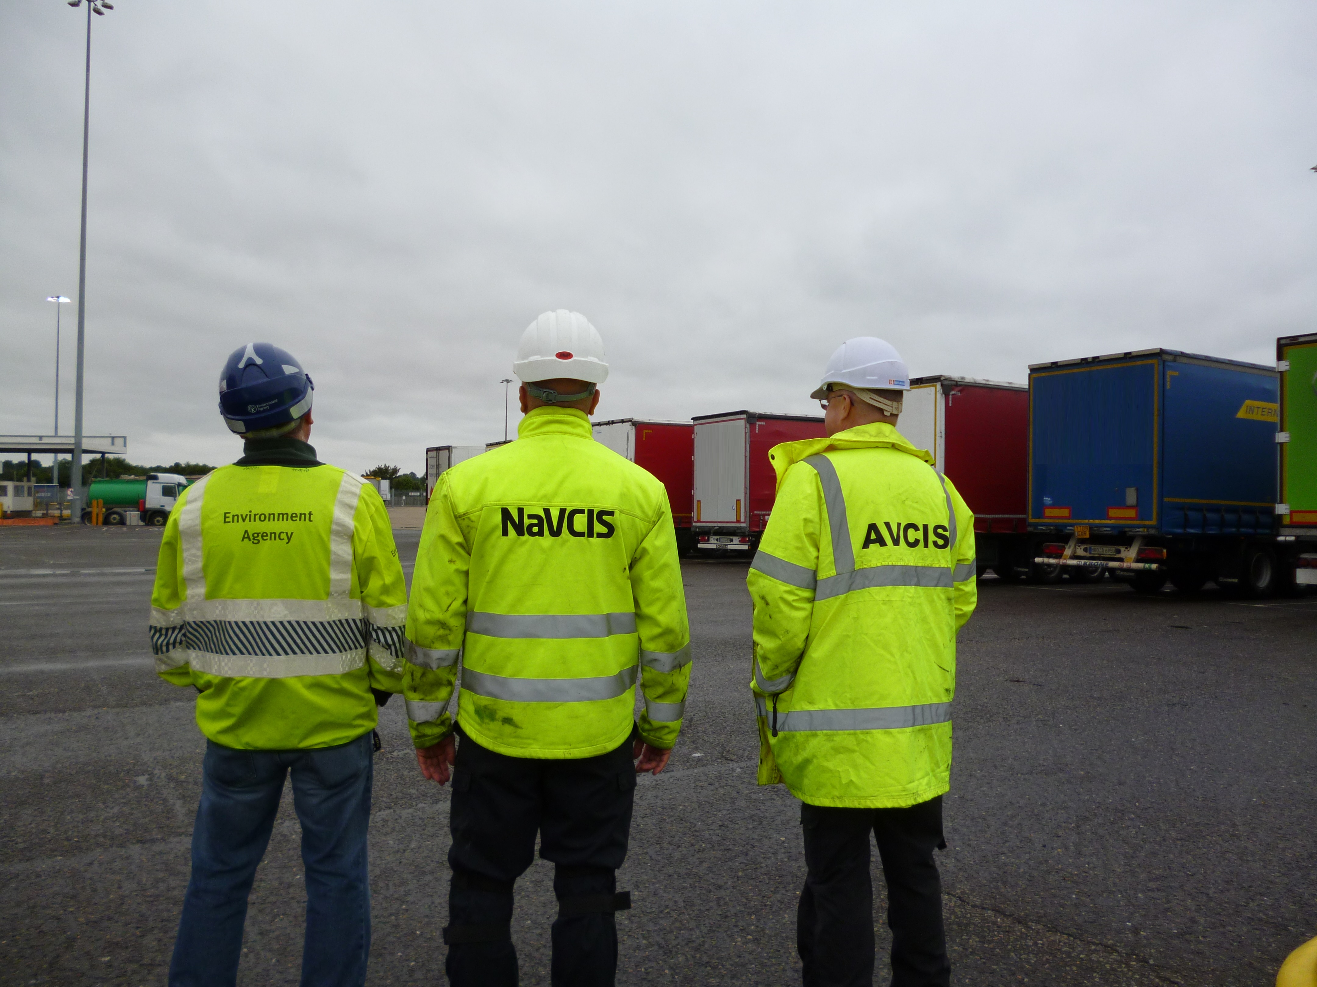

**Leaders Group.**

**There are many benefits of this role at the Environment Agency including the salary, annual leave and flexible working. I have personally found my work-life balance to have significantly improved from my previous career and I believe this is because staff welfare is highly valued within the Environment Agency.**

**Katherine Snowden – Intelligence Research officer, Solihull**



# Training and development

You will receive a mixture of development opportunities including e-learning and on-the-job training especially during your first six months probationary period.

Your learning and development doesn’t stop once you have completed your probation; we continue to invest in ensuring you have the rights skills to do your job by offering modular based development programmes linked to your role. With a strong focus on Continued Professional Development, you will be encouraged to take up to ten days every year to work on your own development. This could range from formal training to a shadowing opportunity in another department to attendance at a conference or being a mentor.

This strong emphasis on Continued Professional Development will include identifying your own opportunities as well as those for your team.

**What will the initial training cover?**

Typically the first six months will cover;

* an introduction the Environment Agency
* bespoke HR systems
* health, safety and wellbeing
* legislation and regulation
* national enforcement structure
* knowledge of Business Plan and priorities
* Powercase training

**What will I achieve?**

The training is all geared towards developing the ability to do something whilst actually doing it! Therefore the training process provides you with the opportunity to apply your acquired knowledge and demonstrate competence. The aim is to get you working comfortably as Team Leader in the Major Investigation Room team as soon as possible.



# Salary and benefits

**Starting salary:** £34,879 per annum. We also offer a salary bonus scheme that is linked to your performance throughout the year.

**Hours of work:**  37 hours (pro rata if part time)

**Leave entitlement:** Your annual leave allowance will be 27 days (pro rata if part time) plus bank holidays. This increases to 29 days with length of service. We also offer up to two days paid environmental outcome days each year. These give you the opportunity to take part in community activities with a clear environmental outcome for people and wildlife.

**Pension:** We will enrol you into the [Environment Agency Pension Fund](https://www.eapf.org.uk/) (EAPF) on commencing employment. The EAPF is part of the [Local Government Pension Scheme](https://www.lgpsmember.org/) (LGPS). It is a career average defined benefits scheme, which means you will build up benefits based on your pay each year.

We will base your pension contributions on your pensionable pay and you will receive tax and national insurance relief on your contributions. You will begin by contributing 6.5% of your pensionable pay. Whilst you are in the scheme we will also pay an employer contribution into your pension pot. We currently pay 18.5%, so this is a very generous scheme.

**Work/life balance:** We support flexible working hours and practices to help you strike a good balance between your work life and your personal life. We will also encourage you to keep developing your skills and professional knowledge throughout your career.



**Diversity:** We are committed to diversity and inclusion. We want all our staff to

feel valued and respected and to see this as a great place to work.

Diversity: it’s in our nature.

**Tenancy deposit loan:** Our Tenancy deposit loan scheme assists employees to cover the

**scheme** costs of a deposit for a privately rented home, which can sometimes act as a barrier to moving. The scheme gives access to an interest free loan to pay for some, or all of, a deposit and can be paid back over a period of up to 12 months, directly from your monthly salary.

# H:\Documents\AAA Projects\A Capability\Recruitment\Candidate packs\Pics for packs\Enf5.jpg

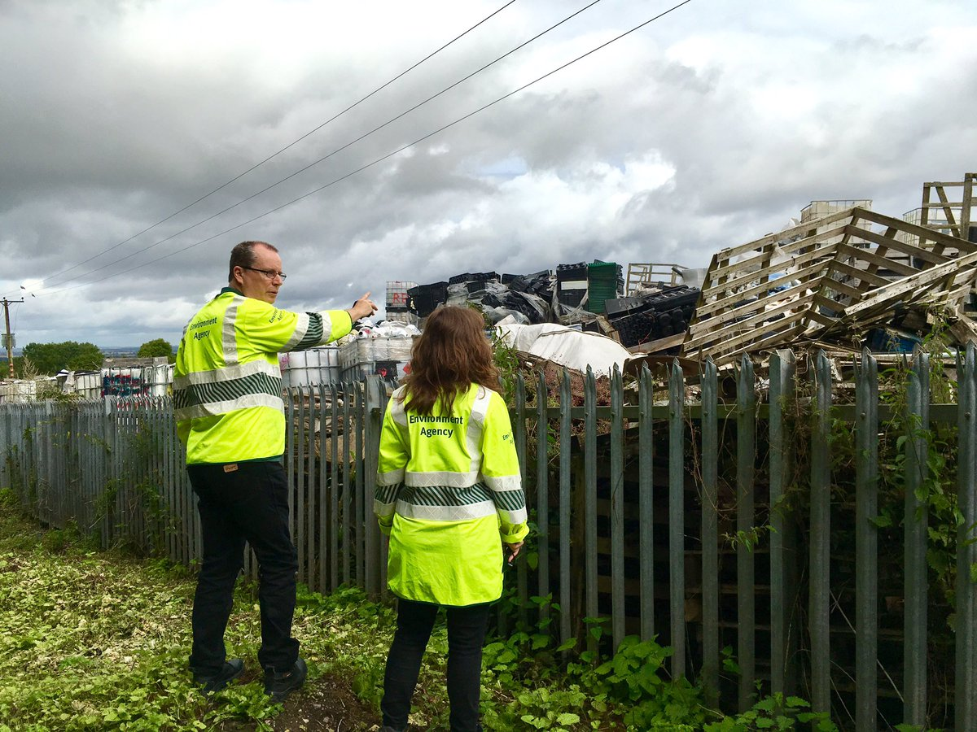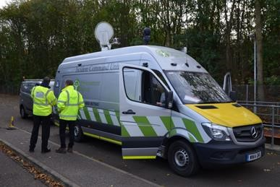

# zx uy7777777777

# Further information`

We are fully committed to having an inclusive workforce to reflect the communities we serve.   
We welcome applications from candidates seeking flexible working patterns, including part time and job share.

Please note that Environment Agency employees are not civil servants, so you may wish to check your eligibility for continuity of employment by contacting your HR department. All eligible bodies are listed in the Redundancy Payments (Continuity of Employment in Local Government etc.) (Modification) Order 1999.

Employment agency workers and contractors are considered to be external candidates and should therefore only apply for positions that are being advertised externally. They are also not eligible to claim continuity of employment should they be successful in securing a position with the Environment Agency.

Please note all successful applicants must undergo Baseline Personnel Security Standard (BPSS) checks prior to commencement of employment. This includes a basic criminal records check.

# EA header countryHow to apply

We use an online recruitment system. To make the application process simple and straightforward, and so that you know how it works and what we need from you, we’ve put together a few hints and tips.

The first thing you need to do is sign up to our online recruitment system. You’ll need a valid e-mail address to log in and apply for jobs, as all communication from us will be via e-mail. You can do this via the vacancy you are interested in by selecting **‘Apply’** at the bottom of the advert. Once you’ve clicked this link you’ll then be asked:

1. Do you have the right to live and work in the UK? – please answer ‘yes’ or ‘no’
2. Do you have the required qualifications or equivalent experience, which were stated in the job advert? – we are not seeking any specific qualifications or experience for this role, so please answer ‘yes’ to this question
3. Are you currently an employee of this organisation? – please answer ‘yes’ or ‘no’

You’ll then see the **‘Register’** page. Simply complete the details and select **‘Submit Registration’** and register to the system. You only need to sign up to the system once; you’ll just be able to login next time. You can then carry on with your application.

When it comes to the actual application, you need to fill out each section. Please be aware that the system will **automatically time out** if you are inactive for more than 60 minutes. This will result in any unsaved information being lost, so please make sure you save what you are doing regularly. Once you’ve finished, your details and information will be saved on the system for any future applications – of course, you can edit your details at any point.

When you apply to the Environment Agency for a job we will ask you to provide your personal data on our application form. We need this information so that we can establish your identity and your right to work in the UK. You can read our Data Protection Statement on the application process page of our recruitment system.  It is also available for reference on each page of the actual application.



**Capability questions**

We’re keen to know what makes you right for the job you’re applying for and why we should invite you for an interview. The capability questions are your chance to convince us! You should demonstrate how your skills, qualities and experience meet the requirements of the job (as described in the job advert and this candidate pack). Instead of simply telling us, show us: use real life examples of where you’ve used a certain skill or how you’ve practically applied your experience.

There’s a 250 word limit per question. It’s a **crucial** part of the selection process so make sure you dedicate plenty of time to completing this part of the application form. Think about what we need to know about you and what you’d bring to the role and our organisation.

**How to prepare your answers for a capability based application**

Capabilities are high level descriptions of key behaviours, skills and knowledge that underpin effective performance. They are the behaviours, skills and knowledge employees must have, or must acquire, to achieve high levels of performance. Please refer to the **Top Capabilities** document (attached to the vacancy) that describes our capability framework in further detail.

Capability questions target a specific skill, so we will be looking for some key components in your answer:

* + an indication that **you** understand the importance of that capability to the role for which you have applied
  + evidence that **you** understand the fundamental skills associated with that capability
  + an **example** that highlights your possession of that capability
  + an awareness from **you** of how the critical skills will be used to good effect in the new role

**The STAR approach**

STARstands for:

* **S**ituation
* **T**ask
* **A**ction
* **R**esult



The STAR approach is a universally-recognised communication technique designed to enable you to provide a meaningful and complete answer to questions asking for examples and it has the advantage of being simple.  
  
**Step 1 – Situation or Task**

Describe the situation that you were confronted with or the task that needed to be accomplished. With the STAR approach you need to set the context. Make it concise and informative, concentrating solely on what is useful to the story. For example, if the question is asking you to describe a situation where you had to deal with a difficult person, explain how you came to meet that person and why they were being difficult. If the question is asking for an example of teamwork, explain the task that you had to undertake as a team.

**Step 2 – Action**

This is the most important section of the STAR approach as it is where you will need to demonstrate and highlight the skills and personal attributes that the question is testing. Now that you have set the context of your story, you need to explain what **you** did. In doing so, you will need to remember the following:

1. Talk about yourself, not the rest of the team
2. Go into detail
3. Steer clear of technical information, unless it is crucial to your story
4. Explain **what** you did, **how** you did it, and **why** you did it

**What, how and why**

When we shortlist your application, we would like to know how you reacted to the situation. This is where you can start selling your skills. For example, you may want to describe how you used the team to achieve what you wanted and how you used your communication skills to keep everyone updated on progress, etc.

This is probably the most crucial part of your answer. We want to know that you are using a variety of transferrable skills in order to achieve your objectives. You must be able to demonstrate in your answer that you took specific actions because you were trying to achieve what you wanted, and that things didn’t happen simply by chance.



When discussing a situation where you had to deal with conflict, a good answer might provide an example of how you intervened to diffuse the situation, how you approached it with consideration for both yourself and others. For example:

“I could sense that my colleague was irritated and I asked him gently to tell me what he felt the problem was. By allowing him to vent his feelings and his anger, I gave him the opportunity to calm down. I then explained to him my own point of view on the matter, emphasising how important it was

that we found a solution that suited us both.”

This answer helps us understand what drove your actions and reinforces the feeling that you are considering the needs of others before acting. It provides much more information about you as an individual and is another reason why the STAR approach is so useful.

**Step 3 – Result**

Explain the positive outcome of your action(s) – how it all ended. Use the opportunity to describe what you **accomplished** and what you **learnt** in that situation. This helps you make

the answer personal and enables you to highlight further skills.

**An example**

For example, a strong answer to this capability question might be constructed in the following way:

“Can you tell us of an occasion when you demonstrated strong leadership in order to produce a positive outcome?”

1. Consider an introductory sentence or two about the importance of strong leadership in general terms.
2. Explain what strong leadership looks like to you. Make this personal to you; express an opinion on leadership rather than regurgitate leadership theory.
3. Talk about how you exhibited strong leadership. Draw upon a couple of real life examples which shows good evidence that you have the skills that you say you do.
4. Don’t dwell too much on the details of the situation – word count (and time in interviews) is limited; we want to hear about what you did and how you contributed, added value, and drew on your skills, and how your leadership intervention was critical.
5. Discuss how these skills would transfer to the new position you are applying for.

The key in answering all capability questions is that you are required to **demonstrate** that you have the right skills by using an example (or examples) based on your work or life experience, and not just talk about the topic in a theoretical, general or impersonal manner.

**How we shortlist**

We will shortlist your application based **only** on the information you’ve provided in your application form, including the answers to the capability questions. We score your answers to the capability questions and use these scores to make decisions on whether we’d like to invite you for an interview. We may also take into account your previous work experience or qualifications, depending on whether this is a requirement of the role or not.

**Should I attach my CV?**

If you choose to attach your CV (this is not necessary), please note that your CV **is not visible to us** **at the shortlisting stage.**

**Application questions**

For some roles, we’ll ask you some specific questions, like if you have a preferred work location. If you’re disabled and you’d like to be part of our Guaranteed Interview Scheme, you can add this information in here.

**Equality and diversity**

We’re committed to reflecting the communities we serve and we’d like you to tell us about yourself and your background.



**Submitting your application**

Once you’ve filled out and completed everything, you’ll be prompted to submit your application. Simply click the button and you’re done. If, at any stage, you have questions or problems with our online application system, please contact SSCL on 0345 300 1861.

Don’t leave your application until the last minute – technical support is provided Monday to Friday only; and most vacancies close at 23:55 in the evening. If you are unable to submit your application at 23:54 on the day applications close, we will be **unable to accept late submissions**.

**Sign up for job alerts**

You can set up email alerts for future vacancies and will automatically receive an email when a job that matches your criteria becomes available. To do this simply login then click on **‘create a new job alert’**, enter your job criteria and save.

