NEAS Environmental Project Manager

Candidate Information Pack







**Job title: NEAS Environmental Project Manager**

**Job location: Any of the Eastern Area Hub offices**

**Date: 14 September 2021**

**Reference: 19504**

Contents

1. **Our organisation**
2. **Salary and benefits**
3. **The role**
4. **Further information**
5. **How to apply**







1. Our organisation

**Our organisation**

We are the Environment Agency. We protect and improve the environment. Acting to reduce the impacts of a changing climate on people and wildlife is at the heart of everything we do. We reduce the risks to people, properties and businesses from flooding and coastal erosion. We protect and improve the quality of water, making sure there is enough for people, businesses, agriculture and the environment. Our work helps to ensure people can enjoy the water environment through angling and navigation. We look after land quality, promote sustainable land management and help protect and enhance wildlife habitats. And we work closely with businesses to help them comply with environmental regulations. We can’t do this alone. We work with government, local councils, businesses, civil society groups and communities to make our environment a better place for people and wildlife.

Of course, none of this will be possible without the professionalism and dedication of our staff. We are committed to promoting equality and diversity in all we do, and to valuing the diversity of our workforce, customers and communities.

We’re committed to helping our people to find new ways of working and to maintain our focus on creating a better place for people and wildlife. For more information on the Environment Agency and what we do, please visit:

[**www.environment-agency.gov.uk/aboutus**](http://www.environment-agency.gov.uk/aboutus)

[Website](http://www.gov.uk/environment-agency) | [Twitter](https://twitter.com/envagency) | [Facebook](https://www.facebook.com/environmentagency) | [LinkedIn](https://www.linkedin.com/company/environment-agency) | [Instagram](https://www.instagram.com/envagency) | [Flickr](https://www.flickr.com/photos/environment-agency) | [YouTube](http://www.youtube.co.uk/user/EnvironmentAgencyTV)



2. Salary and benefits

Join us in this role and you will enjoy the following benefits:

**Grade Rate:**  Staff Grade 4 £28,785 (pro-rata - if part time)

**Location:** 2 roles available in any of the Eastern Hub offices: Peterborough, Welwyn Garden City, Reading, Ipswich, Norwich or Brampton

**Hours of work:** 37 hours FTE per role, permanent contract, open to job-sharing, part-time and other flexible working patterns.

**Leave entitlement:** Your leave allowance in this role will be 25 days or equivalent, depending on working pattern, plus bank holidays. Your allowance will be pro-rata if you work part time or you are on an assignment to a role at a higher grade that attracts an increased entitlement. Your entitlement depends on your grade, your contracted hours, and your length of continuous service.

We offer up to two days paid environmental outcome days each year. These give you the opportunity to take part in community activities with a clear environmental outcome for people and wildlife.

**Pension:** We will enrol you into the Environment Agency Pension Fund (EAPF) on commencing employment, if your employment contract is for 3 months or more. The EAPF is part of the Local Government Pension Scheme (LGPS). It is a career average scheme, which means you will build up benefits based on your pay each scheme year rather than your final salary.

We will base your pension contributions on your actual pay and you will receive tax and national insurance relief on your



2. Salary and benefits continued

contributions.  The pension contribution rates currently range between 5.5% to 12.5%.  Whilst you are in the scheme we will also

pay an employer contribution into your pension pot. We currently pay 19%, so this is a very generous scheme.

**Work/life balance:** We support flexible working hours and practices to help you strike a good balance between your work life and your personal life. We will also encourage you to keep developing your skills and professional knowledge throughout your career.

As government restrictions continue to lift, Defra group is exploring future ways of working with flexibility in mind. This means, that subject to business need, successful candidates will be offered the option to combine working at home with working at their contractual Defra group workplace, with occasional travel to other work locations. Further information relevant to this post will be available for candidates invited to interview.

**Diversity:** We are committed to diversity and inclusion. We aspire to be the best employer in the country for equality, diversity and inclusion (EDI) and want all our staff to feel valued and respected and to see this as a great place to work. From our EDI executive champions to our EDI employee networks, everyone has a part to play to embed equality, diversity and inclusion in our organisation. Diversity: it’s in our nature.

**Relocation:** If you need to relocate to take up this role, we might be able to offer financial help with this. This will depend on your circumstances, so if it’s something you are interested in, please discuss it with us to find out what the options are.

**Tenancy deposit loan:** Our Tenancy Deposit Loan scheme assists employees directly employed by the Environment Agency in meeting the costs of a



2. Salary and benefits continued

deposit for a privately rented home, which can sometimes act as a barrier to moving.

The scheme gives access to an interest free loan to pay for some or all of a deposit on a privately rented home. The loan can be paid back over a period of up to 12 months, directly from the monthly salary.

3. The role

Our advert describes the day to day activities of the role, the team it operates within and the skills/experience we’re looking for from applicants. This information should be read in conjunction with the job family role profile that we’ve provided.

In the Environment Agency, our roles are grouped by grade and similar characteristics into one of seven job families. Job families describe the work undertaken in broad terms. This enables us to use generic profiles to broadly describe 80% of the key accountabilities, skills and experience for each job family at each grade.

The role of NEAS Environmental Project Manager fits into our Asset Management job family at grade 4.

Please contact the vacancy manager if you would like to discuss the role in more detail. You are also **welcome to meet the team virtually** at **11.00am on Wednesday 29 September** and ask us about what we do and how we do it. Please be assured that this informal session is to answer your queries and will not have any bearing on your application.

Please refer to **Annex I** for further information on the interview process. Below are a few case studies to showcase some of our work.

3. The role continued

**Flood risk management schemes with direct influence from NEAS**

**Houghton Brook FSA**

The Houghton Brook Flood Storage Area (FSA) Scheme is located approximately 3.5km north of Dunstable town centre and is designed to increase the flood storage capacity of Houghton Brook upstream of the M1 motorway, which will reduce high flows and reduce the potential for flooding in Luton. Scheme development started in 2009 and construction is now (August 2021) almost complete apart from some landscape planting, which will completed this winter. The scheme comprises construction of a flood storage basin, an earth embankment dam, associated control structure and spillway. The Scheme will result in an increase in storage to 143,000m3 in a 100-year plus climate change flood event. Close liaison was required throughout with Luton Borough Council, Highways England and affected landowners who were progressing commercial developments nearby.

NEAS have provided support to all the environmental management aspects of this scheme as part of the wider project team from the initial design through detailed design, obtaining Planning

Permission, permitting and oversight of the construction programme. NEAS responsibilities also included working with our internal Fisheries, Biodiversity and Geomorphology colleagues to ensure that modifications to re-naturalise Houghton Brook, landscaping and proposed post-construction management of the scheme maintain high standards of sustainability and biodiversity.



3. The role continued

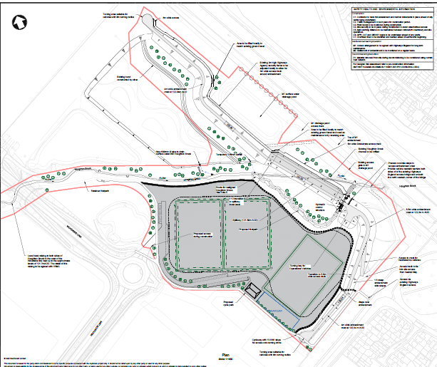



3. The role continued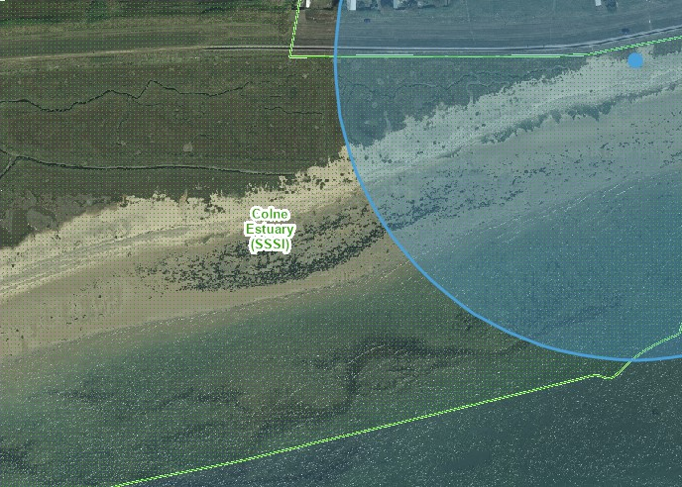

**Seawick Rock Revetment Scheme**

The purpose of this scheme was to improve coastal defences to protect communities on the Essex coast. It consisted of rock placement to protect approx. 400m of sea wall which was at risk from erosion. NEAS played a pivotal role in coordinating environmental assessments and mitigation plans needed to secure planning permission and a marine licence. Of particular note were our coordination of reptile surveys, protection measures for sensitive coastal habitats and monitoring the effects of construction on waders in an adjacent Site of Special Scientific Interest (SSSI).

NEAS has also led the development of a package of environmental enhancements at the works site and surrounding area. This has included creation of intertidal rock features including artificial rock pools and striations to allow marine invertebrates to colonise the rock structures more quickly. Additionally, rocks that were placed above the high tide line have had holes of a range of sizes drilled to encourage solitary bees to nest. We are also still working with internal EA teams to deliver a programme of tree and hedgerow planting on nearby land to provide new habitats for breeding and migrating birds in the area whilst offsetting some of the carbon emissions from the works.

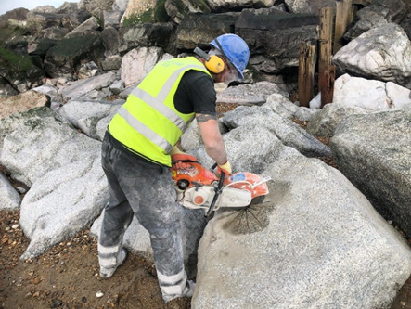 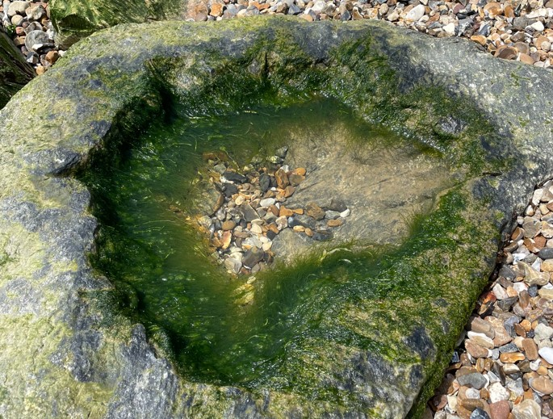

*Fig 1. Creating rock features to encourage marine invertebrates*



3. The role continued

**Great Yarmouth Flood Defence Epoch 2 Tidal Defences Project**

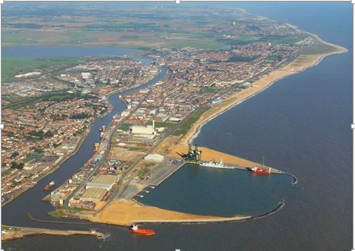

The residential and commercial area of Great Yarmouth, a medium-sized town located on the East coast of Norfolk, is at risk of tidal flooding. The defences generally comprise raised concrete walls forming the top part of mostly steel sheet pile quays. The condition of the quay piling have been regularly assessed over the years and found to be badly corroded in many locations. Although the project is largely concerned with refurbishing the existing sheet piling with some elements of improvement, we had to reach agreement *Fig* *1. Tidal defences at Great Yarmouth*

with the relevant authorities as to whether or not certain permissions, *c*onsents and licenceswould be needed prior to construction.

During preparatory work on the full business case for this extensive project, NEAS engaged with and received agreement from the Local Planning Authority (LPA) and Marine Management Organisation (MMO), following the submission of screening opinions, that environmental impact assessments would not be necessary under the regulations for development falling within the Town and Country Planning rules and/or the Marine Works rules.

This generated a worthwhile saving for the project in financial and time costs. Further financial and time costs were achieved by NEAS (1) successfully gaining agreement from the LPA that the works could be treated as falling under Environment Agency permitted development rights and therefore not require planning permission: (2) also arranging for the MMO to visit a number of the sites, which led to them accepting the majority of the works on the various quays did not need



3. The role continued

marine licences: (3) working with our suppliers on getting clearance from Natural England that detailed Habitats Regulations Assessments would not be required.

**Ouse Washes Section 10 Reservoir Safety Works**

The Ouse Washes Flood Storage Reservoir is a 90,000,000m3 flood storage reservoir located in Cambridgeshire. The Ouse Washes is one of the largest remaining areas of lowland wet grassland in the UK and holds notable environmental value as a Site of Special Scientific Interest (SSSI), Special Area of Conservation (SAC), Special Protection Area (SPA), and a Ramsar site.

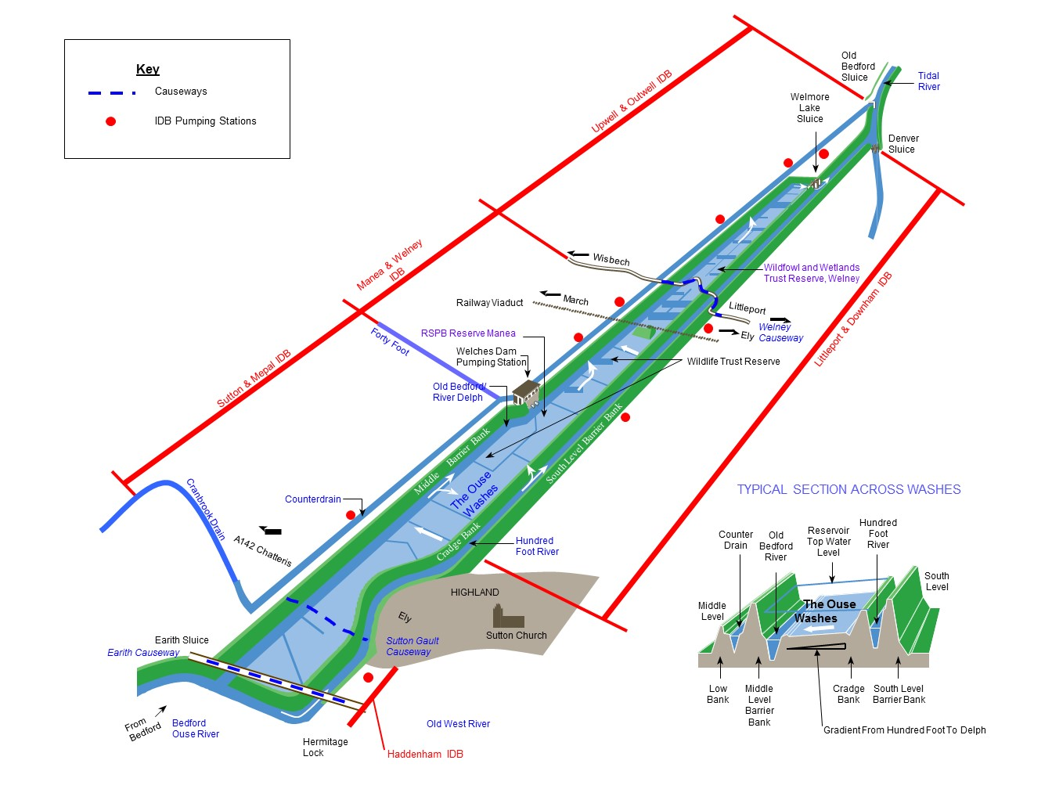NEAS have been integral to the project team from the outset: completing the EIA screening of the scheme, liaising with the relevant LPAs regarding using our permitted development powers, contributing to the contractual scope for the project (including appointing an Environmental Clerk of Works), regularly liaising with Natural England (NE), the RSPB and Wildfowl & Wetland Trust (WWT) regarding their respective sites at the Ouse Washes and Welney, and obtaining NE’s assent for all aspects of the works which could disturb the designated features of the Ouse Washes nature conservation sites (including wetlands, breeding/ overwintering birds, and spined loach).

*Fig 1. Ouse Washes catchment*



4. Further Information

The Environment Agency values a diverse workforce and welcomes applications from all sections of the community who wish to join a workforce which embraces difference and welcomes everyone.

We aim to create and maintain a diverse workforce (including our Board and Executives) that better reflects the UK’s economically active population. Therefore, we particularly welcome applications from Black, Asian and Minority Ethnic (BAME), disabled, female and LGBT+ candidates who are under-represented across our workforce.

We will consider flexible working patterns for all our vacancies, including job share, so please include clearly any information regarding your preferred working arrangements on your application.

Some travel to project sites and Hub offices within East Anglia and/or Herts and North London areas will be expected.

**Eligibility to apply and continuity of employment**

Employment agency workers and contractors are considered to be external candidates and should therefore only apply for positions that are being advertised externally. They are also not eligible to claim continuity of employment should they be successful in securing a position with the Environment Agency.

If you have been a member of a Regional Flood and Coastal Committee in the last 12 months we will not be able to continue with your application based on agreed appointment rules related to employing ex-RFCC members. We would welcome an application from you once the 12 month period have passed.



4. Further Information continued

For applicants who currently work in local government or other bodies listed in the Redundancy Payments (Continuity of Employment in Local Government etc.) (Modification) Order 1999, you may be eligible for continuous service for the purpose of calculating any future redundancy payment. In addition, if you can demonstrate that you have worked at the Environment Agency immediately before joining the Civil Service and are now being re-employed by the Environment Agency within a period of three years of leaving, you may also count your Civil Service employment for the purpose of calculating your service related entitlements as outlined above. If you are unsure of your status then you should contact your own HR Team.

**Pre-employment Checks**

We apply the Baseline Personnel Security Standard (BPSS) check when recruiting staff to our posts. This includes a basic criminal records check.

For the great majority of roles in the Environment Agency this will be sufficient and only certain roles will require a higher level of clearance. Should this be necessary, you will be advised of this during the recruitment process.

Positions based at our London office or roles that require frequent travel to London require CTC level security clearance. This will be confirmed to you during the recruitment process.

**Want to find out more?**

To find out more about what it’s like to work at the Environment Agency, please visit: <https://www.gov.uk/government/organisations/environment-agency/about/recruitment>









5. How to apply

We use an online recruitment system. To make the application process simple and straightforward, and so that you know how it works and what we need from you, we’ve put together a few hints and tips. Make sure you have all the information you need about the vacancy. For some jobs, you’ll be asked to download a candidate pack, like this one, where you’ll find specific application instructions.

The first thing you need to do is sign up to our recruitment system. You will need a valid e-mail address to log in and apply for opportunities, as all communication from us will be via e-mail. You can do this via the vacancy you are interested in by selecting **‘Apply’** at the bottom of the advert.

Once you’ve clicked this link you’ll then be asked:

* Do you have the right to live and work in the UK?
* Do you have the required qualifications or equivalent experience, which were stated in the job advert?
* Are you currently an employee of this organisation?

Simply answer yes or no and you can carry on with your application. You’ll then see the **‘Register’** page. Simply complete the details and select **‘Submit Registration’** and register to the system. You only need to sign up to the system once; you’ll just be able to login next time.

When it comes to the actual application, you need to fill out each section, please be aware that the system will automatically time out if you are inactive for more than 60 minutes. This will result in any unsaved information being lost so make sure you save what you are doing regularly. Once you’ve finished, your details and information will be saved on the system for any future applications – of course, you can edit your details at any point.



5. How to apply continued

When you apply to the Environment Agency for a job we will ask you to provide your personal data on our application form. We need this information so that we can establish your identity and your right to work in the UK.

You can read our Data Protection Statement on the application process page of our recruitment system.  It is also available for reference on each page of the actual application.

**Competence Questions/Statement**

We’re keen to know what makes you right for the job you’re applying for and why we should ask you in for an interview. The competence questions/statements are your chance to convince us!

Please contact the vacancy manager if you would like to discuss the role in more detail. You are also **welcome to meet the team virtually** at **11.00am on Wednesday 29 September** and ask us about what we do and how we do it. Please be assured that this informal session is to answer your queries and will not have any bearing on your application.

Please refer to **Annex I** for further information on the interview process. Below are a few case studies to showcase some of our work.

You should demonstrate how your skills, qualities and experience meet the requirements of the job (as described in the job advert and candidate pack). And instead of simply telling us, show us: use real life examples of where you’ve used a certain skill or how you’ve practically applied your experience.

There’s a 250 word limit per competence including spaces. It’s a really important part of the selection process so make sure you keep your statement relevant and concise. Think about what we need to know about you and what you’d bring to the role and our organisation.



5. How to apply continued

**Application questions**

For some roles, we’ll ask you some specific questions, like if you have a preferred work location. If you’re disabled and you’d like to be part of our Guaranteed Interview Scheme, you can add this information in here.

**Equality and Diversity**

We’re committed to reflecting the communities we serve and we’d like you to tell us about yourself and your background.

**Submitting your application**

Once you’ve filled out and completed everything, you’ll be prompted to submit your application. Simply click the button and you’re done.

Please be aware that once you’ve submitted your application, with the exception of the ‘Personal Details’ section you will not be able to edit your application further. If you decide to withdraw your application, you will not be able to submit another application for the same vacancy.

If, at any stage, you have questions or problems, please contact the recruitment team on 0845 241 5350 or email [ea_recruitment@gov.sscl.com](mailto:ea_recruitment@gov.sscl.com)

**Setting up ‘job alerts’**

If you have been unsuccessful with your application you can set up email alerts for future vacancies. You will automatically receive an email when a job that matches your criteria becomes available. To do this simply click on **‘create a new job alert’**, enter your job criteria and save.

# ENVIRONMENT AGENCY BENEFITS



The Environment Agency offers an attractive and competitive benefits package, including:

|  |  |  |  |  |
| --- | --- | --- | --- | --- |
| **Core Benefits**  **Basic Salary**  Based on skills and experience, in which salary ranges are subject to review each year as part of the pay award.  **Pension Scheme**  A career average revalued earnings (CARE) pension scheme. Contributions are based on your full time equivalent pay, ranging between 5.5% and 12.5%. The EA contribution is currently 19% of your pay.  **Holidays**  Annual holiday entitlement starting at 25 days plus statutory bank holidays (pro-rata for flexible workers). We also offer up to two days paid environmental outcome days each year  **Enhanced statutory policies**  Enhanced maternity, adoption and paternity leave, and sickness absence provisions. | **Training & Development**  **Performance Management**  Individual performance plans, learning and development matched to your agreed career objectives and progression plans.  **Learning & Development**  A range of training courses, leadership development initiatives and access to L&D materials are available, covering technical, managerial and personal skills.  **Examination Leave**  Paid leave for exams and revision for approved studies.  **Professional subscriptions**  We will pay the membership fees for one relevant professional association. | **Work/life Balance**  **Flexible Working**  Flexible working patterns including job share.  **Travel & Transport Benefits**  A range of travel and transport benefits. Discounts on Haven Holidays and HotelStay.  **Shopping & Leisure Benefits**  A variety of discounts at online stores and leisure experiences available via Mylifestyle. | **Health & Wellbeing**  **Occupational Health**  Access to Duradiamond Healthcare advisory service.  **Eye Care**  Free eye tests.  **Employee Assistance Service**  Access to Workplace Wellness available to you and your family  **Sports & Social Club**  Opportunity to benefit from a wide range of subsidised events and discounts.  **Health Discounts**  Optional discounts provided by a number of external providers and health clubs  **Local Benefits**  These vary from region to region. | **Finance**  **Interest Free Loans**  For season tickets, bicycles and safety equipment.  **Special Leave**  Additional paid leave is available for employees taking part in public duties, trade union activities, special/trained forces and for health & safety representatives.  **Financial Education Club**  Providing guidance on how to manage your finances including information on credit scores, pensions, buying your first house and getting debt-free.  **Tenancy deposit loan scheme**  Access to an interest free loan to pay for some, or all of a deposit on a privately rented home.  *The following benefits only apply to eligible roles:*  **Lease Car Scheme**  **Relocation Assistance**  **Free Car Parking** |

# 

**Annex 1 – COMPETENCY INFORMATION**

To be shortlisted for an interview, we will score the answers you provide to the competence questions in the application against the corresponding success indicators below.

During the interview, you will be asked to provide specific examples for each of the competencies. You may elaborate on the examples you already used in the application if you wish to or use different ones. The interview panel will score your answer against the corresponding success indicators.

|  |  |
| --- | --- |
| **Environmental Awareness:**  • Establishes the need, plans and initiates an environmental monitoring programme to meet requirements.  • Assesses the impact of regulated activities on the environment by interpreting trends and relationships in data sets and drawing valid conclusions on the environmental impact.  • Maintains environmental management standards and reports issues of non-compliance.  • Correctly Identifies and disposes of waste materials in an appropriate manner.  **Communicates Effectively:**  • Is an active listener, has time for people; seeks their contribution.  • Uses full range of communication methods to ensure effective understanding.  • Considers needs of and impact on audience, anticipates reactions and uses appropriate communication method and style.  • Prepares written reports and data in clear, readable and accurate manner, using appropriate grammar, syntax and style.  • Ensures communication is two-way; responds and acts on feedback  • When presenting is easily understood and inspires attention from an audience.  • Is clear and to the point when speaking.  • Anticipates the main issues and prepares responses. | **Legislative Knowledge:**  • Maintains up-to-date knowledge of, and complies with, all legislation within own area, enhancing and protecting the interests and integrity of the Environment Agency.  • Applies appropriate legislation in line protocol and maintain accurate records of this.  • Keeps up to date with changes to legislation.  **Focuses on Customers and Partners:**  • Recognises the concept of both internal and external customers and treats both equally well.  • Identifies and addresses the needs of customers, delivering what is promised and ensuring that they are satisfied with the outcomes.  • Takes personal responsibility to meet customer needs; is polite, courteous and professional  • Ensures customers receive consistent and clear messages supported by accurate and timely information.  • Regularly monitors and measures customer satisfaction and looks for ways to improve customer service  • Anticipates and balances the needs of a range of customers with conflicting priorities.  • Keeps customers informed and manages expectations  • Handles complaints effectively, defuses anger and tension and resolves problems |