Intelligence Research Officer

Candidate Information Pack

Job title: Intelligence Research Officer

Job location: Solihull, West Midlands

Date: March 2018

Reference: Vacancy number 7817



Contents

1. Our organisation

2. The role

3. Training and development

4. Salary and benefits

5. Further information

6. How to apply













# EA header coastOur organisation

**Our organisation**

We are the Environment Agency. We work to protect and improve the environment and create better, safer places for people and wildlife. We:

* protect and improve the quality of water, making sure there is enough for people, businesses, agriculture and the environment
* fight environmental crime
* work closely with businesses (such as those in the waste industry) to help them comply with environmental regulations
* reduce the risks to people, properties and businesses from flooding and coastal erosion

Our work helps to ensure people can enjoy the water environment through angling and navigation and we also look after land quality, promote sustainable land management and help protect and enhance wildlife habitats.

Of course, none of this will be possible without the professionalism and dedication of our staff.

We work with government, local councils, businesses, civil society groups and communities to make our environment a better place for people and wildlife. As a public body we are committed to promoting equality and diversity in all we do and valuing the diversity of our workforce, customers and communities.

We’re committed to helping our people find new ways of working to maintain our focus on creating a better place for people and wildlife. For more information on the Environment Agency and what we do, please visit: [www.environment-agency.gov.uk/aboutus](http://www.environment-agency.gov.uk/aboutus)

[](http://www.linkedin.com/company/environment-agency/careers?trk=top_nav_careers)[](http://www.youtube.com/user/EnvironmentAgencyTV)[](https://www.facebook.com/environmentagency?ref=hl)[](https://twitter.com/EnvAgencyJobs)

# The role

The Intelligence Research Officer performs a crucial role within the Environment Agency’s growing intelligence department. You will be working alongside a team of analysts, intelligence officers and other researchers who work centrally to provide a proactive and timely intelligence service to teams both within the agency and to our partner agencies.

In this role you will become an expert on our systems whilst using your research abilities to build the intelligence picture on criminals committing environmental crime. Often assisting investigations you will be conducting research into people and companies, making sense of large datasets and evaluating information for its usefulness all in order to help prevent, reduce and detect environmental crime on a local, regional, national and sometimes international scale.

There are many different aspects to the Intelligence Research Officer role. You may be trying to dig out that ‘golden nugget’ of information to deny a waste criminal from operating or you may be pulling together a detailed profile on a company’s past criminality. You may find yourself running checks on multiple vehicles to prove who owns them, or advising someone outside of the team on how to capture good intelligence. Regardless, the questions that you are asked to answer will change from day to day. Typically you will:

* Research and evaluate information and intelligence on key investigations and projects
* Shape an intelligence picture that helps influence management decision making
* Liaise with external partner agencies such as the Police, DVLA and HMRC
* Develop and maintain strong relationships with customers including other Environment Agency teams
* Ensure team data, systems and records are accurate, up to date and handled correctly

**What skills do you need?**

Relevant experience working with sensitive information would be useful, but we are primarily looking for your research skills and resourcefulness to uncover what needs to be uncovered. You will need plenty of drive and curiosity in this role to give us the best support to tackle environmental crime. Ideally you will have:

* Exceptional research and problem-solving skills
* An inquisitive, ‘no stone left unturned’ mentality
* Excellent written and verbal communication skills
* Excellent attention to detail
* Great IT skills and confidence with Microsoft Office
* Self-motivated with the ability to work with minimum supervision
* Good organisational skills
* Be able to work under pressure and manage and prioritise a varied workload

**Top capabilities**

As part of the application and interview processes, we’ll be looking at you to tell us how you:

* communicate effectively
* achieve results
* manage data and information
* engage others
* build and sustain relationships
* focus on customers and partners
* focus on efficiency, innovation and quality
* take decisions and solve problems
* use your initiative

Please refer to the **Top Capabilities** document (attached to the vacancy) that describes our capability framework in further detail. The **How to Apply** section (section 6 below) provides advice on how to complete your application.

**What experience do you need?**

You do not need previous experience working within law enforcement, or within intelligence. If you do have experience of research in any setting (perhaps work or educational), please tell us about it in the evidence you provide in the application form.

**What qualifications and knowledge do you need?**

We are not seeking any specific qualifications for this role. As mentioned in the skills section above, you will ideally have great written and verbal skills with a good grasp of IT.

Some knowledge of the legislation surrounding law enforcement, intelligence and handling sensitive data would be of real benefit but is not essential. Training will be received in these areas both formally and on the job.

**What else do you need to know?**

* The role is centrally based (in Solihull, West Midlands) but working amongst a dispersed team so there may be occasions where you will need to travel
* Many people within the Environment Agency have a dual role in Incident Management (such as flooding). Full training is provided for these roles and you will be invited to find a role that suits if you wish to do so.

**To help bring the role to life, here are some views from current Intelligence Research Officers:**

The best part of the role as an Intelligence Research Officer (IRO) is the wide range of requests we get given, therefore the work cannot be seen as repetitive, as one day I am completing an internal intelligence package, and the next day I am assisting in operational work contacting external agencies for information. Working in intelligence often relates to handling a lot of data, some of which needs to be manually collated and organised by an IRO. Sometimes this can be a little monotonous, but it is an essential part of ensuring we have valuable and credible intelligence to ensure we are an ‘intelligence led’ team.

There are a number of benefits to working for the Environment Agency, one of which is their flexible working policy. This is handy for individuals like myself who travel a fair distance to get to the office, this allows me to adjust my working times to suit my needs and ensure I am able to get to and from work easily.

This job is ideal for anyone who is looking for a career in intelligence, as the IRO role allows for learning of the essential legislation and systems used within the team it is a great stepping stone to other opportunities which often arise in the intelligence team.

Chloe – Intelligence Research Officer, Solihull

As an Intelligence Research Officer (IRO) I have been able to develop in many areas through either working independently or as part of the wider team. Being part of a team lead by supportive and approachable managers has allowed me to be involved in the decision making and shaping of day-to-day processes. Working independently, I interrogate a range of systems in order to gather intelligence and data which I then report accordingly.

Over time I have had the opportunity to develop and broaden my knowledge of different intelligence systems. I am also encouraged on a regular basis to use my initiative to drive my own personal development. In the eight months I have been at the Environment Agency I have become a representative for the People’s Group which focuses on staff wellbeing as well as a member of the Aspiring Team Leaders Group.

There are many benefits of this role at the Environment Agency including the salary, annual leave and flexible working. I have personally found my work-life balance to have significantly improved from my previous career and I believe this is because staff welfare is highly valued within the Environment Agency.

Katharine – Intelligence Research Officer, Solihull

I joined the Environment Agency in July 2017, as a researcher in the Intelligence Team having previously worked in legal and analyst professions. My role has largely been working on a specific intelligence project which was being tested to see whether it was effective in reducing environmental crime.

The role of a researcher involves a lot of data analysis, from different sources from within the agency with the primary focus of determining whether the data subject poses a specific risk. The majority of the data is sensitive and has to be handled accordingly. The work itself can seem mundane at times, however, this is outweighed by the main benefit which is that you will see the results of your work which in turn make a real impact in creating a healthier, cleaner environment.

There is a lot of training at the start and this continues with the differing requirements of the role and as EA objectives / risk assessments change.

Pete – Intelligence Research Officer, Solihull

# 

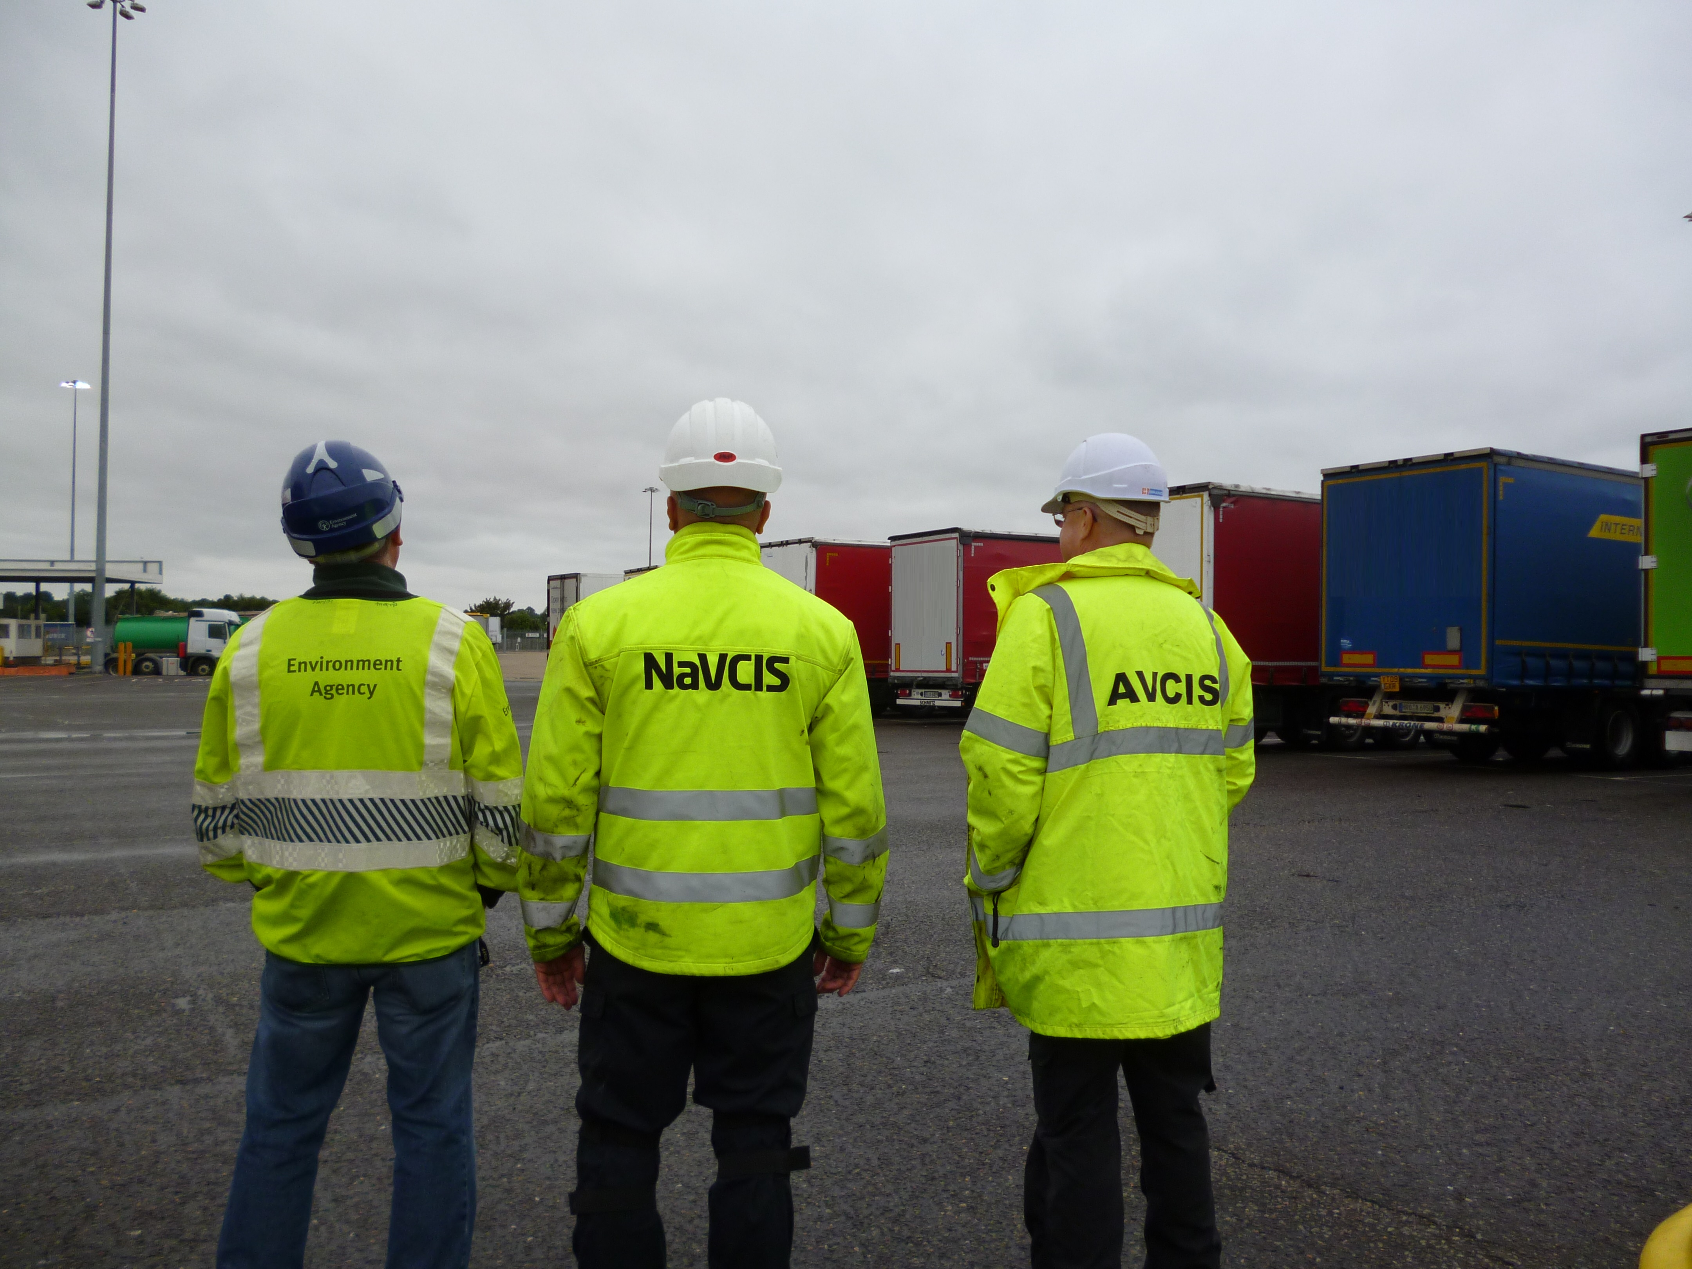

# Training and development

You will receive the necessary training and development to ensure that you have the skills needed to perform the role of an Intelligence Research Officer to a high standard. This will include a mixture of on the job training, mentoring, e-learning and some structured classroom based learning sessions. You will undertake much of this training and development during your first six month probationary period.

You will be assigned a mentor on your very first day, someone already in the department that will help you get started and answer any questions that you have (and you will have many).

Your learning and development doesn’t stop once you have completed your probation; we continue to invest in ensuring you have the rights skills to do your job by offering modular based development programmes linked to your role. With a strong focus on Continued Professional Development, you will be encouraged to take up to ten days every year to work on your own development. This could range from formal training to a shadowing opportunity in another department to attendance at a conference or mentoring someone new to your team.

We all learn at different rates and you will be given time to put what you’ve learnt into practice. There is flexibility to extend the time spent in each training stage according to individual needs – you will learn at your own pace and progress only when you and your Team Leader feel you’re absolutely ready to.

**What will the initial training cover?**

Typically the first six months will cover;

* intelligence and research systems
* data sources
* health, safety and wellbeing
* legislation and regulation
* enforcement
* waste issues

**What will I achieve?**

The training is all geared towards developing the ability to do something, rather than simply knowing about it. Therefore the training process provides you with the opportunity to apply your acquired knowledge and demonstrate competence. The aim is to get you up and running in the role as soon as possible, exposing you to as many aspects of the Intelligence Research Officer.

We are currently exploring the possibility of working to an accreditation scheme (such as the Intelligence Professionalisation Programme through the College of Policing) for all intelligence staff. This would mean that you would be required to evidence your competency in the role over time and ultimately become an accredited intelligence professional.

# Salary and benefits

**Starting salary:** £22,433 per annum. We also offer a pay award scheme that is linked to your performance throughout the year.

**Hours of work:**  37 hours (pro rata if part time)

**Leave entitlement:** Your annual leave allowance will be 25 days (pro rata if part time) plus bank holidays. This increases to 30 days with length of service. We also offer up to two days paid environmental outcome days each year. These give you the opportunity to take part in community activities with a clear environmental outcome for people and wildlife.

**Pension:** We will enrol you into the [Environment Agency Pension Fund](https://www.eapf.org.uk/) (EAPF) on commencing employment. The EAPF is part of the [Local Government Pension Scheme](https://www.lgpsmember.org/) (LGPS). It is a career average defined benefits scheme, which means you will build up benefits based on your pay each year. We will base your pension contributions on your pensionable pay and you will receive tax and national insurance relief on your contributions. You will begin by contributing 6.5% of your pensionable pay. Whilst you are in the scheme we will also pay an employer contribution into your pension pot. We currently pay 18.5%, so this is a very generous scheme.

**Work/life balance:** We support flexible working hours and practices to help you strike a good balance between your work life and your personal life. We will also encourage you to keep developing your skills and professional knowledge throughout your career.

**Diversity:** We are committed to diversity and inclusion. We want all our staff to feel valued and respected and to see this as a great place to work.

Diversity: it’s in our nature.

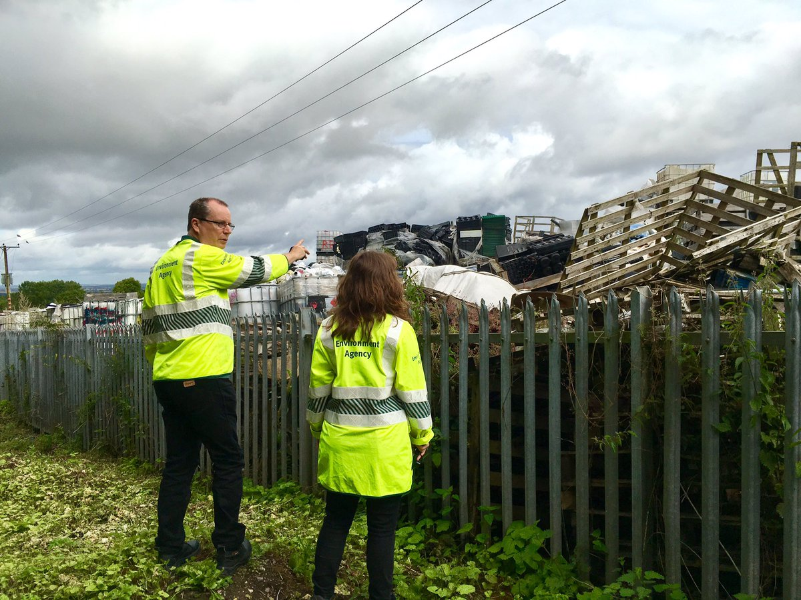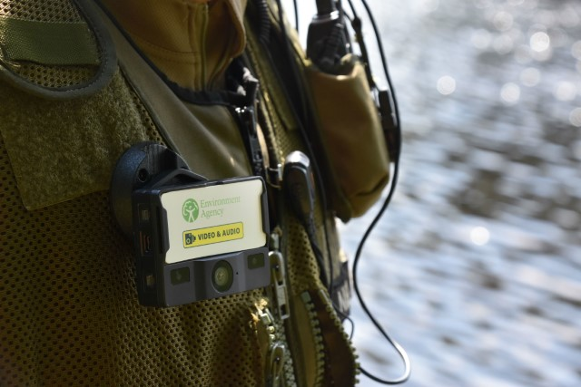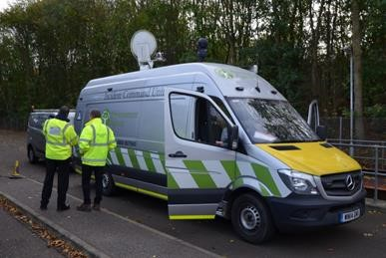

# EA header country 2Further information

We are fully committed to having an inclusive workforce to reflect the communities we serve.   
We welcome applications from candidates seeking flexible working patterns, including part time and job share.

Please note that Environment Agency employees are not civil servants, so you may wish to check your eligibility for continuity of employment by contacting your HR department. All eligible bodies are listed in the Redundancy Payments (Continuity of Employment in Local Government etc.) (Modification) Order 1999.

Employment agency workers and contractors are considered to be external candidates and should therefore only apply for positions that are being advertised externally. They are also not eligible to claim continuity of employment should they be successful in securing a position with the Environment Agency.

Please note all successful applicants must undergo Baseline Personnel Security Standard (BPSS) checks prior to commencement of employment. This includes a basic criminal records check.

Once employed, we will require you to successfully undertake vetting to SC (Security Check) level to work within an Intelligence environment.

# How to apply

We use an online recruitment system. To make the application process simple and straightforward, and so that you know how it works and what we need from you, we’ve put together a few hints and tips.

The first thing you need to do is sign up to our online recruitment system. You’ll need a valid e-mail address to log in and apply for jobs, as all communication from us will be via e-mail. You can do this via the vacancy you are interested in by selecting **‘Apply’** at the bottom of the advert. Once you’ve clicked this link you’ll then be asked:

1. Do you have the right to live and work in the UK? – please answer ‘yes’ or ‘no’
2. Do you have the required qualifications or equivalent experience, which were stated in the job advert? – we are not seeking any specific qualifications or experience for this role, so please answer ‘yes’ to this question
3. Are you currently an employee of this organisation? – please answer ‘yes’ or ‘no’

You’ll then see the **‘Register’** page. Simply complete the details and select **‘Submit Registration’** and register to the system. You only need to sign up to the system once; you’ll just be able to login next time. You can then carry on with your application.

When it comes to the actual application, you need to fill out each section. Please be aware that the system will **automatically time out** if you are inactive for more than 60 minutes. This will result in any unsaved information being lost, so please make sure you save what you are doing regularly. Once you’ve finished, your details and information will be saved on the system for any future applications – of course, you can edit your details at any point.

When you apply to the Environment Agency for a job we will ask you to provide your personal data on our application form. We need this information so that we can establish your identity and your right to work in the UK. You can read our Data Protection Statement on the application process page of our recruitment system.  It is also available for reference on each page of the actual application.

**Capability questions**

We’re keen to know what makes you right for the job you’re applying for and why we should invite you for an interview. The capability questions are your chance to convince us! You should demonstrate how your skills, qualities and experience meet the requirements of the job (as described in the job advert and this candidate pack). Instead of simply telling us, show us: use real life examples of where you’ve used a certain skill or how you’ve practically applied your experience.

There’s a 250 word limit per question. It’s a **crucial** part of the selection process so make sure you dedicate plenty of time to completing this part of the application form. Think about what we need to know about you and what you’d bring to the role and our organisation.

**How to prepare your answers for a capability based application**

Capabilities are high level descriptions of key behaviours, skills and knowledge that underpin effective performance. They are the behaviours, skills and knowledge employees must have, or must acquire, to achieve high levels of performance. Please refer to the **Top Capabilities** document (attached to the vacancy) that describes our capability framework in further detail.

Capability questions target a specific skill, so we will be looking for some key components in your answer:

* + an indication that **you** understand the importance of that capability to the role for which you have applied
  + evidence that **you** understand the fundamental skills associated with that capability
  + an **example** that highlights your possession of that capability
  + an awareness from **you** of how the critical skills will be used to good effect in the new role

**The STAR approach**

STARstands for:

* **S**ituation
* **T**ask
* **A**ction
* **R**esult

The STAR approach is a universally-recognised communication technique designed to enable you to provide a meaningful and complete answer to questions asking for examples and it has the advantage of being simple.  
  
**Step 1 – Situation or Task**

Describe the situation that you were confronted with or the task that needed to be accomplished. With the STAR approach you need to set the context. Make it concise and informative, concentrating solely on what is useful to the story. For example, if the question is asking you to describe a situation where you had to deal with a difficult person, explain how you came to meet that person and why they were being difficult. If the question is asking for an example of teamwork, explain the task that you had to undertake as a team.

**Step 2 – Action**

This is the most important section of the STAR approach as it is where you will need to demonstrate and highlight the skills and personal attributes that the question is testing. Now that you have set the context of your story, you need to explain what **you** did. In doing so, you will need to remember the following:

1. Talk about yourself, not the rest of the team
2. Go into detail
3. Steer clear of technical information, unless it is crucial to your story
4. Explain **what** you did, **how** you did it, and **why** you did it

**What, how and why**

When we shortlist your application, we would like to know how you reacted to the situation. This is where you can start selling your skills. For example, you may want to describe how you used the team to achieve what you wanted and how you used your communication skills to keep everyone updated on progress, etc.

This is probably the most crucial part of your answer. We want to know that you are using a variety of transferrable skills in order to achieve your objectives. You must be able to demonstrate in your answer that you took specific actions because you were trying to achieve what you wanted, and that things didn’t happen simply by chance.

When discussing a situation where you had to deal with conflict, a good answer might provide an example of how you intervened to diffuse the situation, how you approached it with consideration for both yourself and others. For example:

“I could sense that my colleague was irritated and I asked him gently to tell me what he felt the problem was. By allowing him to vent his feelings and his anger, I gave him the opportunity to calm down. I then explained to him my own point of view on the matter, emphasising how important it was that we found a solution that suited us both.”

This answer helps us understand what drove your actions and reinforces the feeling that you are considering the needs of others before acting. It provides much more information about you as an individual and is another reason why the STAR approach is so useful.

**Step 3 – Result**

Explain the positive outcome of your action(s) – how it all ended. Use the opportunity to describe what you **accomplished** and what you **learnt** in that situation. This helps you make the answer personal and enables you to highlight further skills.

**An example**

For example, a strong answer to this capability question might be constructed in the following way:

“Can you tell us of an occasion when you demonstrated strong leadership in order to produce a positive outcome?”

1. Consider an introductory sentence or two about the importance of strong leadership in general terms.
2. Explain what strong leadership looks like to you. Make this personal to you; express an opinion on leadership rather than regurgitate leadership theory.
3. Talk about how you exhibited strong leadership. Draw upon a couple of real life examples which shows good evidence that you have the skills that you say you do.
4. Don’t dwell too much on the details of the situation – word count (and time in interviews) is limited; we want to hear about what you did and how you contributed, added value, and drew on your skills, and how your leadership intervention was critical.
5. Discuss how these skills would transfer to the new position you are applying for.

The key in answering all capability questions is that you are required to **demonstrate** that you have the right skills by using an example (or examples) based on your work or life experience, and not just talk about the topic in a theoretical, general or impersonal manner.

**How are capability answers scored?**

Answers are scored on a scale of one to seven, with seven being the highest score:

|  |  |  |
| --- | --- | --- |
| **Score** | **Category** | **Comment** |
| 1 | Not demonstrated | No positive evidence |
| 2 | Minimal demonstration | Limited positive evidence |
| 3 | Moderate demonstration | Moderate positive evidence |
| 4 | Acceptable demonstration | Adequate positive evidence |
| 5 | Good demonstration | Substantial positive evidence |
| 6 | Strong demonstration | Substantial, positive evidence of the capability and includes some evidence of exceeding expectations |
| 7 | Outstanding demonstration | Evidence provided wholly exceeds expectation at this level |

The minimum benchmark score for each answer is four, but to stand out from the crowd you should be aiming for a score of five or above.

It should be noted that the score is cumulative. This means that if an application is scored over three capability questions, the minimum score needed to be considered for interview will be 12 (three times four). If you score highly on two of the capabilities but poorly on the third, you may still pass the minimum benchmark score of 12.

**How we shortlist**

We will shortlist your application based on the information you’ve provided in your application form. If you choose to attach your CV (this is not necessary), please note that your **CV is not visible to us** **at the shortlisting stage.**

**Application questions**

For some roles, we’ll ask you some specific questions, like if you have a preferred work location. If you’re disabled and you’d like to be part of our Guaranteed Interview Scheme, you can add this information in here.

**Equality and diversity**

We’re committed to reflecting the communities we serve and we’d like you to tell us about yourself and your background.

**Submitting your application**

Once you’ve filled out and completed everything, you’ll be prompted to submit your application. Simply click the button and you’re done. If, at any stage, you have questions or problems with our online application system, please contact SSCL on 0345 300 1861.

Don’t leave your application until the last minute – technical support is provided Monday to Friday only; and most vacancies close at 23:55 in the evening. If you are unable to submit your application at 23:54 on the day applications close, we will be **unable to accept late submissions**.

**Sign up for job alerts**

You can set up email alerts for future vacancies and will automatically receive an email when a job that matches your criteria becomes available. To do this simply login then click on **‘create a new job alert’**, enter your job criteria and save.

