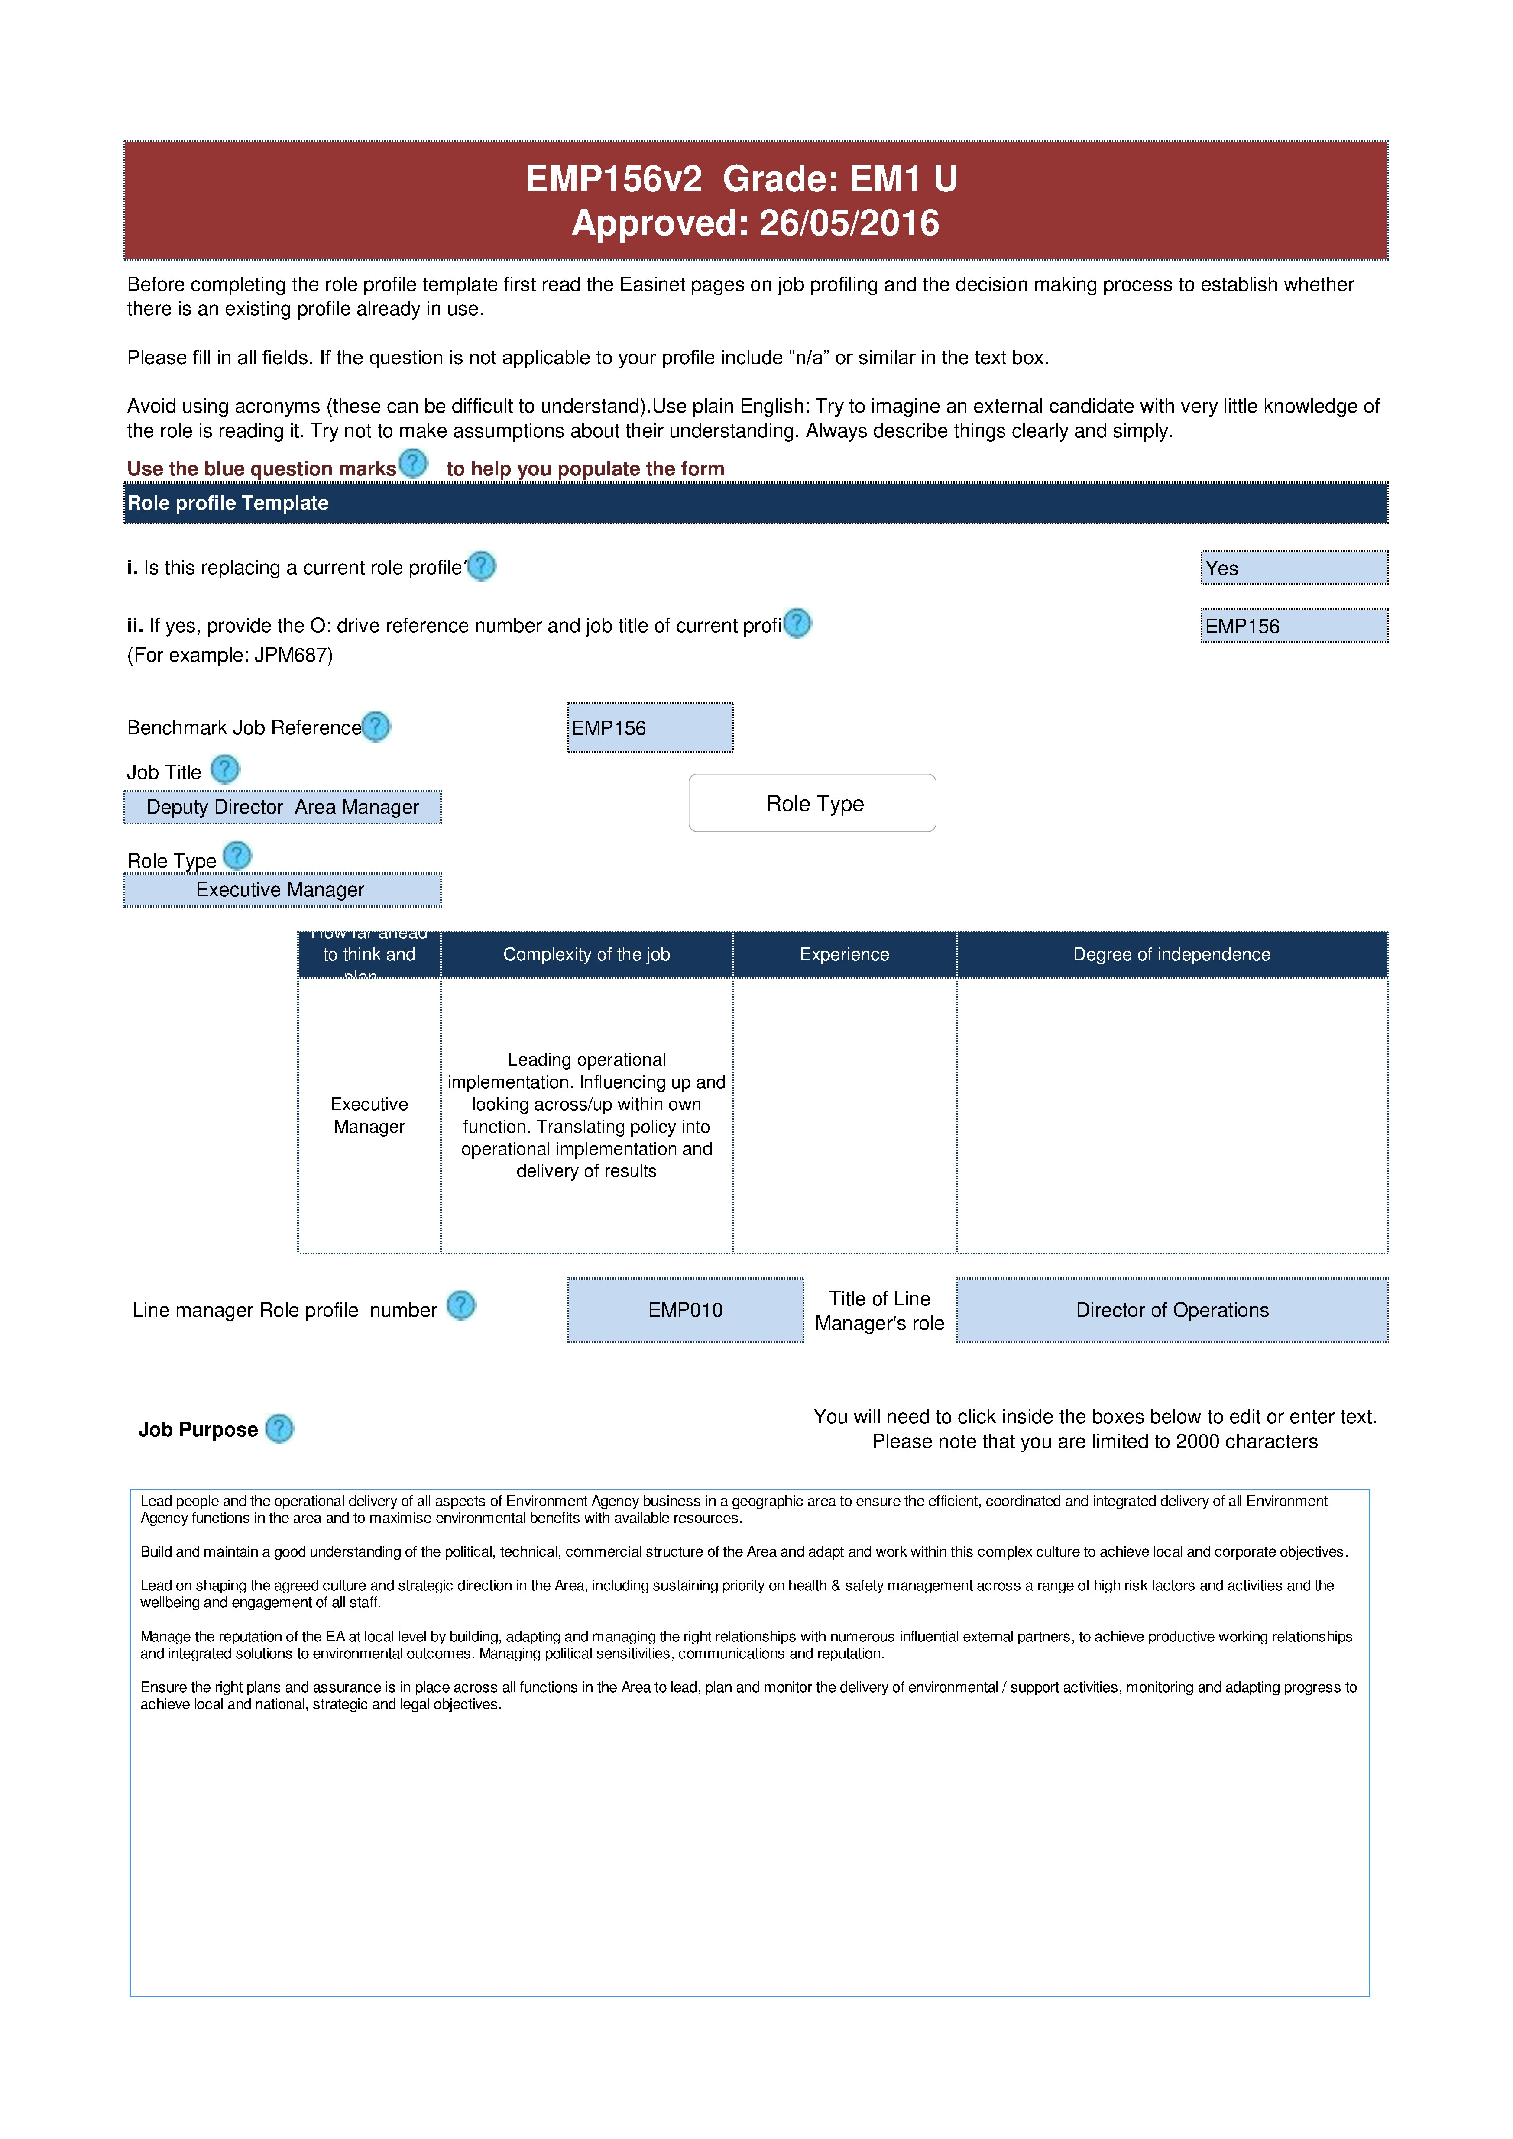

Describe any job specifics within this area (Please input below, text limit 2000 characters):
Ensure you cover the challenges for this role, and what sort of interaction this role has with others?
Develop the capability and confidence of Area team/s to ensure appropriate technical / leadership and behavioural skills and competence, good performance and succession and resilience for the longer term delivery and agility.
Maintain financial accountability for large budgets, ensuring delivery is in within resources or bids for more made effectively, including sourcing and securing external funding to progress projects.
Lead on risk management of the Area including Identifying and managing risks to the delivery of area objectives / people, including the development of a strong/positive health and safety and environmental performance.
Lead on significant change management and continuous improvement and innovation to ensure the business is continually realigned with changes to customer and stakeholder needs and people are involved and engaged.
Lead major incident management and resolution in the Area by directing and coordinating plans, integrating with external partners and the public to take appropriate, coordinated and safe emergency action, to ensure a planned and efficient response which minimises negative impact on people, property and the environment.
Contribute to driving forward and shaping the wider strategic business of the organisation so that corporate policies, plans, targets and ways of working nationally are achieved once and aligned to front line/ strategic Area needs.
Lead on the delivery of large programmes of work and large projects and portfolios on behalf of the EA.
Develop the business through sharing and learning as a team of Area Managers to act as one force team to inform and influence national policy and ways of working.
Does this role have any internal/external stakeholders or customers? If so then please give details below:
Who are the Frequency of contact? e.g. Stakeholder type? stakeholders/customers? daily/monthly/annually e.g. internal/external
MPs, local authorities, flood committees,  Natural England, Chief Executive and Directors, water companies, local industry, other Executive Managers |  | Weekly |  | External and internal
Accountabilities
1. Lead, plan and monitor the strategic direction of the function in order to support the delivery of business plans.
2. Lead, develop and embed a culture of effective change management, to adapt to, optimise and support the changing needs of customers.
3. Originate, champion and lead on initiatives for change to deliver efficient systems and support & improve business delivery.
4. Identify and manage operational risk to the delivery of the business plan to enable the Environment Agency to operate in a safe, innovative and efficient manner.
5. Lead, develop and motivate operational teams to deliver results on time, to required quality standards and cost, to fulfil the business plan and achieve environmental outcomes.
6. Plan, monitor, control and realign resources to maximise their efficient and effective use and ensure objectives are completed to required standards.
Top 3 Capabilities (Use drop downs to list the top 3)
Leads People
Delivers results through others
1
2
3
Influences & persuades others
Additional Recruitment Information
Educational Requirements IMPORTANT INFO
Educated to degree level or equivalent
Professional Qualifications Requirements IMPORTANT INFO
Fully qualified/membership of a relevant professional body

Direct Budget Responsibility
The amount of budget directly controlled by the job holder. Up to £45 million The position is fully accountable for the end results associated with this budget.

Indirect Budget Responsibility

Up to £21 million
Enter the amount of budget (not direct) that the job holder contributes towards or shares with someone else.

n/a
If this role does share budget responsibilities with another role what is the post title of this role?

Control of Budgets
The nature of responsibility for the budget for example do None you monitor for somebody else or yourself, spend or raise revenue?
Experience Requirements IMPORTANT INFO
Proven experience of operational leadership across a diverse range of teams, delegating management through senior direct reports and managing large budgets. The ability to understand a range of information to enable decision making. The ability to understand, develop and influence high level complex relationships with external partners and to translate strategy in action within own areas as part of an Operations leadership team. Experience of managing a team across a complex organisation and matrix management to deliver a technical and professional service. Ability to influence senior internal and external customers plus sound political acumen. Excellent communications skills and being confident to articulate environmental issues to political and technical groups and individuals. Ability to make decisions that can

appear unpopular.
How many staff does this role directly supervise?
How many staff overall does this role have responsibility for?
Delete where applicable:
The job will be based in XXXXX
Some national travel is required
A driving licence is essential
Essential Additional Information
Directly supervise an average of 7-14 Grade 7 posts and a PA; overall have responsibility for between 250-700 staff
500

