NEAS Environmental Project Managers

Candidate Information Pack







**Job title: NEAS (Senior) Environmental Project Manager**

**Job location:** Worthing, Solihull*, Exeter, Leeds, Peterborough **or** Welwyn Garden City (*please note that the Solihull office will soon relocate to Birmingham)

**Date: July 2020**

**Reference: 15027**

Contents

1. **Our organisation**
2. **Salary and benefits**
3. **The role**
4. **Further information**
5. **How to apply**





1. Our organisation

**Our organisation**

We are the Environment Agency. We protect and improve the environment. Acting to reduce the impacts of a changing climate on people and wildlife is at the heart of everything we do. We reduce the risks to people, properties and businesses from flooding and coastal erosion. We protect and improve the quality of water, making sure there is enough for people, businesses, agriculture and the environment. Our work helps to ensure people can enjoy the water environment through angling and navigation. We look after land quality, promote sustainable land management and help protect and enhance wildlife habitats. And we work closely with businesses to help them comply with environmental regulations. We can’t do this alone. We work with government, local councils, businesses, civil society groups and communities to make our environment a better place for people and wildlife.

Of course, none of this will be possible without the professionalism and dedication of our staff. We are committed to promoting equality and diversity in all we do, and to valuing the diversity of our workforce, customers and communities.

We’re committed to helping our people to find new ways of working and to maintain our focus on creating a better place for people and wildlife. For more information on the Environment Agency and what we do, please visit:

[**www.environment-agency.gov.uk/aboutus**](http://www.environment-agency.gov.uk/aboutus)

[Website](http://www.gov.uk/environment-agency) | [Twitter](https://twitter.com/envagency) | [Facebook](https://www.facebook.com/environmentagency) | [LinkedIn](https://www.linkedin.com/company/environment-agency) | [Instagram](https://www.instagram.com/envagency) | [Flickr](https://www.flickr.com/photos/environment-agency) | [YouTube](http://www.youtube.co.uk/user/EnvironmentAgencyTV)



2. Salary and benefits

Join us in this role and you will enjoy the following benefits:

**Grade Rate:**  EPM - Grade 4 £28,123 (pro-rata - if part time)

**Location:** EPM roles available in Worthing, Solihull*, Exeter, Peterborough **or** Welwyn Garden City, Leeds and Warrington

(*please note that the Solihull office will soon relocate to Birmingham)

**Hours of work:** 37 hours FTE, permanent contract

**Leave entitlement:** Your leave allowance will be 25 days. Your allowance will be pro-rata if you work part time to a role at a higher grade that attracts an increased entitlement. Your entitlement depends on your grade, your contracted hours, and your length of continuous service.

We also offer up to two days paid environmental outcome days each year. These give you the opportunity to take part in community activities with a clear environmental outcome for people and wildlife.

**Pension:** We will enrol you into the Environment Agency Pension Fund (EAPF) on commencing employment, if your employment contract is for 3 months or more. The EAPF is part of the Local Government Pension Scheme (LGPS). It is a career average scheme, which means you will build up benefits based on your pay each scheme year rather than your final salary.

We will base your pension contributions on your actual pay and you will receive tax and national insurance relief on your contributions.  The pension contribution rates currently range between 5.5% and 12.5%.  Whilst you are in the scheme we will also pay an employer contribution into your pension pot. We currently pay 19%, so this is a very generous scheme.

**Work/life balance:** We support flexible working hours and practices to help you strike a good balance between your work life and your personal life. We will also encourage you to keep developing your skills and professional knowledge throughout your career.

**Diversity:** We are committed to diversity and inclusion. We aspire to be the best employer in the country for equality, diversity and inclusion (EDI) and want all our staff to feel valued and respected and to see this as a great place to work. From our EDI executive champions to our EDI employee networks, everyone has a part to play to embed equality, diversity and inclusion in our organisation. Diversity: it’s in our nature.

**Relocation:** If you need to relocate to take up this role, we might be able to offer financial help with this. This will depend on your circumstances, so if it’s something you are interested in, please discuss it with us to find out what the options are.

3. National Environmental Assessment & Sustainability (NEAS)

The advertised roles sit at the heart of our National Environmental Assessment and Sustainability team. NEAS drives the Environment Agency’s aspirations as an effective asset and programme management organisation.

NEAS oversee the effective management of environmental risk on our Flood and Coastal Risk Management (FCRM) projects and help identify and deliver environmental enhancements that leave a better place. We work to ensure that sustainability is central to decision-making across our FCRM programme.

As part of a high performing, collaborative team, you’ll be involved in ground-breaking and award-winning work, leaving a lasting legacy for the future. You will work closely across internal departments, the wider Defra group, statutory bodies, our framework delivery partners, businesses and communities. This opportunity to be a part of an inclusive and creative organisation, putting people and wildlife at the heart of what we do will be a life enhancing experience.

**Our teams**

**NEAS Hub Teams**

NEAS have 7 Hub Teams based across England. Our Hub Teams are responsible for the input of high quality environmental and sustainability advice to the Integrated Delivery Teams for each Delivery Hub. Our input is principally at the project development stages to ensure that all environmental risks are identified and appropriate measures are put in place to mitigate and reduce risk to acceptable levels. We are responsible for ensuring that the need for environmental consents and approvals is identified. A critical role of our Hub Teams is to identify opportunities to enhance the environment for people and wildlife and liaise with environmental stakeholders to get their buy-in.

**Flood risk management schemes that NEAS have influenced**

**Upton-upon-Severn**

The area of Upton-Upon-Severn has a close relationship with its river. Pubs, bars and restaurants all line the river front, attracting locals and tourists. But in 2007 after heavy rainfall, the river burst its banks and flooded large swathes of land around it. In response, we completed a £4.6M scheme which, among other things, included a 300m long flood wall topped with a glass wall along the river bank to keep flood waters contained.

We were conscious as a result of our visual assessment and other studies that we did not want to create a high and imposing wall that would close people off from the river and destroy their relationship with it, so we came up with something else which would also be acceptable to the Town Council and Local Planning Authority. Using innovative approaches, we installed a permanent brick clad defence with glass panels along the top. It’s just as stable and resilient as a wall but it retains the important views and interaction with the river.

The wall has been hailed as a huge success allowing people to still see the river while remaining protected. The wall also incorporates floodgates, giving riparian access to beer gardens and other landowners on the banks when the river is low.

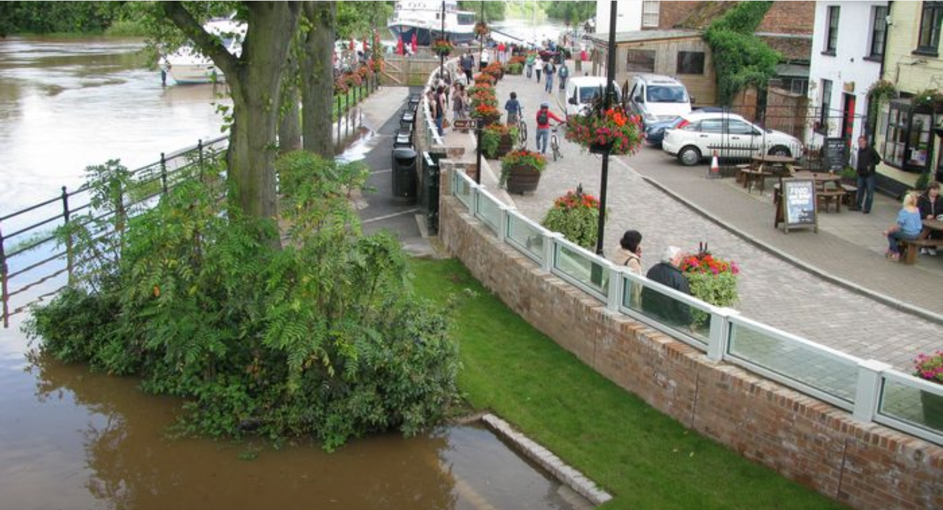

**Medmerry coastal realignment**

The area of Medmerry on the coast of Sussex was prone to flooding. In 2008, the sea breached the shingle sea defence causing around £5M of damage to the nearby towns of Pagham and Selsey. The increasingly ineffective barrier was becoming gradually more expensive to maintain, so we decided to take a new approach.

After negotiating with local landowners, we decided to carry out our largest managed realignment scheme ever….over 180 Hectares. The scheme allowed the sea to breach the shingle defence, flooding an area of low grade farmland along the coast. By doing this, it created a saltmarsh buffer between the sea and the nearby towns, allowing a smaller, more maintainable defence to be built inland. In total, around 300 homes have been protected by the new measure. NEAS played a critical role in this large and complex project.

The area is a great example of sustainable flood risk management and working with natural processes. Medmerry serves as compensatory habitat for projects around the Solent.

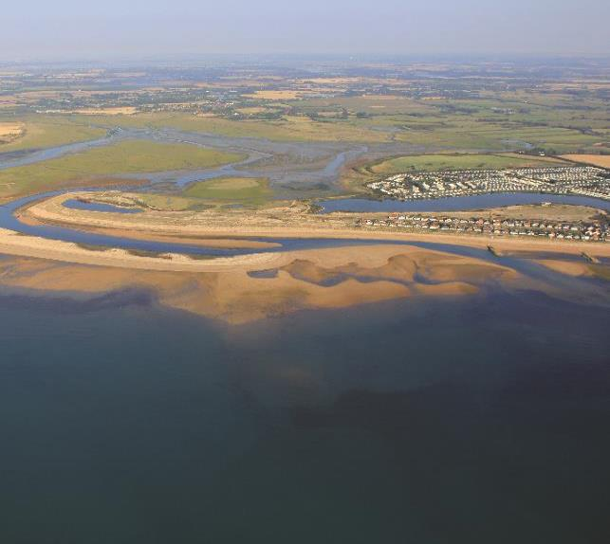

**‘Saltern Wetlands’ Managed Realignment Site, Greatham Creek, Tees Estuary**

NEAS faced and overcame numerous challenges, working as part of a multi-disciplinary team, in recreating intertidal habitats in a heavily industrialised environment at Greatham Creek on the Tees Estuary, Hartlepool. The ‘Saltern Wetlands’ managed realignment scheme is a critical project identified in the Environment Agency’s Tees Flood Risk Management Strategy.  It provides the compensatory habitat that is required as a consequence of proposed flood defence improvements within the Tees Estuary, and predicted habitat losses arising from the of the coastal Redcar Flood Alleviation Scheme. The site delivers 22ha of intertidal habitat (mudflat and saltmarsh) plus 18 ha of freshwater and wet grassland habitat.

NEAS was critical in overseeing the environmental impact assessment and habitats regulations assessment of the scheme, securing all necessary consents, and working with key partners as part of an environmental steering group, to inform the design of the scheme, develop a management and monitoring plan for the site, and ultimately gain widespread stakeholder support for the scheme.

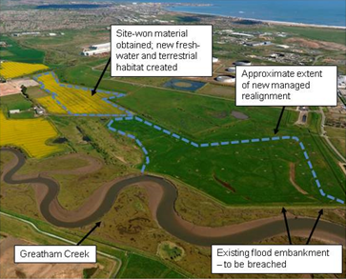



4. The role

We are looking to recruit 6x Environmental Project Managers (EPMs) to join our National Environmental Assessment & Sustainability (NEAS) team.

We are seeking talented, enthusiastic and motivated individuals to join our Team. If you are passionate about the environment, delivering positive outcomes and making a better place for people and wildlife then we’d love to hear from you. It’s an exciting time as we invest £5.4 billion over the next five years to reduce flood risk to homes and businesses across the UK. You can expect to work closely with other teams to deliver exceptional flood risk schemes through:

* Ensuring that engineering projects are environmentally compliant
* Screening, planning and co-ordinating the delivery of EIAs
* Working with a variety of environmental stakeholders
* Identifying environmental opportunities and delivering multiple benefits
* Working with external suppliers and other specialists within integrated project teams
* Championing the development and delivery of Sustainable, low carbon solutions

**Experience/skills required**

You’ll be involved in the appraisal and design of flood risk management schemes which will require experience in environmental assessment, Sustainability and a range of environmental legislation and policy. We’ll be looking for you to manage environmental risks down to acceptable levels as well as identifying and delivering environmental enhancements on the ground. You'll need excellent communication skills and the ability to develop strong relationships with internal and external partners. You should have some experience in an environmental role and it is helpful to have project management skills too. If you can offer this and have a relevant degree or equivalent we welcome hearing from you.

We will support you in progressing your status within the professional institution of your choice. We are always looking at good practice from other sectors and so experience in the water industry is not essential, if you have other valuable experience to offer.

**Contact and additional information**

Your base location will be the Hub office (locations listed above). However, due to Covid-19 restrictions for the safety of our staff the role will be initially home working.

You will need to hold a full UK driving licence. The roles require some travel and overnight stays.  
  
To apply, please visit [www.environment-agency.gov.uk/jobs](http://www.environment-agency.gov.uk/jobs) and search for job reference 15027.

**Please make it clear which post location you are applying for.**

The closing date for applications is **16th August 2020** with virtual interviews held in the fortnight commencing 14th September**.** If you have any questions about the role, please contact [phil.griffiths@environment-agency.gov.uk](mailto:phil.griffiths@environment-agency.gov.uk) in the first instance.

We are fully committed to having a diverse and inclusive workforce to reflect the communities we serve. We welcome flexible working patterns for all our vacancies, including job share, so please include clearly any information regarding your preferred working arrangements on your application.

**Capabilities**

The key capabilities/competencies we are looking for in these role are as follows:

|  |  |
| --- | --- |
| Capability | **Description** |
| Achieves results | Sets and delivers high work standards, demonstrates the drive to meet targets. Prioritises and organises tasks and resources to ensure timely achievement of results |
| Legislative Knowledge | Applies a knowledge of statutory environmental and technical requirements to protect both the Environment Agency and the environment |
| Environmental Awareness | Appreciates the impact that activities have on the environment and identifies ways to protect and preserve the environment for the future and limit negative environmental impact |



4. Further Information

The Environment Agency values a diverse workforce and welcomes applications from all sections of the community. We embrace difference and welcome everyone.

We aim to create and maintain a diverse workforce (including our Board and Executives) that better reflects the UK’s economically active population. Therefore, we particularly welcome applications from Black, Asian and Minority Ethnic (BAME), disabled, female and LGBT+ candidates who are under-represented across our workforce.

We will consider flexible working patterns for all our vacancies, including job share, so please include clearly any information regarding your preferred working arrangements on your application.

**Eligibility to apply and continuity of employment**

Employment agency workers and contractors are considered to be external candidates and should therefore only apply for positions that are being advertised externally. They are also not eligible to claim continuity of employment should they be successful in securing a position with the Environment Agency.

If you have been a member of a Regional Flood and Coastal Committee in the last 12 months we will not be able to continue with your application based on agreed appointment rules related to employing ex-RFCC members. We would welcome an application from you once the 12 month period have passed.

For applicants who currently work in local government or other bodies listed in the Redundancy Payments (Continuity of Employment in Local Government etc.) (Modification) Order 1999, you may be eligible for continuous service for the purpose of calculating any future redundancy payment. In addition, if you can demonstrate that you have worked at the Environment Agency immediately before joining the Civil Service and are now being re-employed by the Environment Agency within a period of three years of leaving, you may also count your Civil Service employment for the purpose of calculating your service related entitlements as outlined above. If you are unsure of your status then you should contact your own HR Team.

**Pre-employment Checks**

We apply the Baseline Personnel Security Standard (BPSS) check when recruiting staff to our posts. This includes a basic criminal records check.

For the great majority of roles in the Environment Agency this will be sufficient and only certain roles will require a higher level of clearance. Should this be necessary, you will be advised of this during the recruitment process.

Positions based at our London office or roles that require frequent travel to London require CTC level security clearance. This will be confirmed to you during the recruitment process.

**Want to find out more?**

To find out more about what it’s like to work at the Environment Agency, please visit: <https://www.gov.uk/government/organisations/environment-agency/about/recruitment>









5. How to apply

We use an online recruitment system. To make the application process simple and straightforward, and so that you know how it works and what we need from you, we’ve put together a few hints and tips. Make sure you have all the information you need about the vacancy. For some jobs, you’ll be asked to download a candidate pack, like this one, where you’ll find specific application instructions.

The first thing you need to do is sign up to our recruitment system. You will need a valid e-mail address to log in and apply for opportunities, as all communication from us will be via e-mail. You can do this via the vacancy you are interested in by selecting **‘Apply’** at the bottom of the advert.

Once you’ve clicked this link you’ll then be asked:

* Do you have the right to live and work in the UK?
* Do you have the required qualifications or equivalent experience, which were stated in the job advert?
* Are you currently an employee of this organisation?

Simply answer yes or no and you can carry on with your application. You’ll then see the **‘Register’** page. Simply complete the details and select **‘Submit Registration’** and register to the system. You only need to sign up to the system once; you’ll just be able to login next time.

When it comes to the actual application, you need to fill out each section, please be aware that the system will automatically time out if you are inactive for more than 60 minutes. This will result in any unsaved information being lost so make sure you save what you are doing regularly. Once you’ve finished, your details and information will be saved on the system for any future applications – of course, you can edit your details at any point.



5. How to apply continued

When you apply to the Environment Agency for a job we will ask you to provide your personal data on our application form. We need this information so that we can establish your identity and your right to work in the UK.

You can read our Data Protection Statement on the application process page of our recruitment system.  It is also available for reference on each page of the actual application.

**Competence Questions/Statement**

We’re keen to know what makes you right for the job you’re applying for and why we should ask you in for an interview. The competence questions/statements are your chance to convince us!

You should demonstrate how your skills, qualities and experience meet the requirements of the job (as described in the job advert and candidate pack). And instead of simply telling us, show us: use real life examples of where you’ve used a certain skill or how you’ve practically applied your experience.

There’s a 250 word limit per competence including spaces. It’s a really important part of the selection process so make sure you keep your statement relevant and concise. Think about what we need to know about you and what you’d bring to the role and our organisation.

**Application questions**

For some roles, we’ll ask you some specific questions, like if you have a preferred work location. If you’re disabled and you’d like to be part of our Guaranteed Interview Scheme, you can add this information in here.



5. How to apply continued

**Equality and Diversity**

We’re committed to reflecting the communities we serve and we’d like you to tell us about yourself and your background.

**Submitting your application**

Once you’ve filled out and completed everything, you’ll be prompted to submit your application. Simply click the button and you’re done.

Please be aware that once you’ve submitted your application, with the exception of the ‘Personal Details’ section you will not be able to edit your application further. If you decide to withdraw your application, you will not be able to submit another application for the same vacancy.

If, at any stage, you have questions or problems, please contact the recruitment team on 0845 241 5350 or email [ea_recruitment@gov.sscl.com](mailto:ea_recruitment@gov.sscl.com)

**Setting up ‘job alerts’**

If you have been unsuccessful with your application you can set up email alerts for future vacancies. You will automatically receive an email when a job that matches your criteria becomes available. To do this simply click on **‘create a new job alert’**, enter your job criteria and save.

# ENVIRONMENT AGENCY BENEFITS



The Environment Agency offers an attractive and competitive benefits package, including:

|  |  |  |  |  |
| --- | --- | --- | --- | --- |
| **Core Benefits**  **Basic Salary**  Based on skills and experience, in which salary ranges are subject to review each year as part of the pay award.  **Pension Scheme**  A career average revalued earnings (CARE) pension scheme. Contributions are based on your full time equivalent pay, ranging between 5.5% and 12.5%. The EA contribution is currently 19% of your pay.  **Holidays**  Annual holiday entitlement starting at 25 days plus statutory bank holidays (pro-rata for flexible workers). We also offer up to two days paid environmental outcome days each year  **Enhanced statutory policies**  Enhanced maternity, adoption and paternity leave, and sickness absence provisions. | **Training & Development**  **Performance Management**  Individual performance plans, learning and development matched to your agreed career objectives and progression plans.  **Learning & Development**  A range of training courses, leadership development initiatives and access to L&D materials are available, covering technical, managerial and personal skills.  **Examination Leave**  Paid leave for exams and revision for approved studies.  **Professional subscriptions**  We will pay the membership fees for one relevant professional association. | **Work/life Balance**  **Flexible Working**  Flexible working patterns including job share.  **Travel & Transport Benefits**  A range of travel and transport benefits. Discounts on Haven Holidays and HotelStay.  **Shopping & Leisure Benefits**  A variety of discounts at online stores and leisure experiences available via Mylifestyle. | **Health & Wellbeing**  **Occupational Health**  Access to Duradiamond Healthcare advisory service.  **Eye Care**  Free eye tests.  **Employee Assistance Service**  Access to Workplace Wellness available to you and your family  **Sports & Social Club**  Opportunity to benefit from a wide range of subsidised events and discounts.  **Health Discounts**  Optional discounts provided by a number of external providers and health clubs  **Local Benefits**  These vary from region to region. | **Finance**  **Interest Free Loans**  For season tickets, bicycles and safety equipment.  **Special Leave**  Additional paid leave is available for employees taking part in public duties, trade union activities, special/trained forces and for health & safety representatives.  **Financial Education Club**  Providing guidance on how to manage your finances including information on credit scores, pensions, buying your first house and getting debt-free.  *The following benefits only apply to eligible roles:*  **Lease Car Scheme**  **Relocation Assistance**  **Free Car Parking** |