Senior Investigation Manager
Candidate Information Pack

Job title: Senior Investigation Manager
Job location: Solihull, West Midlands
Date: May 2018
Reference: 8178

Contents

1. Our organisation
2. Salary and benefits
3. The Role
4. Training & Development
5. Further information
6. How to apply

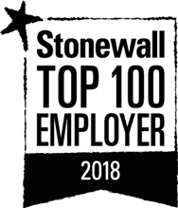

Our organisation

Our organisation

We are the Environment Agency. We work to protect and improve the environment and create better, safer places for people and wildlife. We:

- protect and improve the quality of water, making sure there is enough for people, businesses, agriculture and the environment
- fight environmental crime
- work closely with businesses (such as those in the waste industry) to help them comply with environmental regulations
- reduce the risks to people, properties and businesses from flooding and coastal erosion

Our work helps to ensure people can enjoy the water environment through angling and navigation and we also look after land quality, promote sustainable land management and help protect and enhance wildlife habitats.

Of course, none of this will be possible without the professionalism and dedication of our staff.
We work with government, local councils, businesses, civil society groups and communities to make our environment a better place for people and wildlife. As a public body we are committed to promoting equality and diversity in all we do and valuing the diversity of our workforce, customers and communities.

We’re committed to helping our people find new ways of working to maintain our focus on creating a better place for people and wildlife. For more information on the Environment Agency and what we do, please visit: www.environment-agency.gov.uk/aboutus

2. Salary and benefits

Starting salary: £43,777 per annum. (pro rata if part time or on assignment) We also offer a salary bonus scheme that is linked to your performance throughout the year.
Address: Sapphire House, 550 Streetsbrook Road, Solihull

Hours of work: 37 hours (pro rata if part time), Permanent Contract

Leave entitlement: Your annual leave allowance will be 27 days (pro rata if part time) plus bank holidays. This increases to 30 days with length of service. We also offer up to two days paid environmental outcome days each year. These give you the opportunity to take part in community activities with a clear environmental outcome for people and wildlife.

Pension: We will enrol you into the Environment Agency Pension Fund (EAPF) on commencing employment. The EAPF is part of the Local Government Pension Scheme (LGPS). It is a career average defined benefits scheme, which means you will build up benefits based on your pay each year. We will base your pension contributions on your pensionable pay and you will receive tax and national insurance relief on your contributions. You will begin by contributing 6.8% of your pensionable pay. Whilst you are in the scheme we will also pay an employer contribution into your pension pot. We currently pay 18.5%, so this is a very generous scheme.

Work/life balance: We support flexible working hours and practices to help you strike a good balance between your work life and your personal life. We will also encourage you to keep developing your skills and professional knowledge throughout your career.

Diversity: We are committed to diversity and inclusion. We want all our staff to feel valued and respected and to see this as a great place to work.
Diversity: it’s in our nature.

Tenancy deposit loan: Our Tenancy deposit loan scheme assists employees to cover the
scheme costs of a deposit for a privately rented home, which can sometimes act as a barrier to moving. The scheme gives access to an interest free loan to pay for some, or all of, a deposit and can be paid back over a period of up to 12 months, directly from your monthly salary.

3. The role

The National Investigations department has a national remit to tackle priority offenders and serious organised environmental crime and is part of the Environment Agency’s National Enforcement Service which provides support through several disciplines including Investigations, Financial Investigations, Prevention and disruption and Intelligence.

As the Senior Investigation Manager you will provide a key role in the department as a strategic lead on our Major Investigations, ensuring that our prosecution cases are proportionate and effective in bringing environmental crime offenders to justice.
These major investigations often involve serious organised crime groups so you will need to develop robust and often complex investigation strategies that deliver timely outcomes. You will need to work closely with our Major Investigations Room Team in tasking a team of investigators to an achievable and successful prosecution result.

You will lead on ensuring there is tight governance around your investigations, providing up to date management information that provides assurance that your investigations are meeting the milestones set out in your investigation strategy.
You will work closely with our intelligence function and ensure that criminal intelligence drives your investigations and when unforeseen complexities arise you will be expected to engage with management early to find and implement solutions and minimise the impact on the investigation.

You will be part of the National Investigations Leadership team and have line management responsibility for a small team of investigators. You will also be part of the National Enforcement Service wider Leadership Team, where you will be asked to lead on portfolio project work to help the department evolve and deliver the best service possible. You will also be expected to share your experience and knowledge with the organisation to help develop both the investigations function and how we address environmental crime.

You will need to build strong relationships both internally with our wider enforcement community and with external partners such as HMRC, ROCUs, GAIN and police forces. You will be expected to influence these relationships at a senior level ensuring the Environment Agency’s priorities are supported and recognised by other external enforcement agencies.

You will be proactive in your approach with a strong focus on continual improvement to develop and enhance the National Investigations function, ensuring that learning from the experience of previous and ongoing investigations is shared and embedded

You will need to be robust in your approach, be prepared to challenge where challenge is needed and be prepared to have difficult conversations. Your ability to influence up and down the chain will be paramount to the role as you will be a strong advocate for both the department and intelligence led enforcement.

You will instil the right behaviours within a diverse department to drive a productive and cohesive working environment embracing Environment Agency culture and values.

As the Senior Investigations Manager you will;

- provide strategic direction for our Major investigations providing overall governance on where our resources should be used to best effect
- ensure that we are proactive in our approach and that criminal intelligence leads our investigations
- be proportionate and timely in our response and ensure we get the very best outcome available
- ensure that we are proportionate in the evidence and digital material we seize during an investigation and that it is managed sensitively throughout
- work alongside and task our operational staff and investigators
- make decisions and empower those around you to do the same
- ensure the smooth day to day running of major investigations and make plans to address problems and where it can be improved
- set objectives, measure and manage individual and team performance
- embrace continual improvement supporting team members to ensure the department adapts to the varying demands placed upon it
- identify the potential for and lead on projects to help the National Investigations department and National Enforcement Service continue to evolve
- establish and maintain good relationships with internal teams and external partners, becoming an ambassador for enforcement within the organisation

What skills do you need?

You will be self-motivated, exceptionally well organised and able to handle the many aspects of leading a complex criminal investigation whilst delivering projects that will have strategic aims at their heart. Ideally you will have;

- exceptional leadership skills and the vision to lead a function forward;
- excellent communication skills including delivering feedback, managing performance, motivating your team and nurturing relationships;
- exceptional organisational skills;
- solid understanding of the principles of managing major investigations
- the ability to work with minimum supervision;
- the ability to work under pressure and prioritise a varied workload;
- the ability to highlight areas for improvement, plan how to address them and make sure that this is done;
- evaluation and assessment skills to measure successes and failures in an objective manner;
- an appetite for developing people’s capabilities as well as your own.

Top capabilities

As part of the application and interview processes, we’ll be looking for you to tell us how you:

- achieve results
- build and sustain relationships
- communicates effectively
- deliver results through others
- influence and persuade others
- lead people
- take decisions and solve problems

Please refer to the Top Capabilities document (attached to the vacancy) that describes our capability framework in further detail. The How to Apply section (section 6 below) provides advice on how to complete your application.

What experience do you need?

You will ideally have experience working on and leading complex criminal investigations. If you do not, but believe that your experience is appropriate, please tell us in the evidence you provide in the application form.
Experience in working within a Major Investigation Room would also be useful but not essential.
You will have experience leading and/or line managing a team coupled with a track record of continually improving your working practices and those of your team.

What qualifications and knowledge do you need?

We are not seeking formal educational qualifications for the Senior Investigation Manager however you will need to be highly articulate and driven alongside your experience of managing people and leading teams.
You will ideally have detailed knowledge of the legislation surrounding law enforcement, intelligence and handling sensitive data. Training will be provided on these areas however, being able to apply your knowledge on day one would be a real benefit.

What else do you need to know?

- The role will ideally be based centrally in Solihull in our Major Investigations Room but this may be flexible with the expectation that a large proportion of your time is spent there. There may also be occasions where you will need to travel and a lease car will be made available to you. Overnight stays may occasionally be required but you will be given plenty of notice beforehand.
- Many people within the Environment Agency support our incident management response (such as flooding). Full training is provided for this and you will be invited to find an incident role that suits should you wish to do so.

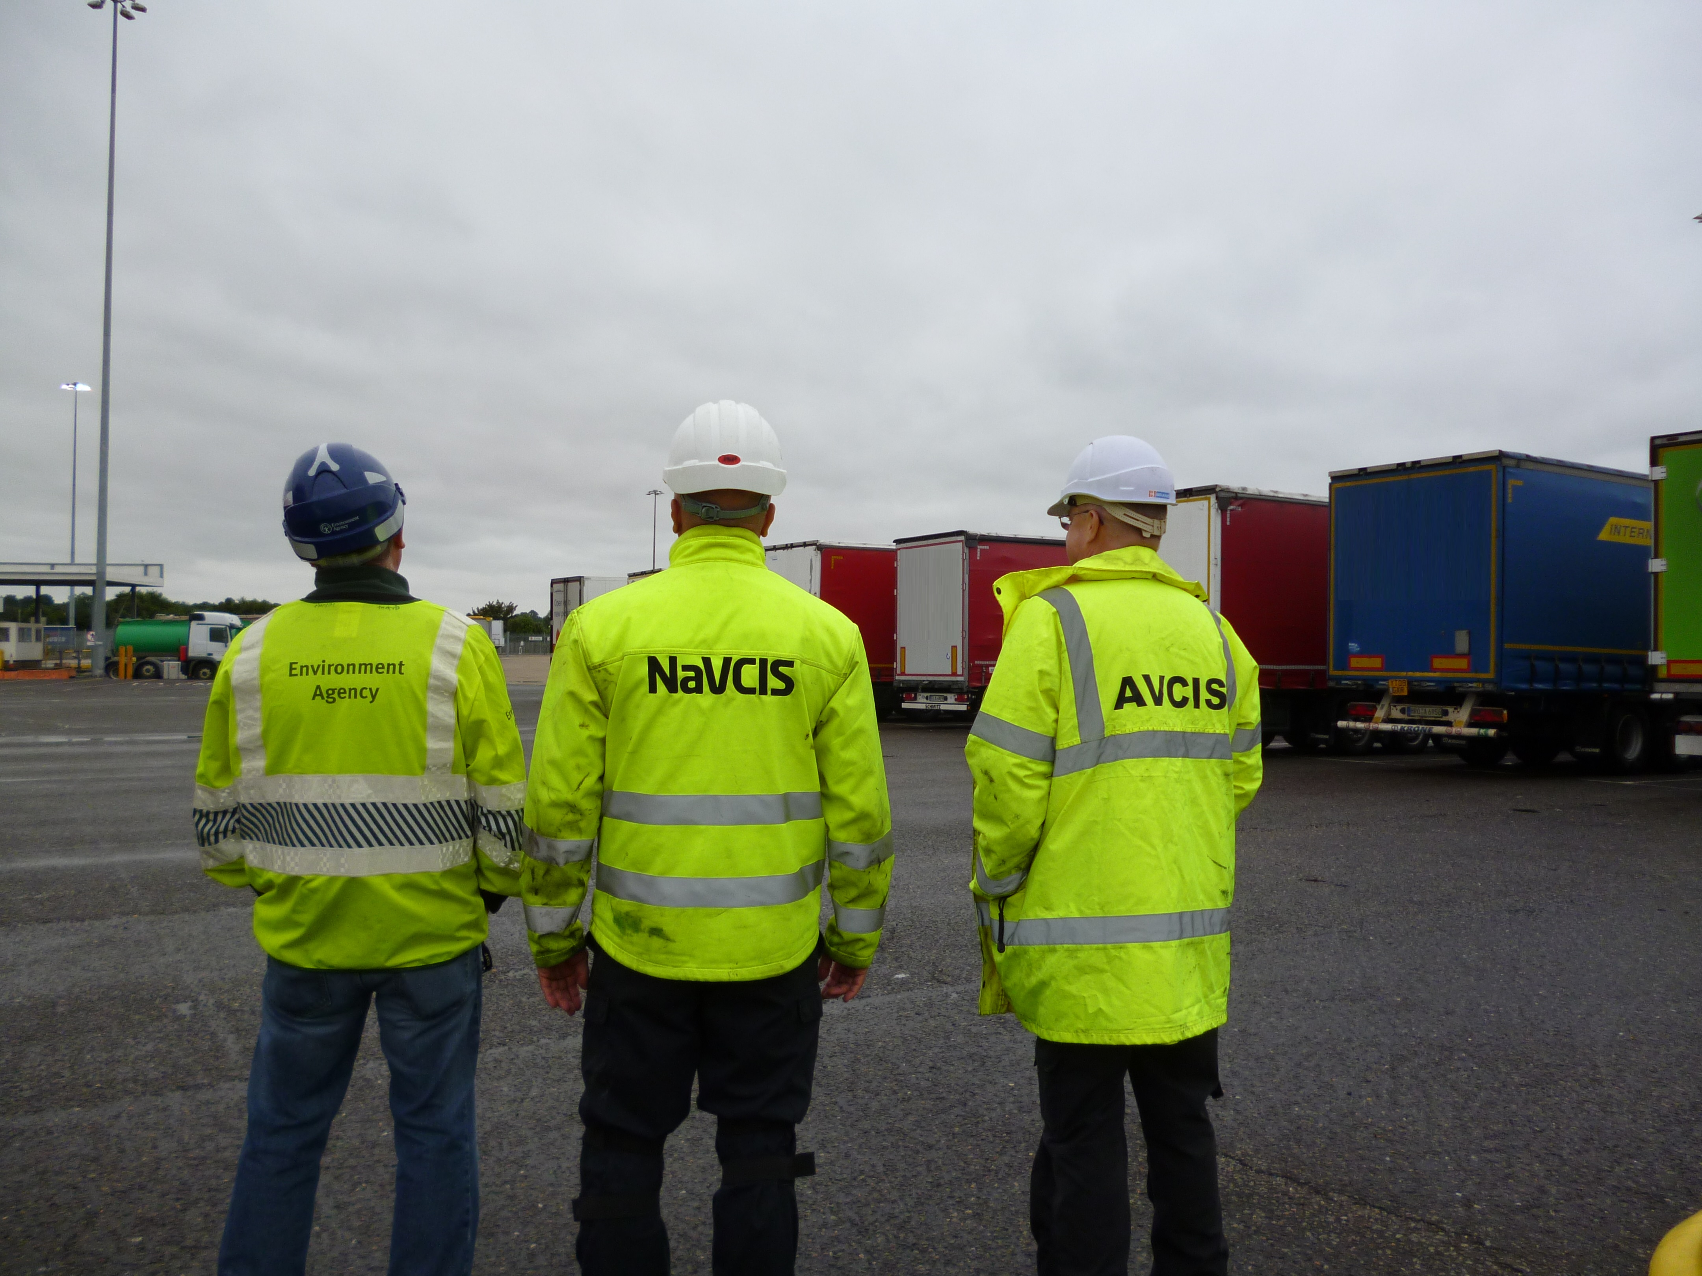
Leaders Group.

There are many benefits of this role at the Environment Agency including the salary, annual leave and ork-life balance to have significantly improved from my previous career and I believe this is because staff welfare is highly valued within the Environment Agency.

Katherine Snowden – Intelligence Research officer, Solihull

To help bring the role and the team to life, here are some views from both a Senior Investigation Manager and our Financial Investigations Team Leader, both of whom sit on the National Investigations Leadership team:

2015 was a big year for me. After 30 years’ service I retired as a Police officer and came to work for the Environment Agency; and what a great place it is to work! There is a huge diversity of roles and staff in this large organisation, but there is a genuine interest in the wellbeing and development of individuals too.
My first role was as a Team Leader, working with a great group of staff to set up the Major Investigation Room for the National Enforcement Service. This team works in line with the principles of MIRSAP, and supports major investigations in to serious organised environmental crime.
After a few months, and with the MIR up and running, I was offered the opportunity to change role, becoming a Senior Investigating Manager within the National Investigations Team. I have led a number of major operations since that time, working with colleagues from across the country, and partner organisations, in tackling significant environmental offending committed by Organised Crime Groups. Working closely with our Financial Investigations Team we also investigate associated money laundering and Proceeds Of Crime Act offences.
The Senior Investigations Manager role is a highly fulfilling position within the EA, allowing me to lead investigations and, at the same time, help to shape the way the organisation tackles serious crime.

Paul, Senior Investigation Manager, Solihull

I joined the Environment Agency in 2008 as a Senior Crime Analyst working within the Intelligence Team. Prior to this I spent 14 years working for various policing organisations as an Intelligence Analyst.
As the EA offers lots of opportunities, I moved across to the National Investigations Team in 2016 and started my current role as Team Leader. I am now leading the Financial Investigations Team which is a very interesting and fulfilling role. Although my role is not a technical one, I have learnt a great deal about this area of investigations by working closely with the Technical Lead and the team. I am also involved in other areas of work across the National Enforcement Service which makes my working life very varied and enjoyable.
As an employer, the EA believes in flexible working. In addition, health, safety and wellbeing of staff is a priority, making it a great place to work!

Fiona, Financial Investigations Team Leader, Newcastle

There is a lot of training at the start and this continues with the differing requirements of the role and as EA objectives / risk assessments change.

Pete – Intelligence Research Officer, Solihull

4. Training and development

We offer various levels of training dependant on experience, centred around a suite of classroom courses that concentrate on management within the Environment Agency. These courses should be completed within your first year.

You will also receive a mixture of development opportunities including e-learning and on-the-job training especially during your first six months probationary period.

Your learning and development doesn’t stop once you have completed your probation; we continue to invest in ensuring you have the rights skills to do your job by offering modular based development programmes linked to your role. With a strong focus on Continued Professional Development, you will be encouraged to take up to ten days every year to work on your own development. This could range from formal training to a shadowing opportunity in another department to attendance at a conference or being a mentor.

This strong emphasis on Continued Professional Development will include identifying your own opportunities as well as those for your team.

What will the initial training cover?

Typically the first six months will cover;
- an introduction to how we manage investigations in the Environment Agency
- managing in the Environment Agency
- bespoke HR systems
- health, safety and wellbeing
- legislation and regulation
- enforcement in the Environment Agency

What will I achieve?

The training is all geared towards developing the ability to do something whilst actually doing it! Therefore the training process provides you with the opportunity to apply your acquired knowledge and demonstrate competence. The aim is to get you working comfortably as part of the National Investigations team as soon as possible.

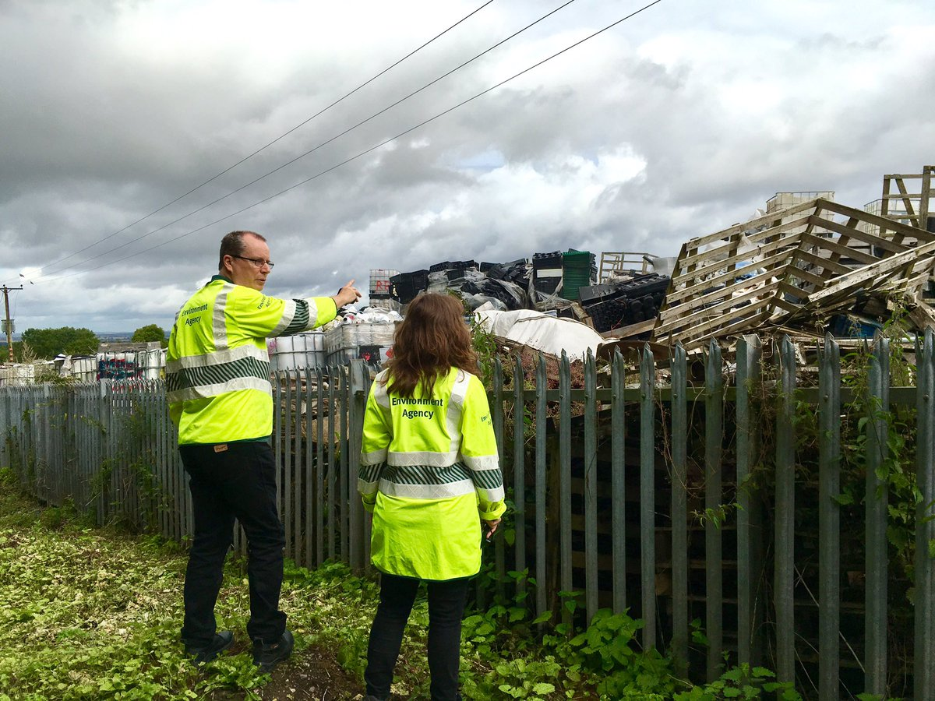
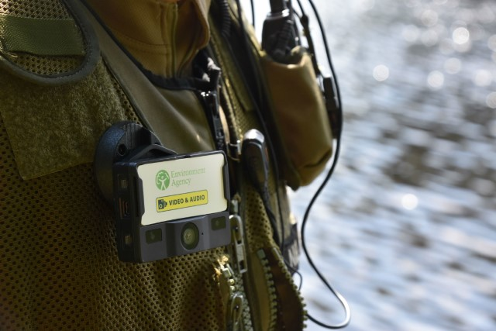
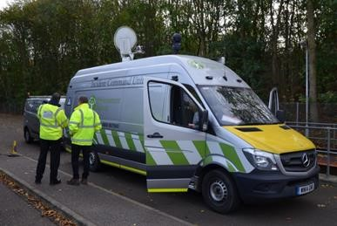

5. Further information

The Environment Agency values a diverse workforce and welcomes applications from all sections of the community who wish to join a workforce which embraces difference and welcomes everyone.

We are fully committed to having an inclusive workforce to reflect the communities we serve. We particularly welcome applications from Black, Asian and Minority Ethnic (BAME) and female candidates who are under-represented across our workforce.

We will consider flexible working patterns for all our vacancies, including job share, so please include clearly any information regarding your preferred working arrangements on your application.

Include any additional information that might be useful, e.g. travel involved with the role.

Eligibility to apply and continuity of employment

Employment agency workers and contractors are considered to be external candidates and should therefore only apply for positions that are being advertised externally. They are also not eligible to claim continuity of employment should they be successful in securing a position with the Environment Agency.

If you have been a member of a Regional Flood and Coastal Committee in the last 12 months we will not be able to continue with your application based on agreed appointment rules related to employing ex-RFCC members. We would welcome an application from you once the 12 month period have passed.

Please note that Environment Agency employees are not civil servants so you may wish to check your eligibility for continuity of employment by contacting your HR department. All eligible bodies are listed in the Redundancy Payments (Continuity of Employment in Local Government etc) (Modification) Order 1999

Please note all successful applicants must undergo Baseline Personnel Security Standard (BPSS) checks prior to commencement of employment. This includes a basic criminal records check.

Once employed, we will require you to successfully undertake vetting to SC (Security Check) level to work within an Intelligence environment.

6. How to apply

We use an online recruitment system. To make the application process simple and straightforward, and so that you know how it works and what we need from you, we’ve put together a few hints and tips.

The first thing you need to do is sign up to our online recruitment system. You’ll need a valid e-mail address to log in and apply for jobs, as all communication from us will be via e-mail. You can do this via the vacancy you are interested in by selecting ‘Apply’ at the bottom of the advert. Once you’ve clicked this link you’ll then be asked:

- Do you have the right to live and work in the UK? – please answer ‘yes’ or ‘no’
- Do you have the required qualifications or equivalent experience, which were stated in the job advert? – we are not seeking any specific qualifications or experience for this role, so please answer ‘yes’ to this question
- Are you currently an employee of this organisation? – please answer ‘yes’ or ‘no’

You’ll then see the ‘Register’ page. Simply complete the details and select ‘Submit Registration’ and register to the system. You only need to sign up to the system once; you’ll just be able to login next time. You can then carry on with your application.

When it comes to the actual application, you need to fill out each section. Please be aware that the system will automatically time out if you are inactive for more than 60 minutes. This will result in any unsaved information being lost, so please make sure you save what you are doing regularly. Once you’ve finished, your details and information will be saved on the system for any future applications – of course, you can edit your details at any point.

When you apply to the Environment Agency for a job we will ask you to provide your personal data on our application form. We need this information so that we can establish your identity and your right to work in the UK. You can read our Data Protection Statement on the application process page of our recruitment system. It is also available for reference on each page of the actual application.

Capability questions

We’re keen to know what makes you right for the job you’re applying for and why we should invite you for an interview. The capability questions are your chance to convince us! You should demonstrate how your skills, qualities and experience meet the requirements of the job (as described in the job advert and this candidate pack). Instead of simply telling us, show us: use real life examples of where you’ve used a certain skill or how you’ve practically applied your experience.

There’s a 250 word limit per question. It’s a crucial part of the selection process so make sure you dedicate plenty of time to completing this part of the application form. Think about what we need to know about you and what you’d bring to the role and our organisation.

How to prepare your answers for a capability based application

Capabilities are high level descriptions of key behaviours, skills and knowledge that underpin effective performance. They are the behaviours, skills and knowledge employees must have, or must acquire, to achieve high levels of performance. Please refer to the Top Capabilities document (attached to the vacancy) that describes our capability framework in further detail.

Capability questions target a specific skill, so we will be looking for some key components in your answer:

  - an indication that you understand the importance of that capability to the role for which you have applied
  - evidence that you understand the fundamental skills associated with that capability
  - an example that highlights your possession of that capability
  - an awareness from you of how the critical skills will be used to good effect in the new role

The STAR approach

STAR stands for:
- Situation
- Task
- Action
- Result

The STAR approach is a universally-recognised communication technique designed to enable you to provide a meaningful and complete answer to questions asking for examples and it has the advantage of being simple.
Step 1 – Situation or Task

Describe the situation that you were confronted with or the task that needed to be accomplished. With the STAR approach you need to set the context. Make it concise and informative, concentrating solely on what is useful to the story. For example, if the question is asking you to describe a situation where you had to deal with a difficult person, explain how you came to meet that person and why they were being difficult. If the question is asking for an example of teamwork, explain the task that you had to undertake as a team.

Step 2 – Action

This is the most important section of the STAR approach as it is where you will need to demonstrate and highlight the skills and personal attributes that the question is testing. Now that you have set the context of your story, you need to explain what you did. In doing so, you will need to remember the following:
- Talk about yourself, not the rest of the team
- Go into detail
- Steer clear of technical information, unless it is crucial to your story
- Explain what you did, how you did it, and why you did it

What, how and why

When we shortlist your application, we would like to know how you reacted to the situation. This is where you can start selling your skills. For example, you may want to describe how you used the team to achieve what you wanted and how you used your communication skills to keep everyone updated on progress, etc.

This is probably the most crucial part of your answer. We want to know that you are using a variety of transferrable skills in order to achieve your objectives. You must be able to demonstrate in your answer that you took specific actions because you were trying to achieve what you wanted, and that things didn’t happen simply by chance.

When discussing a situation where you had to deal with conflict, a good answer might provide an example of how you intervened to diffuse the situation, how you approached it with consideration for both yourself and others. For example:

“I could sense that my colleague was irritated and I asked him gently to tell me what he felt the problem was. By allowing him to vent his feelings and his anger, I gave him the opportunity to calm down. I then explained to him my own point of view on the matter, emphasising how important it was
that we found a solution that suited us both.”
This answer helps us understand what drove your actions and reinforces the feeling that you are considering the needs of others before acting. It provides much more information about you as an individual and is another reason why the STAR approach is so useful.

Step 3 – Result

Explain the positive outcome of your action(s) – how it all ended. Use the opportunity to describe what you accomplished and what you learnt in that situation. This helps you make
the answer personal and enables you to highlight further skills.
An example

For example, a strong answer to this capability question might be constructed in the following way:

“Can you tell us of an occasion when you demonstrated strong leadership in order to produce a positive outcome?”

- Consider an introductory sentence or two about the importance of strong leadership in general terms.
- Explain what strong leadership looks like to you. Make this personal to you; express an opinion on leadership rather than regurgitate leadership theory.
- Talk about how you exhibited strong leadership. Draw upon a couple of real life examples which shows good evidence that you have the skills that you say you do.
- Don’t dwell too much on the details of the situation – word count (and time in interviews) is limited; we want to hear about what you did and how you contributed, added value, and drew on your skills, and how your leadership intervention was critical.
- Discuss how these skills would transfer to the new position you are applying for.

The key in answering all capability questions is that you are required to demonstrate that you have the right skills by using an example (or examples) based on your work or life experience, and not just talk about the topic in a theoretical, general or impersonal manner.

How we shortlist
We will shortlist your application based only on the information you’ve provided in your application form, including the answers to the capability questions. We score your answers to the capability questions and use these scores to make decisions on whether we’d like to invite you for an interview. We may also take into account your previous work experience or qualifications, depending on whether this is a requirement of the role or not.

Should I attach my CV?
If you choose to attach your CV (this is not necessary), please note that your CV is not visible to us at the shortlisting stage.

Application questions
For some roles, we’ll ask you some specific questions, like if you have a preferred work location. If you’re disabled and you’d like to be part of our Guaranteed Interview Scheme, you can add this information in here.

Equality and diversity
We’re committed to reflecting the communities we serve and we’d like you to tell us about yourself and your background.

Submitting your application
Once you’ve filled out and completed everything, you’ll be prompted to submit your application. Simply click the button and you’re done. If, at any stage, you have questions or problems with our online application system, please contact SSCL on 0345 300 1861.

Please be aware that once you’ve submitted your application, with the exception of the ‘Personal Details’ section you will not be able to edit your application further. If you decide to withdraw your application, you will not be able to submit another application for the same vacancy.

Don’t leave your application until the last minute – technical support is provided Monday to Friday only; and most vacancies close at 23:55 in the evening. If you are unable to submit your application at 23:54 on the day applications close, we will be unable to accept late submissions.

Sign up for job alerts
You can set up email alerts for future vacancies and will automatically receive an email when a job that matches your criteria becomes available. To do this simply login then click on ‘create a new job alert’, enter your job criteria and save.

