Candidate information pack

Geomatics Intern Student

www.gov.uk/environment-agency
Please consider the environment and only print this document if you really need to.

Candidate information pack

Job title: Geomatics Intern Student
Job location: Bath
Date: February 2019
Reference number: 9897

Contents
- Our organisation
- Geomatics
- The role
- Our requirements
- Salary and benefits
- Further information
- How to apply

www.gov.uk/environment-agency 2

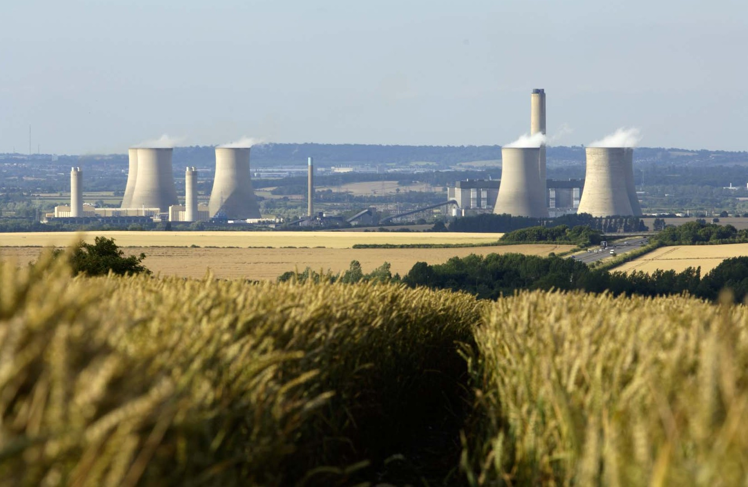Our organisation
Didcot Power Station.

We are the Environment Agency. We protect and improve the environment. Acting to reduce the impacts of a changing climate on people and wildlife is at the heart of everything we do. We reduce the risks to people, properties and businesses from flooding and coastal erosion. We protect and improve the quality of water, making sure there is enough for people, businesses, agriculture and the environment. Our work helps to ensure people can enjoy the water environment through angling and navigation. We look after land quality, promote sustainable land management and help protect and enhance wildlife habitats. And we work closely with businesses to help them comply with environmental regulations. We can’t do this alone. We work with government, local councils, businesses, civil society groups and communities to make our environment a better place for people and wildlife.

www.gov.uk/environment-agency
Of course, none of this will be possible without the professionalism and dedication of our staff. We are committed to promoting equality and diversity in all we do, and to valuing the diversity of our workforce, customers and communities.

We’re committed to helping our people to find new ways of working and to maintain our focus on creating a better place for people and wildlife. For more information on the Environment Agency and what we do, please visit:

www.gov.uk/environment-agency/aboutus

3

Geomatics

Geomatics is the centre of expertise for remote sensing and data analysis within the Environment Agency.

We deliver integrated spatial data products to inform flood & coastal risk management and other environmental decisions. We also support partner organisations including Natural England, Forestry Commission, local authorities and government agencies.

Our services can be broadly divided into the following:
- New data capture from aerial platforms, vessels and land based systems;
- Aerial incident response;
- Geomatics Mapping Services;
- Data storage and distribution on behalf of the Environment Agency.

Our geospatial products help support a wide range of applications including environmental planning, flood monitoring, asset management and urban planning.

We also support incident response, surveying and monitoring events such as floods and environmental disasters.
We offer the capability to capture a range of high resolution data including LIDAR, bathymetry, digital aerial photography, hyperspectral and thermal data.

Flight operations are based at East Midlands Airport, although aircraft are able to forward-base from any suitable airport. We also have access to a large network of depots for operating terrestrial and marine surveys. All data is processed in-house from our offices in Bath.

We are focused on delivering the highest quality data and providing a fully integrated approach to the delivery of geo-information. Combining cutting edge technology with expert personnel, we work to the highest scientific and ethical standards to provide accurate and high quality GIS ready products. As an ISO accredited business (ISO 9001 and ISO 14001 certified), our survey and data processing procedures include stringent quality control and we firmly believe that our passion and dedication is self-evident in the quality product that we provide our clients.

Data download: https://environment.data.gov.uk/DefraDataDownload/?Mode=survey

www.gov.uk/environment-agency

LIDAR DSM integrated with digital aerial photography, Isles of Scilly.

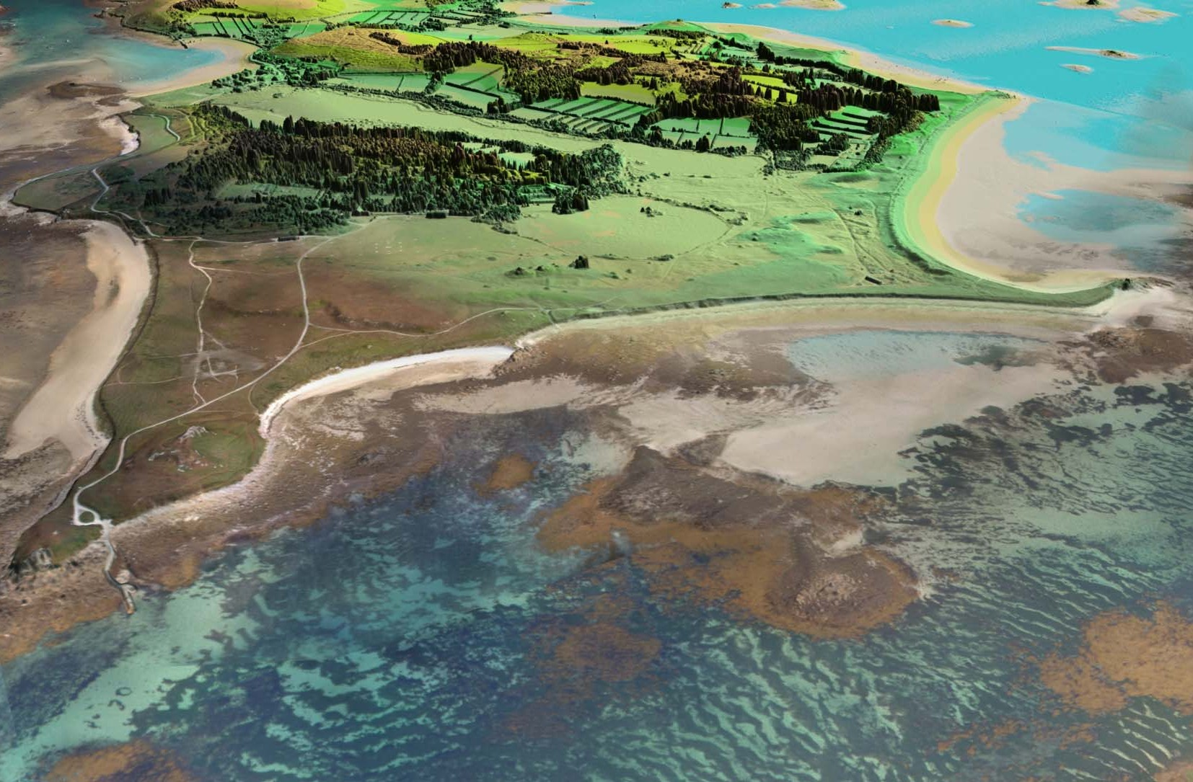4

The role

We are looking for an undergraduate student to work in a small team, supporting the delivery and analysis of high quality GIS ready products derived from remote sensing techniques.

This job provides an opportunity to integrate career related experience into undergraduate education by participating in work based experience. Your personal and professional development will be gained through job shadowing, on the job work experience and challenging assignments.

Tasks will include:

- Using GIS and remote sensing software to undertake complex spatial analysis of elevation and other spectral datasets;

- Processing data captured using our state of the art airborne LIDAR and digital aerial camera systems to an agreed accuracy specification;

- Production of high quality Digital Surface Models and classification of surface objects to create Digital Terrain Models;
- Ortho-rectification of colour and near-infrared airborne imagery to create seamless photo mosaics;

- Generation of QC reports and archiving of data to ensure availability for future use.

You’ll receive training in various industry standard and bespoke software applications, guided by a number of coaches.

At the same time you’ll gain practical experience, building up skills in activities such as spatial analysis, IT and team work.

You’ll have the opportunity to gain exposure to a wide range of environmental applications such as flood mapping, coastal monitoring, archaeological studies and forestry management.

In addition to your team leader who will oversee your daily work, you’ll have an independent mentor. They’ll be around to answer any questions you have, pass on their knowledge and experience, and help you become the best Geomatics Analyst you can possibly be.

www.gov.uk/environment-agency 5

Our requirements

Knowledge/qualifications
You must be approaching the final year of an undergraduate degree programme in an appropriate discipline, which includes content associated with Remote Sensing and/or Geographic Information Systems (GIS).

Your university must support sandwich year options or break in studies.

Skills/abilities/experience
We are looking for individuals with a well-developed sense of spatial awareness who are committed to a career in geomatics and/or the environmental sector.

You should be able to demonstrate the following:

  - High level of computer literacy, specifically in Microsoft Windows environment;

- Understanding of GIS and associated data management;

- Practical experience of GIS software would be advantageous, although not essential;

- Analytical and problem solving skills;

- Working independently and organising your work and time with minimal supervision;

- Working as part of a team to deliver projects in a timely manner;

- Using good written and spoken communication skills to convey information;

- Providing a polite and professional service to colleagues and customers.

www.gov.uk/environment-agency
LIDAR Point Cloud, Olympic Park, London.

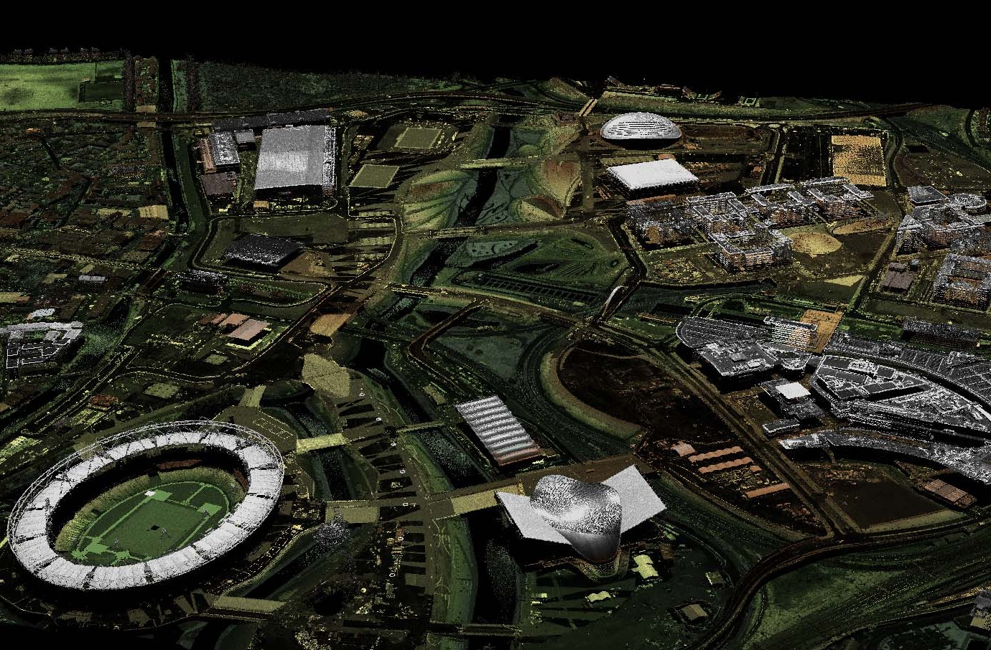6

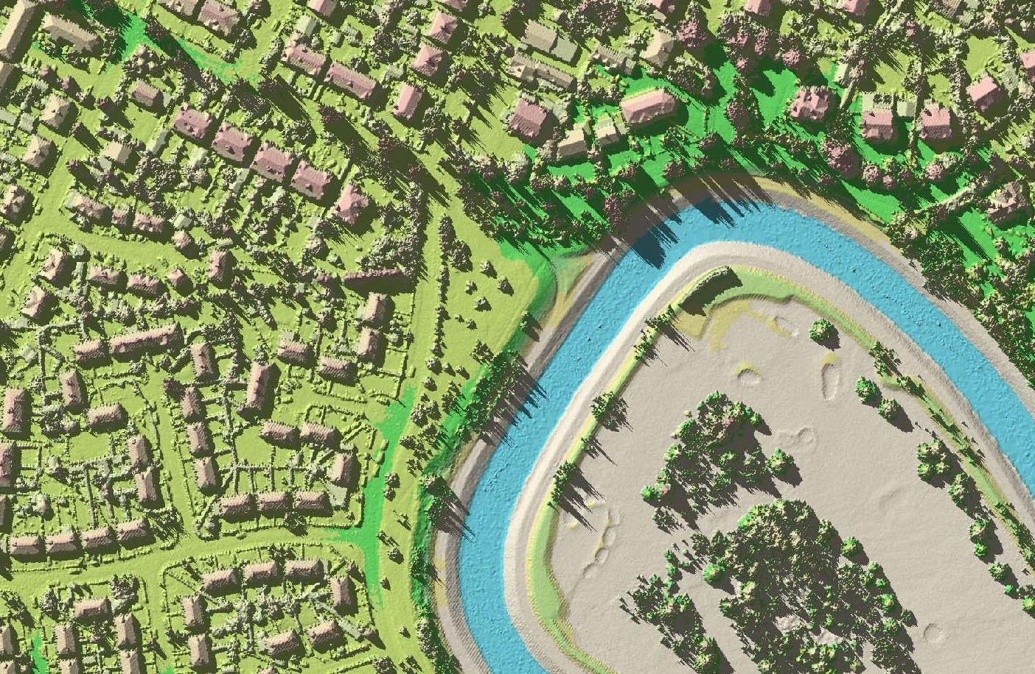
25cm resolution LIDAR DSM.

Salary and benefits

Join us in this role and you will enjoy the following benefits: Salary: £18,392 per annum
Location: Rivers House, Lower Bristol Road, Bath, BA2 9ES
Hours of work: 37 hours per week, Fixed Term/Assignment until 31 July 2020
Leave entitlement: Your leave allowance in this role will be 25 days plus bank holidays. We offer up to two days paid environmental outcome days each year. These give you the opportunity to take part in community activities with a clear environmental outcome for people and wildlife.
Pension: We will enrol you into the Environment Agency Pension Fund (EAPF) on commencing employment, if your employment contract is for 3 months or more. The EAPF is part of the Local Government Pension Scheme (LGPS). It is a career average scheme, which means you will build up benefits based on your pay each scheme year rather than your final salary. We will base your pension contributions on your actual pay and you will receive tax and national insurance relief on your contributions. The pension contribution rates currently range between 5.5% to 12.5%. Whilst you are in the scheme we will also pay an employer contribution into your pension pot. We currently pay 18.5%, so this is a very generous scheme.
Work/life balance: We support flexible working hours and practices to help you strike a good balance between your work life and your personal life. We will also encourage you to keep developing your skills and professional knowledge throughout your career.
Diversity: We are committed to diversity and inclusion. We aspire to be the best employer in the country for equality, diversity and inclusion (EDI) and want all our staff to feel valued and respected and to see this as a great place to work. From our EDI executive champions to our EDI employee networks, everyone has a part to play to embed equality, diversity and inclusion in our organisation. Diversity: it’s in our nature.
Tenancy Deposit Loan: Our tenancy deposit loan scheme assists permanent employees and individuals directly by the Environment Agency on a Fixed Term Contract of more than 3 months, to cover the costs of a deposit for a privately rented home.
The scheme gives access to an interest free loan to pay for some, or all of, a deposit and can be paid back over a period of upto 12 months (or by the end of your fixed term contract), directly from your monthly salary.

www.gov.uk/environment-agency 7

Further information

We will continue to support the successful candidate through their final year at university with careers mentoring and where desired and possible the provision of data and / or a project brief for their dissertation.

If you have any questions about the post please email geomaticsinternships@environment-agency.gov.uk

Closing date for applications: Sunday 3rd March 2019.

Please note that this vacancy will close at 23:59, on the closing date stated above.

Interviews will be held week commencing 25 March 2019. You must be available to attend an Interview in Bath during this period.

We expect successful candidates to start in July 2019.
We are fully committed to having an inclusive workforce to reflect the communities we serve. To find out more about what it’s like to work at the Environment Agency, please visit: www.gov.uk/government/organisations/environment- agency/about/recruitment

Please note all successful applicants must undergo Baseline Personnel Security Standard (BPSS) checks prior to commencement of employment. This includes a basic criminal records check.

You can also follow us on:

Environment Agency Careers

Geomatics

www.gov.uk/environment-agency
Oblique aerial photograph, St. Asaph.

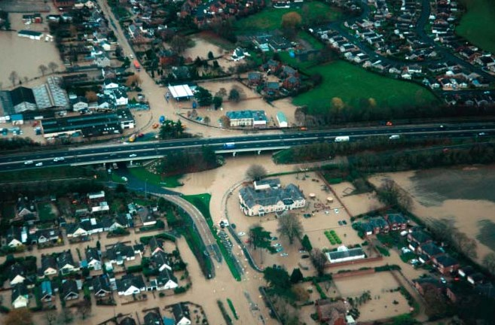8

How to apply

We use an online recruitment system. To make the application process simple and straightforward, and so that you know how it works and what we need from you, we’ve put together a few hints and tips. Make sure you have all the information you need about the vacancy. For some jobs, you’ll be asked to download a candidate pack, like this one, where you’ll find specific application instructions.

The first thing you need to do is sign up to our recruitment system. You will need a valid e-mail address to log in and apply for opportunities, as all communication from us will be via e-mail. You can do this via the vacancy you are interested in by selecting ‘Apply’ at the bottom of the advert.

Once you’ve clicked this link you’ll then be asked:

  - Do you have the right to live and work in the UK?
  - Do you have the required qualifications or equivalent experience, which were stated in the job advert?
  - Are you currently an employee of this organisation?

Simply answer yes or no and you can carry on with your application. You’ll then see the ‘Register’ page. Simply complete the details and select ‘Submit Registration’ and register to the system. You only need to sign up to the system once; you’ll just be able to login next time.

When it comes to the actual application, you need to fill out each section, please be aware that the system will automatically time out if you are inactive for more than 60 minutes. This will result in any unsaved information being lost so make sure you save what you are doing regularly. Once you’ve finished, your details and information will be saved on the system for any future applications – of course, you can edit your details at any point.

When you apply to the Environment Agency for a job we will ask you to provide your personal data on our application form. We need this information so that we can establish your identity and your right to work in the UK.

You can read our Data Protection Statement on the application process page of our recruitment system. It is also available for reference on each page of the actual application.

Competence Questions/Statement
We’re keen to know what makes you right for the job you’re applying for and why we should ask you in for an
interview. The competence questions/statements are your chance to convince us!

You should demonstrate how your skills, qualities and experience meet the requirements of the job (as described in the job advert and candidate pack). And instead of simply telling us, show us: use real life examples of where you’ve used a certain skill or how you’ve practically applied your experience.

There’s a 250 word limit per competence including spaces. It’s a really important part of the selection process so make sure you keep your statement relevant and concise. Think about what we need to know about you and what you’d bring to the role and our organisation.

Application questions
For some roles, we’ll ask you some specific questions, like if you have a preferred work location. If you’re disabled and you’d like to be part of our Guaranteed Interview Scheme, you can add this information in here.

Equality and Diversity
We’re committed to reflecting the communities we serve and we’d like you to tell us about yourself and your background.

Submitting your application
Once you’ve filled out and completed everything, you’ll be prompted to submit your application. Simply click the button and you’re done.

Please be aware that once you’ve submitted your application, with the exception of the ‘Personal Details’ section you will not be able to edit your application further. If you decide to withdraw your application, you will not be able to submit another application for the same vacancy.

If, at any stage, you have questions or problems, please contact the recruitment team on 0845 602 6099 or ea_recruitment@sscl.gse.gov.uk

If you have been unsuccessful with your application you can set up email alerts for future vacancies. You will automatically receive an email when a job that matches your criteria becomes available. To do this simply click on ‘create a new job alert’, enter your job criteria and save.

www.gov.uk/environment-agency 9

Would you like to find out more about us, or about your environment?

Then call us on
03708 506 506 (Mon-Fri 8-6)
Calls to 03 numbers cost the same as calls to standard geographic numbers (i.e. numbers beginning with 01 or 02).

email
enquiries@environment-agency.gov.uk

or visit our website www.gov.uk/environment-agency

incident hotline 0800 80 70 60 ₍₂₄ _{hours)}
floodline 0845 988 1188

