Water Resources – Prolonged Dry Weather Management Coordinator

Candidate Information Pack

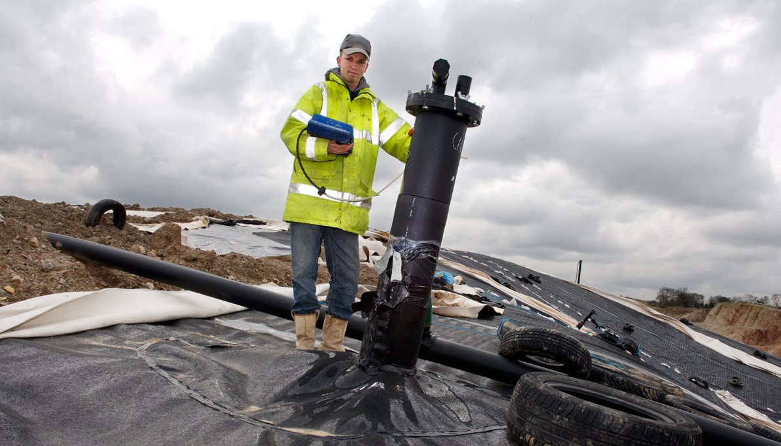

Contents

1. **Our organisation**
2. **The role**
3. **Training and development**
4. **Is this the right career for you?**
5. **Roles available**
6. **Principal accountabilities for each role**
7. **Salary and benefits**
8. **Further information**
9. **How to apply**



1. Our organisation

We are the Environment Agency. We protect, improve the environment and support sustainable development.

Acting to reduce the impacts of a changing climate on people and wildlife is at the heart of everything we do. We reduce the risks to people, properties and businesses from flooding and coastal erosion. We protect and improve the quality of water, making sure there is enough for people, businesses, agriculture and the environment.

Our work helps to ensure people can enjoy the water environment through angling and navigation. We look after land quality, promote sustainable land management and help protect and enhance wildlife habitats. And we work closely with businesses to help them comply with environmental regulations. We can’t do this alone.

We work with government, local councils, businesses, civil society groups and diverse communities to make our environment a better place for people and wildlife.

Of course, none of this would be possible without the professionalism and dedication of our staff. We’re committed to helping our people to find new ways of working and to maintain our focus on creating a better place for people and wildlife. For more information on the Environment Agency and what we do, please visit:

[**www.environment-agency.gov.uk/aboutus**](http://www.environment-agency.gov.uk/aboutus)

[LinkedIn](http://www.linkedin.com/company/environment-agency/careers?trk=top_nav_careers)[YouTube](http://www.youtube.com/user/EnvironmentAgencyTV)[Facebook](https://www.facebook.com/environmentagency?ref=hl)[Twitter](https://twitter.com/EnvAgencyJobs)

1. [LinkedIn](https://www.linkedin.com/company/163648?trk=tyah&trkInfo=clickedVertical:company,clickedEntityId:163648,idx:2-1-4,tarId:1475580698169,tas:environment%20agency)[YouTube](http://www.youtube.com/user/EnvironmentAgencyTV)[Facebook](https://www.facebook.com/environmentagency?ref=hl)[Twitter](https://twitter.com/EnvAgencyJobs)Water Resources – Prolonged Dry Weather Management

Area / National Operations

**Our role**

The Environment Agency is responsible for safeguarding water resources in England and protecting the environment. As the water regulator, we have overall responsibility for drought management and overseeing the actions water companies take to secure public water supplies. Water companies are ultimately responsible for managing water supplies to meet the needs of customers.

A drought is a natural event that we can’t prevent and every drought is different. Droughts occur as a result of a prolonged period of low rainfall, affecting available water supplies to different users. Droughts can also affect different sources (rivers or aquifers), depending on when the lack of rainfall occurs. Some droughts will and have historically affected a large area of England while others will be and have been concentrated in just a few catchments.

It is the role of the Environment Agency to monitor, report and act to reduce the impact of drought on the natural environment. We take specific actions to manage environmental droughts, where low river flows and lake levels have the potential to cause damage to the natural environment and ecology. In this case there may or may not be an impact on drinking water supplies. Water companies are also responsible for maintaining supply while protecting the natural environment.

Our organisation-wide response to these events requires multiple skillsets and a diverse set of people, who can work together across different teams at both a National and local (Area) level. The teams included in this response are covered in the next section and the roles available are detailed in section 5.

**Incident Response**

The Environment Agency are a Category 1 responder (the same as other Emergency Services).

All our teams play an important part in incident management.

There are many opportunities for you to get involved in incident management. With 70% of incident management roles being office based, it’s a unique and exciting opportunity to have a direct impact on your local community. You’ll also be making an immediate impact upon people’s lives in their hour of need.

**Diversity and Flexibility**

We are passionate about employing people from all backgrounds that reflect the diverse communities we serve. Likewise, we respect family and caring responsibilities, religious practices and disabilities. We welcome applications from candidates seeking flexible working patterns, including job share and we also operate a Guaranteed Interview Scheme for candidates with a disability.

“*We want the Environment Agency to be a life-enhancing place to work - a place where you feel able to bring your whole self to work and where difference is truly valued. Being a diverse and inclusive organisation is essential for everyone’s wellbeing, engagement and productivity. It also means we will better reflect the communities we serve, helping us to do even better for people and wildlife*.” James Bevan, Environment Agency Chief Executive.

We look forward to welcoming you the Environment Agency and hope you can play a pivotal role in one of the following four teams.

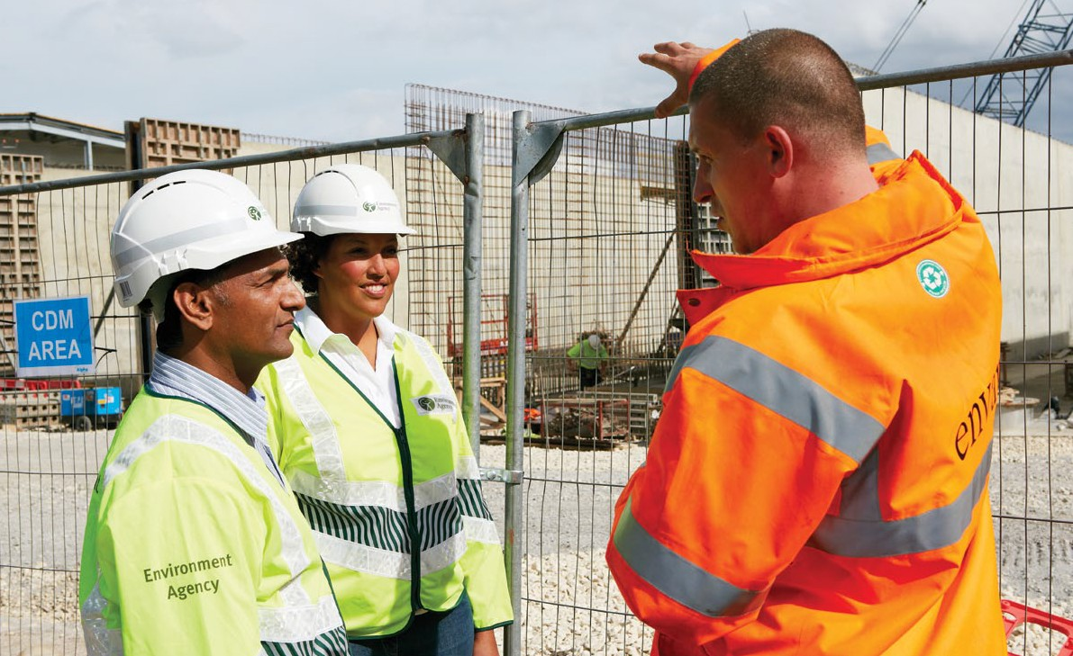

**Our Prolonged Dry Weather Response teams**

**Area Integrated Environmental Planning (IEP)**

The team manage data and policy using information from across the organisation. They assess and report on the state of the environment. They provide integrated planning for all disciplines across their Area.

**Area Environment Programme**

The team ensure that all projects funded by Environment and Business and FCRM work well together. They allocate money, deliver projects themselves or programme delivery carried out in different teams such as FRB. They work very closely with IEP to use environmental data to make decisions. They manage the catchment Partnerships and seek to form new partnerships and engage with communities and 3rd parties to get environmental projects delivered.

**Area Land and Water**

Deal with water quality, water resources and agriculture issues in their area. This includes:

* inspection of water company sites and other permitted water discharges,
* advice and guidance to operators with permitted discharges,
* regulation of abstraction licences,
* pre-application advice for water discharge permits,
* working with farmers and the agricultural sector,
* pollution prevention advice and incident response related to water quality and resources.

**Area Fisheries, Biodiversity, Geo-morphology**

The Fisheries team concentrate on:

* Conserving and maintaining the diversity of freshwater fish, salmon, sea trout and eel and to conserve their aquatic environment.
* Increasing the contribution salmon and freshwater fisheries make to the economy.
* Increasing the social value of fishing as an accessible and healthy form of recreation.

The Geomorphologists staff advise on:



* consultations for environmental consents and permits.
* options appraisals for scheme designs, supporting National Environment Assessment Service (NEAS), National Capital Programme Management Service (NCPMS) and Area Flood and Coastal Risk Management (FCRM) teams to make more sustainable decisions.

The Biodiversity team work on:

* The protection of native species and the monitoring and management of invasive species.

**National Incident Management & Resilience – Operations Team**

The Operations team is part of Incident Management & Resilience. Our purpose is to ensure we are a professional, trusted emergency responder helping people, businesses and the environment. As the Operations team we develop new ways of working and ensure our day to day incident management service is robust and resilient. The Operations team is based in the National Incident Room and is at the heart of ensuring we can effectively manage all kinds of incidents.

**National Permitting Service (NPS)**

NPS assess applications for a range of environmental permitted activities located all across the country. The team carry out technical assessments according to Environment Agency (EA) processes and regulatory obligations, to ensure the environment is protected. These activities range from waste management sites to sewage treatment works and hydropower sites.

Our teams are based in one of our four main permitting centres focussing on assessing either waste or water permits.

The work done in all teams (regimes) includes:

* Determine all types of permit applications in accordance to the Environmental Permitting Regulations and/or the Water Resources Act
* Engaging all types of operators (our customers) and building relationships both internally and externally.
* Where necessary, influencing operators/customers/applicants to use the best available techniques to protect the environment
* Using all of the information and resources available to you to make complex, risk based decisions, before justifying and recording your decision making process.

**National Water Resources Hydrology Team**

Our team produces the regular national water situation reports, provides data analysis and advice at a national level to support water resource regulation and drought management. We also support the Area based Hydrology Service (e.g. promoting best practise datasets, tools and techniques).

1. Employee testimonials

**“Essentially, the role is to manage water resources and assess the impact on the environment …”**

I’ve been working for the EA for just over 6 months. This time has gone by quickly - I have definitely enjoyed my time here so far! After completing my MSc in Environmental Management, I was excited to begin my career with the EA and my role in Water Resources. It has been wonderful to work with like-minded, environmentally passionate people.

Life at the EA was quite demanding at first due to the amount of training required. Once I began working on the permit applications, both my knowledge and confidence grew. Although it is an office based job, it doesn’t lack in variety! Applications can range from water abstraction licences, restrictions during drought, water transfers or impoundments. Each application is different and I have dealt with a range of customers from farmers to managers of laundry businesses or golf courses. There hasn’t been a day go by where I haven’t learnt something new. With so many applications it is vital to prioritise and organise my own workload to ensure excellent service.

Essentially, the role is to manage water resources and assess the impact on the environment. It is very rewarding, knowing I am helping to protect the environment through my role and the decisions I make every day.

The EA is a great organisation to work for as there is always something to get involved in outside the day job. I am currently training for an incident role where you help out with local or national incidents. This provides a great opportunity to meet new colleagues and gain extra skills and knowledge.

**Lauren Cater – Water Resources Permitting Officer**

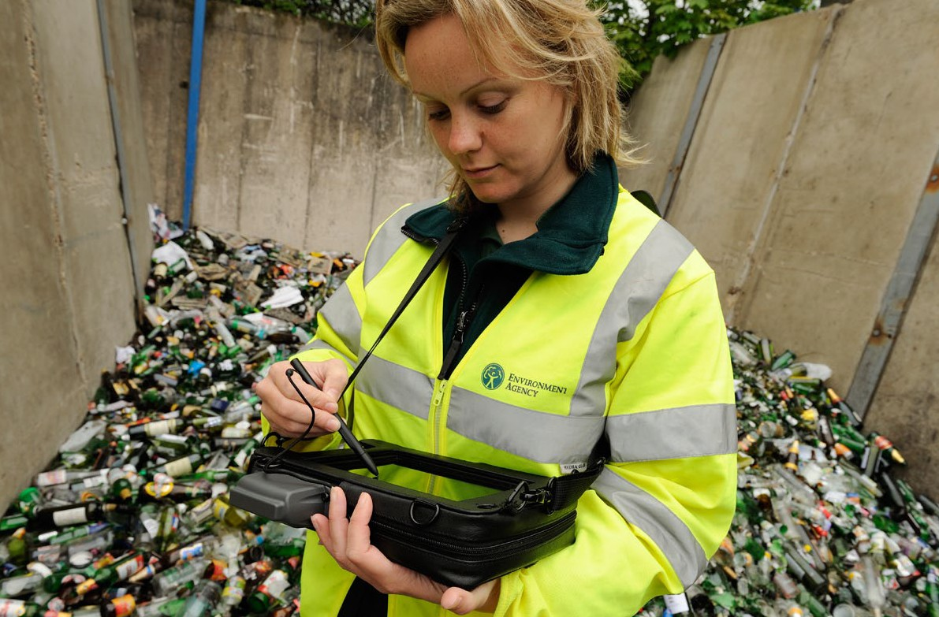

**“There is always something new to learn and many ways for you to personally develop …”**

“Since joining the EA I have been able to work alongside a really supportive team. Each member of the team has spent time training, developing and explaining all of the different ways we help safeguard the environment. I have always had an interest in the natural world and I am keen to ensure it is preserved and improved.

My education background is in the area of digital communications and technology but the experience from my studies has enabled me to feel comfortable with the many systems, processes and technologies the EA uses. Our job involves using a lot of technology and computer software whether that be; computer modelling, Geographical Information Systems (GIS) or office applications, the role of technology is ever increasing and a core part of the role.

In the short period I have been with the team I have already learnt so much. There is always something new to learn and many ways for you to personally develop. While the majority of our work is based in the office I have had the opportunity to visit a number of sites to see how the work we do translates into outcomes for the environment. This experience has helped me to understand how the work we do can ultimately make a positive difference.

I have also taken part in an environmental outcome day, it was a great team building exercise, fun and educational. It also allowed us to enhance a local nature reserve which was personally fulfilling. I also had the opportunity to engage with students at a local University sharing my own experience and encouraging them that there is a role at the EA for people from all backgrounds, and showing the willingness to learn can take you where you want to be.

I hope to continue to develop myself and take up an incident response role in the near future. I have enjoyed my time so far and look forward to the future.”

**Justin Orme – Water Quality Permitting Officer**

**Responding to incidents…**

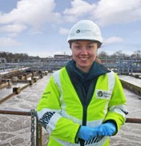“It was during one of my first weeks on standby that I really got the chance to put my incident training into practice.

I’d just settled down at home for the evening when I received a call from the duty officer telling me that a major sewage works had caught fire, destroying the control room and cutting off the power supply. If we didn’t act quickly then untreated sewage could enter the river, completely obliterating the delicate ecosystems in the watercourse.

When I arrived on site I was ushered into a command meeting with the other emergency responders and the sewerage company, where they looked to me for advice and guidance in dealing with the incident.

At first it felt strange that they were relying on me for my input when I felt so new and inexperienced, but then I realised that to them I was a representative of the Environment Agency and an expert in my field, and the fact that I was less than a year into my job was of no importance to them. I drew on the knowledge that I had gained throughout my training and used this in conjunction with the help I received from my more experienced colleagues, which enabled me to work effectively with the other responders to reduce the impact of the pollution.

The incidents aren’t always of this intensity but they are all important. Whether it is a noisy waste site causing stress to neighbours, or a kitchen sink discharging dirty water to a stream, dealing with these incidents helps improve quality of life and the environment for everyone, and gives you, as an Environment Officer, a sense of satisfaction that you’ve helped contribute. It’s one of my favourite parts of the job.”

**Stephanie Illsley, Kent, South London & East Sussex**

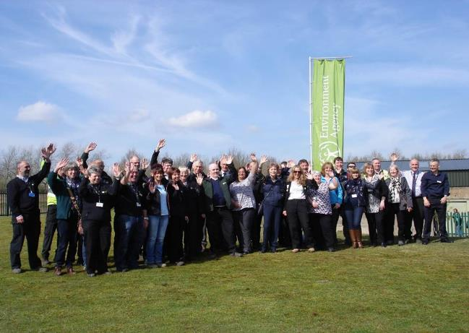

1. Roles available

**Coordinator Roles**

|  |  |  |  |  |  |
| --- | --- | --- | --- | --- | --- |
| **Job Title** | **Team** | **Starting**  **Salary** | **Locations** | Vacancy Reference | Contracts Available |
| Water Resources Coordinator | Area Land and Water | Grade 4 - £27,138 | Ipswich | Ref: 7852 | Permanent |
| Environment Programme Coordinator | Area Environment Programme | Grade 4 - £27,138 | Norwich, Ipswich, Kelvedon, Ely, Brampton | Ref: 7852 | Fixed Term |
| Hydrometry and Telemetry Coordinator | Area Land and Water | Grade 4 - £27,138 | Ipswich | Ref: 7852 | Fixed Term |
| Hydrogeology Coordinator | Area Land and Water | Grade 4 - £27,138 | Brampton, Ipswich | Ref: 7852 | Fixed Term |
| Hydrology technical Coordinator | Area Land and Water | Grade 4 - £27,138 | Brampton | Ref: 7852 | Fixed Term |
| Hydrologist | National Water Resources Hydrology Team | Grade 4 - £27,138 | Reading, Exeter, Bristol | Ref: 7852 | Fixed Term |
| Water Resources Coordinator | National Permitting Service (NPS) | Grade 4 - £27,138 | Sheffield, Nottingham, Ipswich, Solihull, Exeter | Ref: 7852 | Permanent |

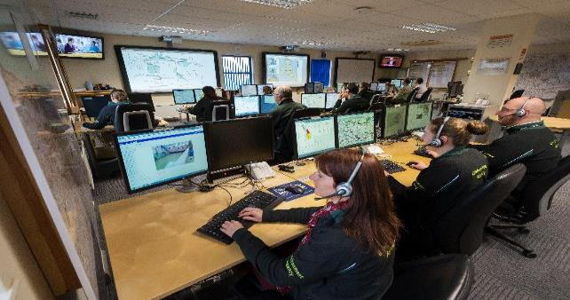

6. Principal accountabilities for each role

We are recruiting nationally across the teams involved in the EA response to Prolonged Dry Weather. We are recruiting to over 50 staff at various grades from entry level roles to more experienced. Vacancies are across all 9 teams and are a mixture of permanent and fixed term positions (To the end of March 2019).

***Please include within the additional requirements field of your application (after location / office selection) which role(s) you are particularly interested in.***

**Dry Weather Response Coordinator**

**You will be involved in one of the following team roles:**

**Water Resources Coordinator**

This post will focus on Water Resources ensuring that water use is sustainably managed in our Area. You will work with specialists on assigning licences for water abstraction and ensuring catchments have sufficient water. You will work with Area teams to make sure there are adequate flows and that they are in a natural seasonal pattern by working with water companies on their reservoir releases  
As part of the role you will consider Catchment planning and Water Quality, ensuring that we have the right evidence in place to be able to put environmental measures in place.

**Environment Programme Coordinator**

The role draws upon a diverse range of skills. Working closely with other teams, you will be involved in:

* Ensuring that Area projects are environmentally compliant
* Working with a variety of environmental stakeholders
* Identifying environmental opportunities and delivering multiple benefits
* Working with external suppliers and other Environment Agency specialists within integrated project teams
* Providing focus on Water Resources ensuring that water use is sustainably managed in our Area.

**Hydrometry and Telemetry Coordinator**

Telemetry systems are critical to the Environment Agency’s incident management, flood and coastal risk management, water resources and environmental protection.

You will be responsible for the delivery of accurate and timely data and information received from the field, interpreted in our systems and made available for a range of internal and external customers. This is a highly technical role where you'll work as part of a team to maintain and enhance our telemetry service whilst ensuring the continuous flow of business critical data and information to our customers.

The successful candidate will have a good knowledge of the telemetry system, in particular the Swantel system, and be keen to develop in this area. You will be able to demonstrate a range of technical capabilities needed for telemetry system management and configuration.

**Hydrogeology Coordinator**

We need enthusiastic candidates to help us preserve and protect groundwater throughout East Anglia Area.  
We have a fantastic opportunity for Hydrogeologists to help us preserve and protect groundwater throughout the Area. Working as part of a team of experts, you’ll put your skills to meaningful use, supporting important work that guarantees a sustainable water supply for the local population and environment.   
Involved in the work the Groundwater Resources and Hydrology team carry out, promoting sustainable water management across the Great Ouse and other catchments, this is a varied and rewarding role for a person passionate about making a positive difference to the environment.

**Hydrology Technical Coordinator**

We need you to help us to regulate and improve the water environment of East Anglia Area. Your role will be to analyse, interpret and report on hydrology data for water resources activities, which will include contributing to the production of the water situation report, carrying out quality assurance of river flow data and technical assessments into the impact of water abstractions on river flows. You’ll work closely with your Hydrology team members and also with internal and external customers and partners.

Join us as a Hydrologist and you’ll play an important role in ensuring that future generations inherit a cleaner, healthier environment.

**National Hydrologist (Coordinator)**

This hydrology position is essential to allow the National Water Resources Hydrology team to maintain its level of response during dry weather and the recovery phase of the current incident. It will also allow the team to focus on day job strategic water resources activities which have largely been on hold for the last 12 months. The team provides hydrological advice and analysis and projections, in a timely manner both supporting the National Drought Manager and Drought Co-ordinator together with the Area based Hydrology Service. You will be expected to support the National Hydrology rostered team member (within office hours only) within the National Dry Weather planning cell.  The team provide regular hydrological updates for both the National Incident Room and Defra. You will be involved in the production of the national weekly rainfall and river-flow brief and supporting the production of the monthly water situation reports together with associated data management activities. There may also be opportunities to get involved in other work areas supporting dry weather and strategic water resources projects.

This job will be right for you if you are already familiar with the Hydrology Service in Areas and would be interested in getting some experience of the national perspective.

**Top competencies**

* **Achieves Results**
* **Data and Information Management**
* **Takes Decisions and Solves Problems**
* **Communicates Effectively**

7. Training and development

You will receive the necessary training and development to ensure that you have the skills needed to perform your role in Water Resources to a high standard. This will include a mixture of on the job training, mentoring, e-learning and role specific training courses.

Below is a list of some of training courses and development opportunities, you will be eligible for if you are successful in gaining a role in the Environment Agency:

* Incident Management,
* Health & Safety; including ‘Working Near Water’ and ‘Manual Handling’,
* Programme and Project Management; Association of Project Management / PRINCE 2 – Foundation to Practitioner,
* ArcGIS – Geographic Information Systems,
* Legislation and Law relating to water quality and resources,
* Environmental Awareness; Climate Change, Hydrology Foundation and Geomorphology,
* Financial Management,
* Incident Management,
* Mentoring / Coaching and Assignment opportunities within the organisation.

In addition to a comprehensive training package, the Environment Agency will support and fully fund your Continuous Professional Development (CPD). We encourage our staff to become certified in their field and will provide the time, resources and reimburse costs for membership of any preferred Professional Institution i.e. CIWEM.

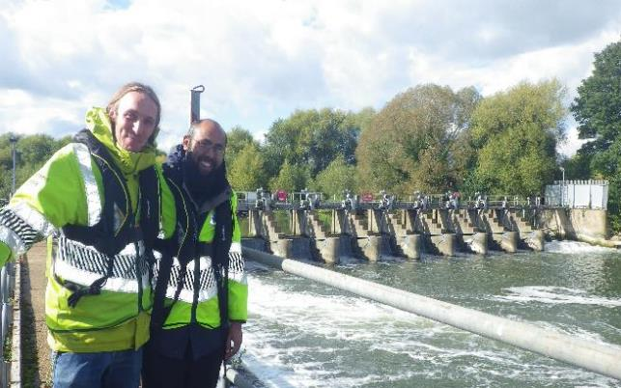

**Apprenticeships**

We are committed to the personal and professional development of employees and offer over thirty, fully funded, different apprenticeship qualifications across our business. These allow eligible employees to gain technical qualifications (for example in civil or maintenance engineering) or general business skills (for example qualifications in Leadership and Management, Project Management and Business Administration). A number of these are offered up to and including degree level, allowing employees to obtain a BSc or BA qualification that is fully funded by the Environment Agency.

If you are successful in securing a permanent role at the Environment Agency, you will have the opportunity to complete an apprenticeship that is linked with your role. Examples of those apprenticeships relevant to Prolonged Dry Weather include:

|  |  |
| --- | --- |
| Apprenticeship | Qualification |
| Project Management (Associate Project Manager | Accredited by the Association of Project Managers |
| Leadership & Management –  Team Leader | Chartered Management Institute Level 3 Diploma in First Line Management |
| Data Analyst | Entry onto the Register of IT Technicians |

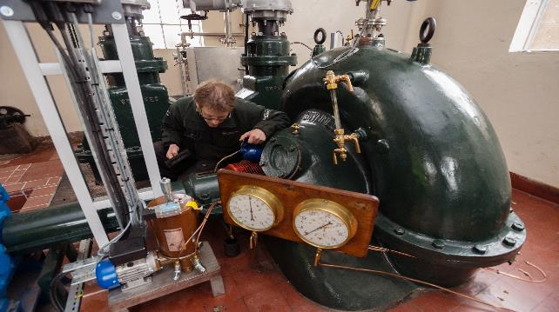

8. Salary and benefits

Join us in this role and you will enjoy the following benefits:

**Grade Rate:**  Grade 4 - £27,138 (pro-rata - if part time or an assignment)

**Location:** Various locations dependent on role.

**Hours of work:**  37 hours, Permanent or Fixed Term Contract until end of March 2019

**Leave entitlement:** Your leave allowance in this role will be 25 days plus bank holidays (pro-rata - if part time or an assignment).

We also offer up to two days paid environmental outcome days each year. These give you the opportunity to take part in community activities with a clear environmental outcome for people and wildlife.

**Pension:** We will enrol you into the Environment Agency Pension Fund (EAPF) on commencing employment, if your employment contract is for 3 months or more. The EAPF is part of the Local Government Pension Scheme (LGPS). It is a career average scheme, which means you will build up benefits based on your pay each scheme year rather than your final salary.

We will base your pension contributions on your actual pay and you will receive tax and national insurance relief on your contributions.  The pension contribution rates currently range between 5.5% to 12.5%.  Whilst you are in the scheme we will also pay an employer contribution into your pension pot. We currently pay 18.5%, so this is a very generous scheme.

**Work/life balance:** We support flexible working hours and practices to help you strike a good balance between your work life and your personal life. We will also encourage you to keep developing your skills and professional knowledge throughout your career.

**Diversity:** We are committed to diversity and inclusion. We want all our staff to feel valued and respected and to see this as a great place to work.

Diversity: it’s in our nature.

9. Further information

As a national organisation we with work and customers across England, in some of our roles you may be asked to undertake infrequent national travel usually to London or Birmingham.

The Environment Agency values a diverse workforce and welcomes applications from all sections of the community who wish to join a workforce which embraces difference and welcomes everyone.

We particularly welcome applications from Black, Asian and Minority Ethnic (BAME) and female candidates who are under-represented across our workforce.

**We welcome flexible working patterns for all our vacancies, including job share, so please include clearly any information regarding your preferred working arrangements on your application.**

As part of our commitment to flexible working we offer up to 15 additional days ‘flexi-time’ per year.

These directly correlate with any hours worked above your core 37 hour contracted working week (pro-rata - if part time or an assignment).

Please note that Environment Agency employees are not civil servants so you may wish to check your eligibility for continuity of employment by contacting your HR department. All eligible bodies are listed in the Redundancy Payments (Continuity of Employment in Local Government etc) (Modification) Order 1999.

Employment agency workers and contractors are considered to be external candidates and should therefore only apply for positions that are being advertised externally. They are also not eligible to claim continuity of employment should they be successful in securing a position with the Environment Agency.

To find out more about what it’s like to work at the Environment Agency, please visit: <https://www.gov.uk/government/organisations/environment-agency/about/recruitment>

Please note all successful applicants must undergo Baseline Personnel Security Standard (BPSS) checks prior to commencement of employment. This includes a basic criminal records check.

For the great majority of roles in the Environment Agency this will be sufficient and only certain roles will require a higher level of clearance. Should this be necessary, you will be advised of this during the recruitment process.

10. How to apply

We use an online recruitment system. To make the application process simple and straightforward, and so that you know how it works and what we need from you, we’ve put together a few hints and tips.

The first thing you need to do is sign up to our recruitment system. You will need a valid e-mail address to log in and apply for opportunities, as all communication from us will be via e-mail. You can do this via the vacancy you are interested in by selecting **‘Apply’** at the bottom of the advert. (For some jobs, you’ll be asked to download a candidate pack, like this one, where you’ll find specific application instructions.) Once you’ve clicked this link you’ll then be asked ‘Do you have the right to live and work in the UK?’, ‘Do you have the required qualifications or equivalent experience, which were stated in the job advert?’ and ‘Are you currently an employee of this organisation?’ Simply answer yes or no and you can carry on with your application. You’ll then see the **‘Register’** page. Simply complete the details and select **‘Submit Registration’** and register to the system. You only need to sign up to the system once; you’ll just be able to login next time.

When it comes to the actual application, you need to fill out each section, please be aware that the system will automatically time out if you are inactive for more than 60 minutes. This will result in any unsaved information being lost so make sure you save what you are doing regularly. Once you’ve finished, your details and information will be saved on the system for any future applications – of course, you can edit your details at any point.

When you apply to the Environment Agency for a job we will ask you to provide your personal data on our application form. We need this information so that we can establish your identity and your right to work in the UK.

You can read our Data Protection Statement on the application process page of our recruitment system.  It is also available for reference on each page of the actual application.

**Competence Questions/Statement**

We’re keen to know what makes you right for the job you’re applying for and why we should ask you in for an interview. The competence questions/statements are your chance to convince us!

You should demonstrate how your skills, qualities and experience meet the requirements of the job (as described in the job advert and candidate pack). And instead of simply telling us, show us: use real life examples of where you’ve used a certain skill or how you’ve practically applied your experience.

There’s a 250 word limit per competence including spaces. It’s a really important part of the selection process so make sure you keep your statement relevant and concise. Think about what we need to know about you and what you’d bring to the role and our organisation.

**Application questions**

For some roles, we’ll ask you some specific questions, like if you have a preferred work location. If you’re disabled and you’d like to be part of our Guaranteed Interview Scheme, you can add this information in here.

**Equality and Diversity**

We’re committed to reflecting the communities we serve and we’d like you to tell us about yourself and your background.

**Role Specific Questions**

For further information relating to any of these roles, please contact

[StrategicResourcing@environment-agency.gov.uk](mailto:StrategicResourcing@environment-agency.gov.uk)

**Submitting your application**

Once you’ve filled out and completed everything, you’ll be prompted to submit your application. Simply click the button and you’re done. If, at any stage, you have questions or problems, please contact the recruitment team on 0845 602 6099 or email [ea_recruitment@sscl.gse.gov.uk](mailto:ea_recruitment@sscl.gse.gov.uk)

For further information on this role

If you have been unsuccessful with your application you can set up email alerts for future vacancies. You will automatically receive an email when a job that matches your criteria becomes available. To do this simply click on **‘create a new job alert’**, enter your job criteria and save.



