Business Support Team Member (Recruitment) G3

Candidate Information Pack



**Job title: Business Support Team Member (Recruitment) G3**

**Job location: Multiple locations available - please see table on page 11**

**Date: July 2022**

**Reference: 23513**

Contents

1. **Our organisation**
2. **Salary and benefits**
3. **The team**
4. **The role**
5. **Training and development**
6. **Further information**
7. **How to apply**









1. Our organisation

We are the Environment Agency. We protect and improve the environment. Acting to reduce the impacts of a changing climate on people and wildlife is at the heart of everything we do. We reduce the risks to people, properties and businesses from flooding and coastal erosion. We protect and improve the quality of water, making sure there is enough for people, businesses, agriculture and the environment. Our work helps to ensure people can enjoy the water environment through angling and navigation. We look after land quality, promote sustainable land management and help protect and enhance wildlife habitats. And we work closely with businesses to help them comply with environmental regulations. We can’t do this alone. We work with government, local councils, businesses, civil society groups and communities to make our environment a better place for people and wildlife.

Of course, none of this will be possible without the professionalism and dedication of our staff. We are committed to promoting equality and diversity in all we do, and to valuing the diversity of our workforce, customers and communities.

We’re committed to helping our people to find new ways of working and to maintain our focus on creating a better place for people and wildlife. For more information on the Environment Agency and what we do, please visit: [**www.environment-agency.gov.uk/aboutus**](http://www.environment-agency.gov.uk/aboutus)

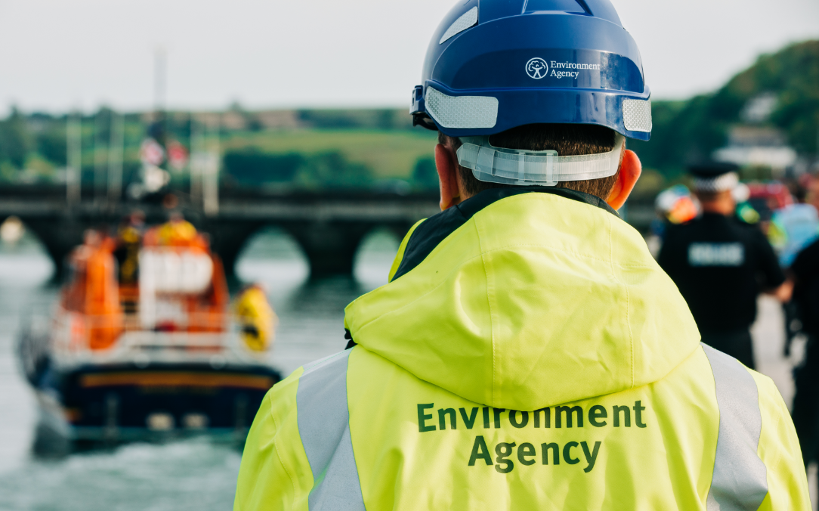

[Website](http://www.gov.uk/environment-agency) | [Twitter](https://twitter.com/envagency) | [Facebook](https://www.facebook.com/environmentagency) | [LinkedIn](https://www.linkedin.com/company/environment-agency) | [Instagram](https://www.instagram.com/envagency) | [Flickr](https://www.flickr.com/photos/environment-agency) | [YouTube](http://www.youtube.co.uk/user/EnvironmentAgencyTV)

2. Salary and benefits

Join us in this role and you will enjoy the following benefits:

**Grade Rate:**  Grade 3 - £24, 213 (pro-rata if part time)

**Location:** Multiple locations available – please see table on page 11

**Hours of work:** 37 hours, full time/part time/job share (all options considered)

**Leave entitlement:** Your leave allowance in this role will be 25 days plus bank holidays (pro-rata - if part time or an assignment). Your allowance will be pro-rata if you work part time or you are on an assignment to a role at a higher grade that attracts an increased entitlement. Your entitlement depends on your grade, your contracted hours, and your length of continuous service.

We offer up to two days paid environmental outcome days each year. These give you the opportunity to take part in community activities with a clear environmental outcome for people and wildlife.

**Pension:** We will enrol you into the Environment Agency Pension Fund (EAPF) on commencing employment, if your employment contract is for 3 months or more. The EAPF is part of the Local Government Pension Scheme (LGPS). It is a career average scheme, which means you will build up benefits based on your pay each scheme year rather than your final salary.

We will base your pension contributions on your actual pay and you will receive tax and national insurance relief on your contributions.  The pension contribution rates currently range between 5.5% to 12.5%.  Whilst you are in the scheme we will also pay an employer contribution into your pension pot. We currently pay 19%, so this is a very generous scheme.

2. Salary and benefits continued

**Work/life balance:** We support flexible working hours and practices to help you strike a good balance between your work life and your personal life. We will also encourage you to keep developing your skills and professional knowledge throughout your career.

As government restrictions continue to lift, Defra group is exploring future ways of working with flexibility in mind. This means, that subject to business need, successful candidates will be offered the option to combine working at home with working at their contractual Defra group workplace, with occasional travel to other work locations. Further information relevant to this post will be available for candidates invited to interview.

**Diversity:** We are fully committed to being an inclusive employer and ensuring equal opportunities. We are keen to make our workforce as diverse as possible, and we hope to attract applications from under- represented groups, including Black, Asian and Minority Ethnic (BAME) people, people with a disability, and people with gender diverse identities. We would also welcome applications from candidates from lower socio-economic backgrounds who are looking to take their first steps into the world of work and into learning

**Relocation:** If you need to relocate to take up this role, we might be able to offer financial help with this. This will depend on your circumstances, so if it’s something you are interested in, please discuss it with us to find out what the options are.

**Tenancy deposit loan:** Our Tenancy Deposit Loan scheme assists employees directly employed by the Environment Agency in meeting the costs of a deposit for a privately rented home, which can sometimes act as a barrier to moving. The scheme gives access to an interest free loan to pay for some or all of a deposit on a privately rented home. The loan can be paid back over a period of up to 12 months, directly from the monthly salary.

3. The Team

Our geographical area teams are an inclusive, diverse and passionate part of our organisation. Our vision is for the organisation to thrive and improve so we can create a better place for people, wildlife and the environment.

Business Support plays a huge part in enabling us to achieve our goals and our work covers a range of activities including recruitment, assurance & risk, health, safety & wellbeing, customer enquiries, engagement and communications. Come join us!

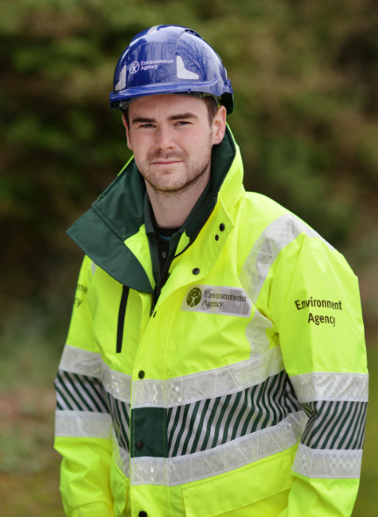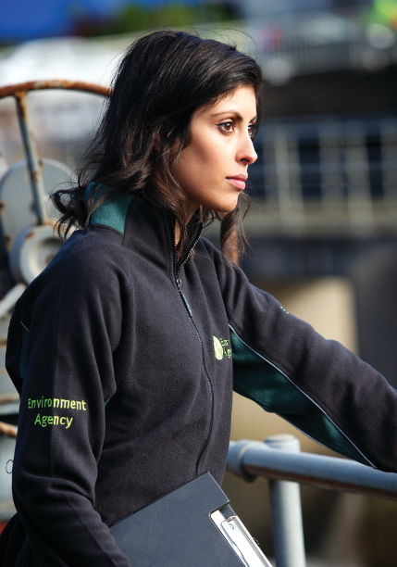

4. The role

Our advert describes the day-to-day activities of the role, the team it operates within and the skills/experience we’re looking for from applicants. This information should be read in conjunction with the job family role profile that we’ve provided. In the Environment Agency, our roles are grouped by grade and similar characteristics into one of seven job families. Job families describe the work undertaken in broad terms. This enables us to use generic profiles to broadly describe 80% of the key accountabilities, skills, and experience for each job family at each grade.

The role of Business Support Team Member fits into our Business Services job family at Grade 3 (BS03).

**Roles and responsibilities**

The successful candidate will contribute to the delivery of the programme of work which will help to achieve the ambition in the Environment Agency’s [People Strategy](https://en.calameo.com/read/00443368075829d4b3f3d?authid=50235hXg0h4Q), including our aim to be best employer for equality, diversity and inclusion in the country.

The successful candidate will be expected to work in an agile way to lend their skills to organisational priorities. Your focus will be on supporting our portfolio of projects which will ensure that the Environment Agency attracts, recruits and retains the people, skills, capability and capacity we need to respond to climate and biodiversity emergencies. You'll help us to achieve the ambition in the Environment Agency’s five-year plan, [EA2025](https://www.gov.uk/government/publications/environment-agency-ea2025-creating-a-better-place), and beyond.

For additional information on starting a career with the Environment Agency, please visit:

<https://environmentagencycareers.co.uk/>

This role will include, but not be limited to:

* Coordinate the administration of the Environment Agency recruitment system (Oleeo) and undertake other associated administration tasks.
* Assist with advert upload and promotion.
* Manage and track the onboarding of new starters into the business, liaising closely with recruiting managers.
* Organise new starter induction and order equipment such as IT and where required, personal protective equipment on behalf of business units.
* Build strong relationships with a community of practitioners and work collaboratively together to share and learn with a view to continuously improve.

  
4. The role continued

**What skills do you need?**

The ideal candidate will: 

* Have a positive, proactive and hard-working attitude.
* Be an organised, flexible person who can deliver quickly in a fast-paced environment.
* Have good written and verbal communication skills and work well in a diverse, dispersed team.
* Be comfortable using different digital tools, such as Microsoft Office 365, Word, Excel and Outlook.

**Top capabilities**

Please note that your answers to the capability questions will be used for shortlisting purposes. Your examples do not necessarily have to be work related, please use the best example from any area of your life. You may find  researching the STAR technique (Situation, Task, Action, Result) useful when answering the questions.

**Competency 1 – Achieves Results**

Description: Sets and delivers high work standards, demonstrates the drive to meet targets. Prioritises and organises tasks and resources to ensure timely achievement of results.

As a Business Support Team Member there will be a variety of different demands on your time. Using examples, please describe how you prioritise your workload to ensure that you meet your targets?

**Competency 2 – Works in Teams**

Description: Works co-operatively as part of a team to achieve common goals.

Please tell us about a time when you have worked as part of a team to achieve an outcome. What was your role within the team and how did you approach working with others to ensure this outcome was achieved?



4. The role continued

**Competency 3 – Data & Information Management**

Description: Collects, analyses, interprets, records, manages, develops and shares data, material or information appropriately for a variety of purposes.

Please describe an occasion when you have had to gather information from a variety of sources.  
  
• How did you go about gathering the information required?  
• How did you ensure you understood all of the information?  
• How did you pull all the different pieces of information together?

For further information on the capabilities being used, please visit:

[EA Capabilities](https://en.calameo.com/read/004433680a6d25bb86da2?authid=xLUKeIjmDC5X)

**What experience do you need?**

Whilst relevant work experience would be an advantage, it’s less important to us than your ability to demonstrate the key transferrable skills and the personal qualities that we’re looking for.



4. The role continued

**Testimonial**

To help bring the role to life, please see below some reflections about the role and working at the Environment Agency.

**Melanie Goacher, Business Support Team Member (Recruitment)**

My role involves providing guidance and support to managers on recruitment system activities, from initial recruitment approval to getting candidates in post. I do this by providing templates and useful information, inputting and downloading data from the recruitment system (Oleeo), and responding to enquires from candidates. I also manage our recruitment mailbox.

I enjoy the role because I interact with a wide range of colleagues and candidates, the work is varied, and I work independently but with regular interaction with a network of colleagues who carry out a similar role. I enjoy working for the Environment Agency because I can work flexible hours which allows me to balance work and home life.

Career development is encouraged and supported with opportunities to improve my skills and experience. It is great to be part of a diverse community of people who share a common purpose and goal.



4. The role continued

**Role locations available**

Please make it clear on your application which area you are applying for.

|  |  |  |  |
| --- | --- | --- | --- |
| **Area** | **Office Locations** | **Contract Type** | **Number of Roles Available** |
| Lincolnshire & Northamptonshire | Lincoln, Kettering | Permanent | 1 |
| Devon, Cornwall & Isles of Scilly | Bodmin, Exeter | Permanent | 1 |
| Hertfordshire & North London | Welwyn Garden City | Permanent | 1 |
| West Midlands | Birmingham, Lichfield, Shrewsbury, Tewkesbury | Fixed Term Contract – 18 months | 1 |

Please note that some of our Areas have additional offices. Unfortunately we cannot list all of these for selection. You can provide further detail on your location in the free text box as part of your application.

5. Training and development

At the EA, it is fundamental to our success that our staff have the appropriate knowledge and understanding in order to effectively deliver our work. We will therefore invest significantly in providing you with excellent training opportunities.

**What will the training be like?**

The training will be a combination of:

* On the job training, computer based learning and virtual classroom sessions
* Coaching and mentoring from more experienced staff
* A ‘buddy’ system for you to get to know the wider team and settle into the organisation

You will also be given training to participate in an incident role, so you can support the Environment Agency with live incidents. Incident response is our top priority and we would like everyone to get involved, wherever you work and whatever your working arrangements. There are roles to suit everyone's personal circumstances, even if you can only work during office hours, travel a lot or have a demanding day job. Some roles will be active during an incident, whilst others support business critical activities or systems.  
  
Your line manager will support you to carry out an incident role and balance the demands of your day job. There are incident roles to suit everyone’s skills - whether you want to choose a role completely different to your day job or whether you want to match a role to your existing skills, you will be given all the support and training you need to be confident in your role.

**What training will you receive when you start?**

The new starter training modules will cover the following:

* Health, safety and wellbeing
* Incident response
* Customer service
* Oleeo, the Environment Agency recruitment system
* Advert upload
* Blind sifting applications & interview score entry

5. Training and development continued

* Advert upload and promotion
* Induction
* Our onboarding processes;

*Equipment ordering such as PPE and IT*

*Submitting relevant paperwork*

*Maintaining contact with new starters to ensure onboarding is smooth*

*Tracking progress and liaising with recruiting managers*



6. Further information

The closing date for applications is **Sunday 21st August 2022**.

The Environment Agency values a diverse workforce and welcomes applications from all sections of the community who wish to join a workforce which embraces difference and welcomes everyone.

We aim to create and maintain a diverse workforce (including our Board and Executives) that better reflects the UK’s economically active population. Therefore, we particularly welcome applications from Black, Asian and Minority Ethnic (BAME), disabled, female and LGBT+ candidates who are under-represented across our workforce.

We will consider flexible working patterns for all our vacancies, including job share. Please highlight any information regarding preferred flexible working arrangements on your application.

All assessments and interviews will be carried out using an online platform, such as MS Teams.  
  
Interviews are scheduled to take place during the fortnight commencing **Monday 12th September 2022.**

For any other queries about the role please contact either

Rhianne Locke, Northern Hub Advisor – [rhianne.locke@environment-agency.gov.uk](mailto:rhianne.locke@environment-agency.gov.uk) or

Pam Coleman, Southern Hub Advisor – [pam.coleman@environment-agency.gov.uk](mailto:pam.coleman@environment-agency.gov.uk)



6. Further information continued

**Eligibility to apply and continuity of employment**

Employment agency workers and contractors are considered to be external candidates and should therefore only apply for positions that are being advertised externally. They are also not eligible to claim continuity of employment should they be successful in securing a position with the Environment Agency.

If you have been a member of a Regional Flood and Coastal Committee in the last 12 months we will not be able to continue with your application based on agreed appointment rules related to employing ex-RFCC members. We would welcome an application from you once the 12-month period have passed.

For applicants who currently work in local government or other bodies listed in the Redundancy Payments (Continuity of Employment in Local Government etc.) (Modification) Order 1999, you may be eligible for continuous service for the purpose of calculating any future redundancy payment. In addition, if you can demonstrate that you have worked at the Environment Agency immediately before joining the Civil Service and are now being re-employed by the Environment Agency within a period of three years of leaving, you may also count your Civil Service employment for the purpose of calculating your service-related entitlements as outlined above. If you are unsure of your status then you should contact your own HR Team.

**Pre-employment Checks**

We apply the Baseline Personnel Security Standard (BPSS) check when recruiting staff to our posts. This includes a basic criminal records check.

For the great majority of roles in the Environment Agency this will be sufficient and only certain roles will require a higher level of clearance. Should this be necessary, you will be advised of this during the recruitment process.

Positions based at our London office or roles that require frequent travel to London require CTC level security clearance. This will be confirmed to you during the recruitment process.



6. Further information continued

**Want to find out more?**

To find out more about what it’s like to work at the Environment Agency, please visit: <https://www.gov.uk/government/organisations/environment-agency/about/recruitment>





[](https://www.bing.com/images/search?q=flickr+logo&id=1CFD4889F53600C7C533F585C107628EB73609E7&FORM=IQFRBA)

[](https://twitter.com/EnvAgencyJobs)[](http://www.linkedin.com/company/environment-agency/careers?trk=top_nav_careers)[](https://www.facebook.com/environmentagency?ref=hl)



7. How to apply

We use an online recruitment system. To make the application process simple and straightforward, and so that you know how it works and what we need from you, we’ve put together a few hints and tips. Make sure you have all the information you need about the vacancy. For some jobs, you’ll be asked to download a candidate pack, like this one, where you’ll find specific application instructions.

The first thing you need to do is sign up to our recruitment system. You will need a valid e-mail address to log in and apply for opportunities, as all communication from us will be via e-mail. You can do this via the vacancy you are interested in by selecting **‘Apply’** at the bottom of the advert.

Once you’ve clicked this link you’ll then be asked:

* Do you have the right to live and work in the UK?
* Do you have the required qualifications or equivalent experience, which were stated in the job advert?
* Are you currently an employee of this organisation?

Simply answer yes or no and you can carry on with your application. You’ll then see the **‘Register’** page. Simply complete the details and select **‘Submit Registration’** and register to the system. You only need to sign up to the system once; you’ll just be able to login next time.

When it comes to the actual application, you need to fill out each section, please be aware that the system will **automatically time** out if you are inactive for more than 60 minutes. This will result in any unsaved information being lost so make sure you save what you are doing regularly. Once you’ve finished, your details and information will be saved on the system for any future applications – of course, you can edit your details at any point.

When you apply to the Environment Agency for a job we will ask you to provide your personal data on our application form. We need this information so that we can establish your identity and your right to work in the UK.

You can read our Data Protection Statement on the application process page of our recruitment system.  It is also available for reference on each page of the actual application.

. 7. How to apply continued

**Competence Questions/Statement**

We’re keen to know what makes you right for the job you’re applying for and why we should ask you in for an interview. The competence questions/statements are your chance to convince us!

You should demonstrate how your skills, qualities and experience meet the requirements of the job (as described in the job advert and candidate pack). And instead of simply telling us, show us: use real life examples of where you’ve used a certain skill or how you’ve practically applied your experience.

There’s a 250-word limit per competence including spaces. It’s a really important part of the selection process so make sure you keep your statement relevant and concise. Think about what we need to know about you and what you’d bring to the role and our organisation.

**Application questions**

For some roles, we’ll ask you some specific questions, like if you have a preferred work location. If you’re disabled and you’d like to be part of our Guaranteed Interview Scheme, you can add this information in here.

**Equality and Diversity**

We’re committed to reflecting the communities we serve and we’d like you to tell us about yourself and your background.



7. How to apply continued

**Submitting your application**

Once you’ve filled out and completed everything, you’ll be prompted to submit your application. Simply click the button and you’re done.

Please be aware that once you’ve submitted your application, with the exception of the ‘Personal Details’ section you will not be able to edit your application further. If you decide to withdraw your application, you will not be able to submit another application for the same vacancy.

If, at any stage, you have questions or problems, please contact the recruitment team on 0845 241 5350 or email [ea_recruitment@gov.sscl.com](mailto:ea_recruitment@gov.sscl.com)

**Setting up ‘job alerts’**

If you have been unsuccessful with your application you can set up email alerts for future vacancies. You will automatically receive an email when a job that matches your criteria becomes available. To do this simply click on **‘create a new job alert’**, enter your job criteria and save.

# ENVIRONMENT AGENCY BENEFITS



The Environment Agency offers an attractive and competitive benefits package, including:

|  |  |  |  |  |
| --- | --- | --- | --- | --- |
| **Core Benefits**  **Basic Salary**  Based on skills and experience, in which salary ranges are subject to review each year as part of the pay award.  **Pension Scheme**  A career average revalued earnings (CARE) pension scheme. Contributions are based on your full time equivalent pay, ranging between 5.5% and 12.5%. The EA contribution is currently 19% of your pay.  **Holidays**  Annual holiday entitlement starting at 25 days plus statutory bank holidays (pro-rata for flexible workers). We also offer up to two days paid environmental outcome days each year  **Enhanced statutory policies**  Enhanced maternity, adoption and paternity leave, and sickness absence provisions. | **Training & Development**  **Performance Management**  Individual performance plans, learning and development matched to your agreed career objectives and progression plans.  **Learning & Development**  A range of training courses, leadership development initiatives and access to L&D materials are available, covering technical, managerial and personal skills.  **Examination Leave**  Paid leave for exams and revision for approved studies.  **Professional subscriptions**  We will pay the membership fees for one relevant professional association. | **Work/life Balance**  **Flexible Working**  Flexible working patterns including job share.  **Travel & Transport Benefits**  A range of travel and transport benefits. Discounts on Haven Holidays and HotelStay.  **Shopping & Leisure Benefits**  A variety of discounts at online stores and leisure experiences available via MyLifestyle. | **Health & Wellbeing**  **Occupational Health**  Access to Duradiamond Healthcare advisory service.  **Eye Care**  Free eye tests.  **Employee Assistance Service**  Access to Workplace Wellness available to you and your family  **Sports & Social Club**  Opportunity to benefit from a wide range of subsidised events and discounts.  **Health Discounts**  Optional discounts provided by a number of external providers and health clubs  **Local Benefits**  These vary from region to region. | **Finance**  **Interest Free Loans**  For season tickets, bicycles and safety equipment.  **Special Leave**  Additional paid leave is available for employees taking part in public duties, trade union activities, special/trained forces and for health & safety representatives.  **Financial Education Club**  Providing guidance on how to manage your finances including information on credit scores, pensions, buying your first house and getting debt-free.  **Tenancy deposit loan scheme**  Access to an interest free loan to pay for some, or all of a deposit on a privately rented home.  *The following benefits only apply to eligible roles:*  **Lease Car Scheme**  **Relocation Assistance**  **Free Car Parking** |